Supplementary data for
Research
Carbon Capture, Utilization, and Storage—Article

High-Temperature Stable Dispersed Particle Gel for Enhanced Profile Control in Carbon Capture, Utilization, and Storage (CCUS) Applications
Lin Du ^{a,b}, Yao-Yu Xiao ^{c}, Zhi-Chao Jiang ^{c}, Hongbo Zeng ^{c,}*, Huazhou Li ^{b,}*
ª College of Energy, Chengdu University of Technology, Chengdu 610059, China
^{b} School of Mining and Petroleum Engineering, Faculty of Engineering, University of Alberta, Edmonton, AB T6G 1H9, Canada
^{c} Department of Chemical & Materials Engineering, University of Alberta, Edmonton, AB T6G 1H9, Canada

* Corresponding Authors.
E-mail addresses: huazhou@ualberta.ca (H. Li), hongbo.zeng@ualberta.ca (H. Zeng).

S1. Mathematical equations used for evaluating the plugging-performance of gels
Pore volume calculation:
$PV=Q×T_{bt}$ (S1)
Porosity calculation:
$ϕ=\frac{PV}{V_{t}}×100\%$ (S2)
Permeability calculation:
$K_{i}=\frac{QμL}{A(P_{5}-P_{80})}×{10}^{-12}$ (S3)
Plugging efficiency calculation:
$η=\frac{K_{i}-K_{s}}{K_{i}}×100\%$ (S4)
Residual resistance factor determination:
$F_{rr}=\frac{K_{i}}{K_{s}}$ (S5)
where PV is the pore volume in m³, Q is the water flow rate in m³/s, T_{bt} is the breakthrough time in s, ϕ is the porosity in %, V_{t} is the total volume of the sandpack in m³, K_{i} is the initial permeability of the sandpack in μm², μ is the water viscosity in Pa⋅s, A is the cross-sectional area of the sandpack in m², L is the length of the sandpack in m, P₅ and P₈₀ are the pressures at 5 cm and 80 cm away from the inlet of the sandpack, respectively, in Pa, K_{s} is the subsequent permeability of the sandpack after DPG injection in μm², F_{rr} is the residual resistance factor, and $η$ is the plugging efficiency in %.

S2. Comparison of the surface roughness of a gel particle in PAAm/SA-DPG and a gel particle in PAAm/SA-PMS₂/SA₃-mDPG.
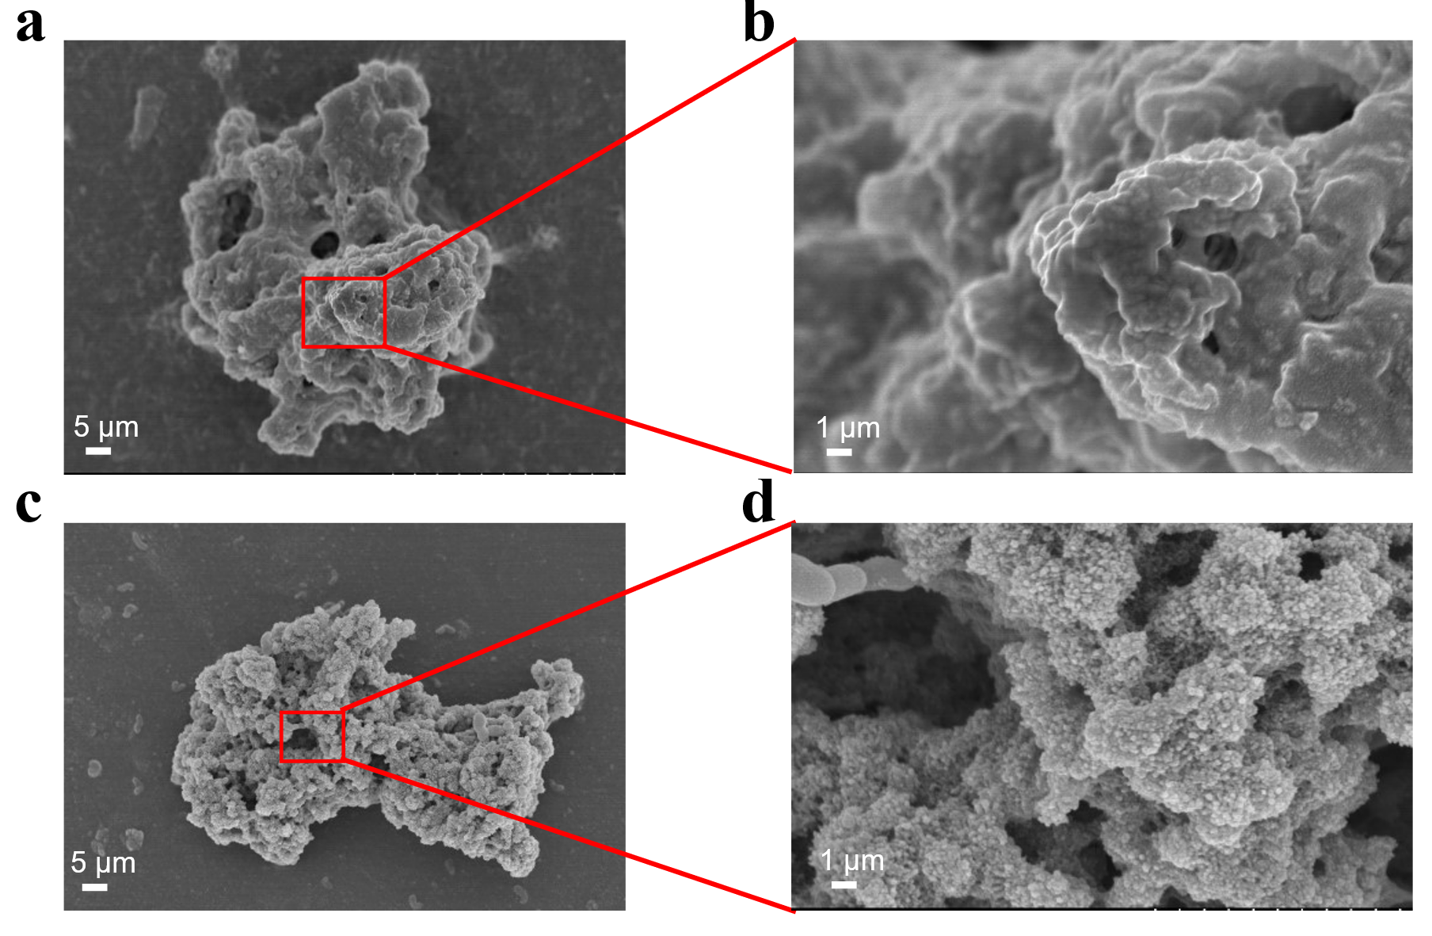
Fig. S2. Comparison of the surface roughness between a particle of the PAAm/SA-DPG and a particle of the PAAm/SA-PMS₂/SA₃-mDPG: (a) A particle of the PAAm/SA-DPG; (b) A zoomed-in region of the particle of the PAAm/SA-DPG; (c) A particle of the PAAm/SA-PMS₂/SA₃-mDPG; (b) A zoomed-in region of the particle of the PAAm/SA-PMS₂/SA₃-mDPG.

S3. The effect of salinity on gel particle swelling
Fig. S3. Particle size distributions of PAAm/SA-DPG and PAAm/SA-PMS₂/SA₃-mDPG in distilled water and in saline water, respectively.

S4. Contact angle measurement
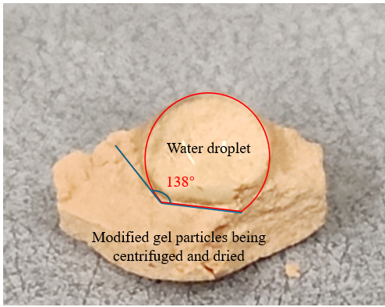
Fig. S4. The contact angle between a water surface and the surface of modified particles of the PAAm/SA-PMS₂/SA₃-mDPG.
S5. FTIR spectrum comparison
Fig. S5. Comparison of the FTIR spectra of the particles in the PAAm/SA-PMS₂/SA₃-mDPG and the precipitate-like substances in the PAAm/SA-PMS₂/SA_{1.875}-mDPG.

S6. Schematical illustration of the structure of the PAAm/unSA-Gel
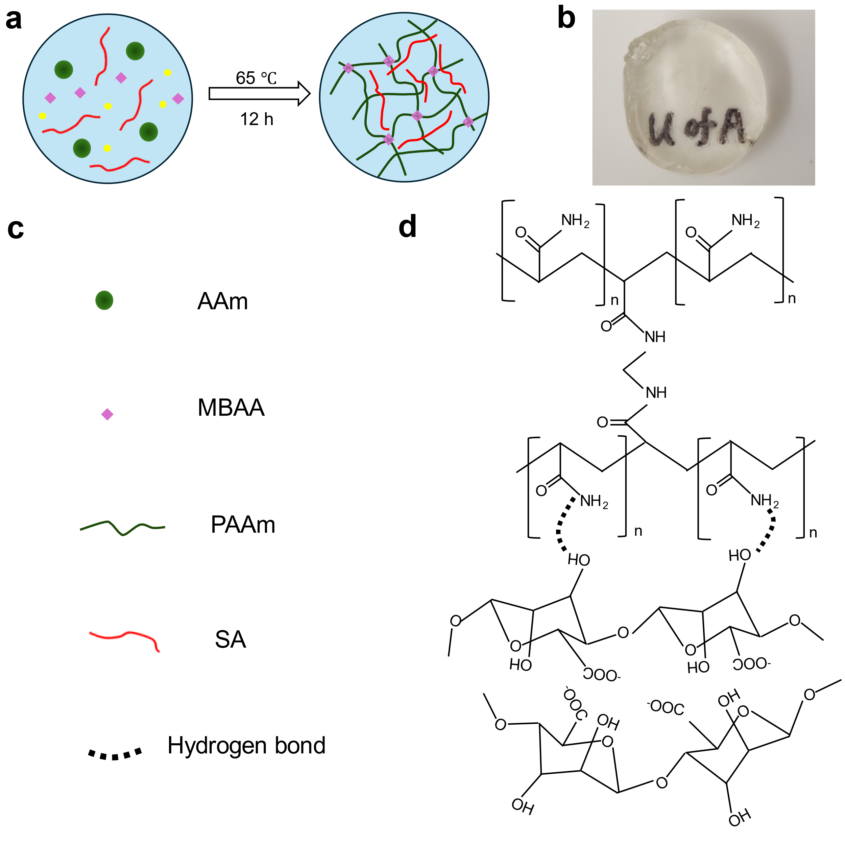
Fig. S6. Schematical illustration of the structure of the PAAm/unSA-Gel: (a) Schematic illustration of the fabrication process; (b) The prepared PAAm/unSA-Gel; (c) Chemicals used in the fabrication process; (d) Illustration of the structure of the PAAm/unSA-Gel.

S7. Modification of gel particles of PAAm/unSA-DPG
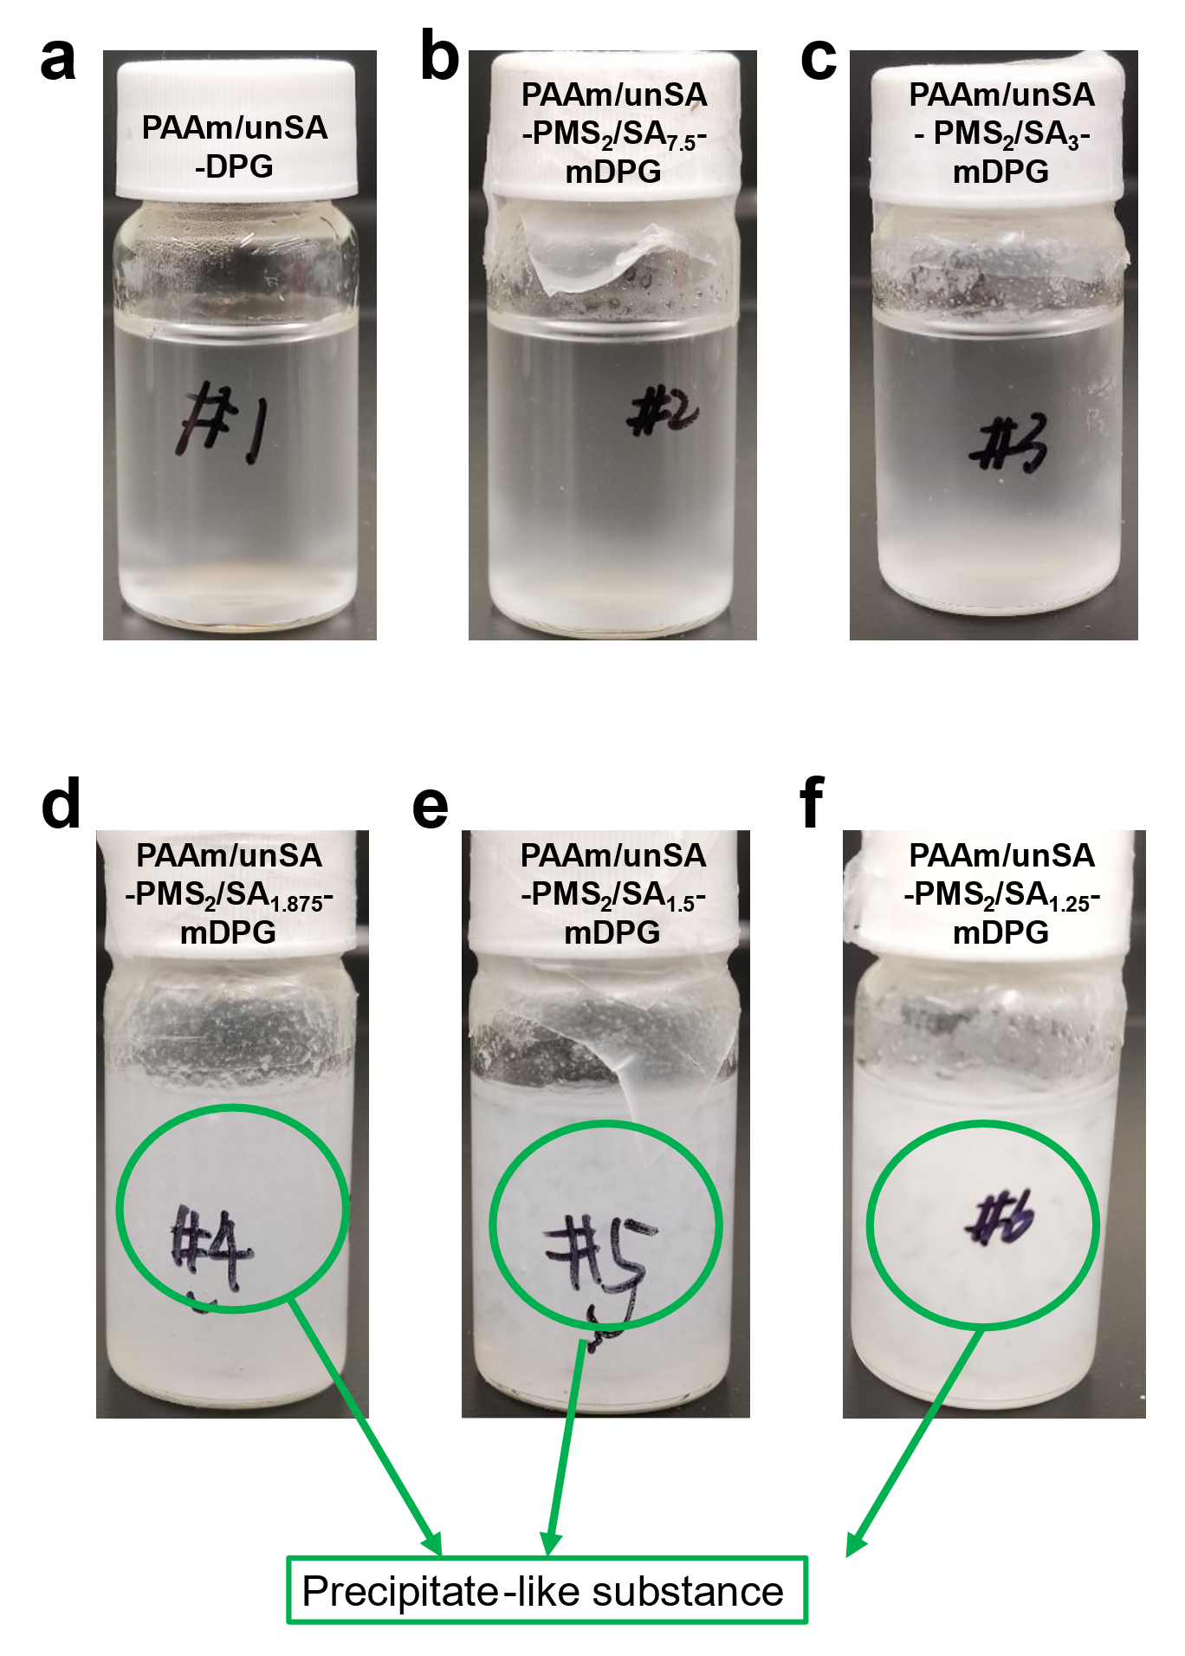
Fig. S7. Captured images of the modified gel particles of the DPGs containing a crosslinked PAAm network and an un-crosslinked SA (unSA) network with different PMS concentrations: (a) PAAm/unSA-DPG; (b) PAAm/unSA-PMS₂/SA_{7.5}-mDPG; (c) PAAm/unSA-PMS₂/SA₅-mDPG; (d) PAAm/unSA-PMS₂/SA_{1.875}-mDPG; (e) PAAm/unSA-PMS₂/SA_{1.5}-mDPG; (f) PAAm/unSA-PMS₂/SA_{1.25}-mDPG.

