Supplementary data for

Simultaneous Denitrification and Decarbonization of Wastewater over In Situ Generation of ·ClO Radicals Through a Fast, High-Performance Electro-Filtration Process
Bin Zhao^{a,#}, Jialin Yang^{b,c,#}, Ruiping Liuª, Jiuhui Quª, Meng Sun^{a,b,}*
^{a.}Center for Water and Ecology, State Key Joint Laboratory of Environment Simulation and Pollution Control, School of Environment, Tsinghua University, Beijing 100084, China.
^{b.}State Key Laboratory of Environmental Aquatic Chemistry, Research Center for Eco-Environmental Sciences, Chinese Academy of Sciences, Beijing 100084, China.
^{c} Science and Technology Innovation Center for Municipal Wastewater Treatment and Water Quality Protection, School of Environment, Northeast Normal University, Changchun 130117, China.
*Corresponding author
E-mail addresses: meng_sun@mail.tsinghua.edn.cn (M. Sun)
# These authors contributed equally to this manuscript.

Table S1
EIS simulating results for Ti-M, PbO₂-M, and RuO₂@PbO₂-M.

Membranes | R_{s} (Ω cm²) | R_{ct} (Ω cm²) | Q_{dl} (mΩ^{―1}/s^{n} cm²) | R_{ads} (Ω cm²) | Q_{ads} (mΩ^{―1}/s^{n} cm²)
Ti-M | 3.41 | 20.25 | 6.02×10^{―6} | 105.2 | 4.39×10^{―6}
PbO₂-M | 4.26 | 11.33 | 3.25×10^{―6} | 36.51 | 8.61×10^{―6}
RuO₂@PbO₂-M | 4.54 | 8.68 | 6.03×10^{―6} | 17.96 | 6.11×10^{―6}

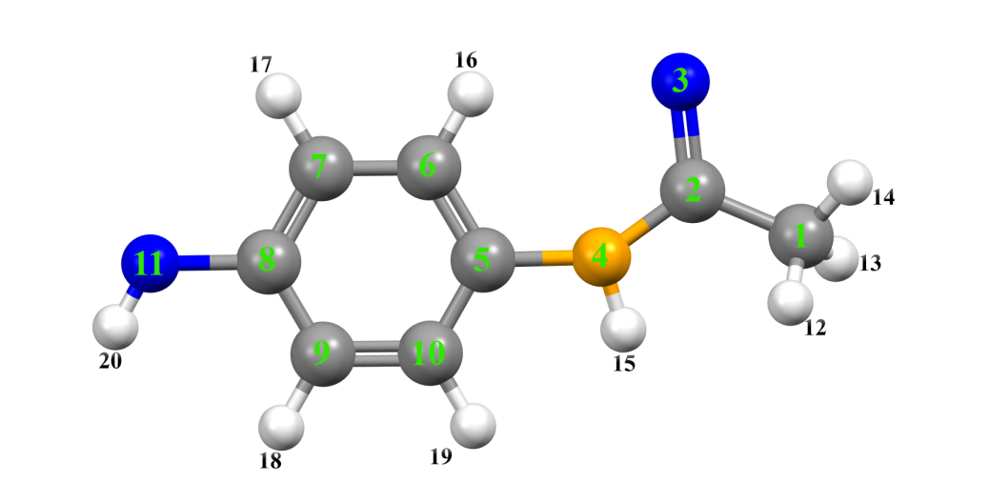
Fig. S1. Ball & stick molecular model of APAP.

Table S2. (next page)
Table S2. Possible intermediates identified by LC-MS during electro-catalytic degradation of acetaminophen .
Code | m/z | Molecular formula | Possible structure
M₁ | 151 | C₈H₉NO₂ | 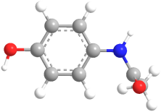
M₂ | 300 | C₁₆H₁₆N₂O₄ | 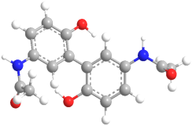
M₃ | 258 | C₁₄H₁₄N₂O₃ | 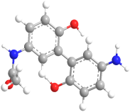
M₄ | 216 | C₁₂H₁₂N₂O₂ | 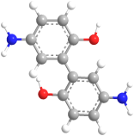
M₅ | 218 | C₁₂H₁₀O₄ | 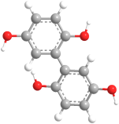
M₆ | 109 | C₆H₇NO | 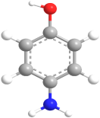
M₇ | 151 | C₆H₆ClNO | 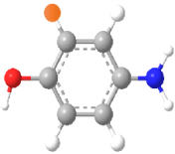
M₈ | 110 | C₆H₆O₂ | 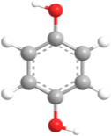
M₉ | 108 | C₆H₄O₂ | 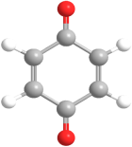
M₁₀ | 176 | C₆H₂Cl₂O₂ | 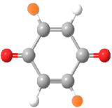
M₁₁ | 185 | C₈H₈ClNO₂ | 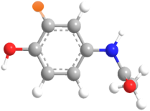

Determination of pore volume in EMs (V_{p}).
First, a freshly prepared plate of dry EMs was weighed as M1 (g). It was then immersed in 30 mL of water, sonicated for 20 s, and shaken at 180 rpm for one hour. The resulting water-filled EMs were then weighed as M2 (g). Compared to the dry EMs, the weight change represents the amount of water in the pores, which can be used to calculate the internal volume of the EMs (V_{p}, m³), as expressed by Equation S1.
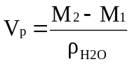 (S1)
where, ρ_{H2O} represents the density of water at ambient temperature, which is 1 g cm^{–3}.
Retention time (t_{R}). The retention time (in seconds) can be determined using Equation S2.
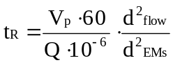 (S2)
where V_{p} represents the pore volume in cubic meters (m³), Q is the flux in cubic centimeters per minute (cm³ min^{–1}), d_{flow} is the effective diameter for the flow-through reaction (0.0037 m), and d_{EMs} denotes the diameter of the prepared EMs.
Surface-to-volume ratio (SVR). The total surface area of the EMs t by Equation S3.
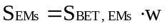 (S3)
where S_{BET} is the specific surface area of the EMs (m² g^{–1}), and w is the weight of each EM (g).
Next, we can compute the SVR (m² m^{–3}) using Equation S4.
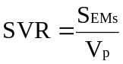 (S4)
Enhancement factor (K_{obs,E}).
The dimensionless K_{obs,E} indicates that, for a normalized surface-to-bulk ratio (i.e., when the concentration of available surface in a system is the same), the enhancement of the kinetic constant in the EMs, relative to that in the batch reactor, can be expressed by Equation S5.
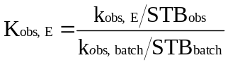 (S5)
where k_{obs} and k_{obs,batch} denote the kinetic constants for the electro-filtration and batch reactor, respectively, in units of S⁻¹, STB_{obs} and STB_{obs,batch} represent the surface-to-bulk rations for the electro-filtration and batch rector, respectively, in units of m²m^{–3}.

Half-life (τ_{H}).
The half-life is inversely proportional to the dimensionless K_{obs,E} and can be expressed by the formula S6 to calculate the half-life value.
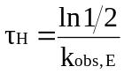 (S6)
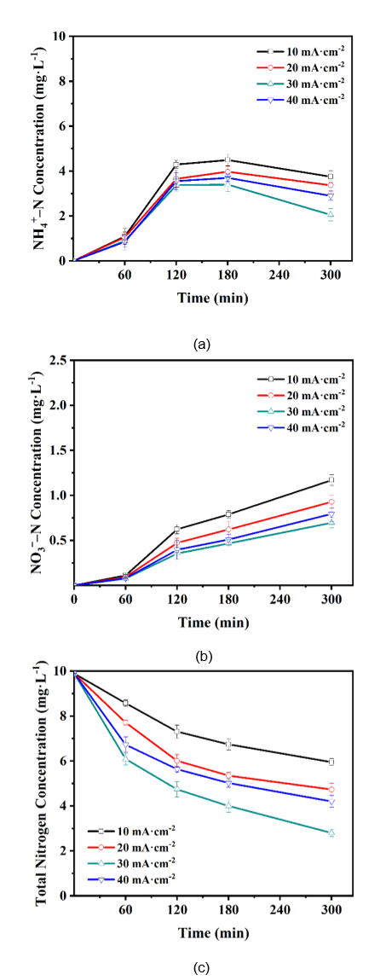
Fig. S2. Effects of the current destiny on NH₃–N removal (a), Effects of the current destiny on NO₃–-N generation (b), Total nitrogen removal (c). Conditions: pH = 3, 100 mg·L^{–1} APAP, and chloride concentration 50 mM.

Fig. S2 show that under different current densities, the NO₃–-N concentration first decreases and then gradually increases as the current density increases. The trend of total nitrogen variation is consistent with that of NH₃-N, although the removal efficiencies differ. Increasing the current density promotes the generation of reactive oxidative species such as ·Cl and ·OH, which enhances the reaction rate with active chlorine and increases the concentration of ·ClO, thereby accelerating the oxidation of NH₃-N to N₂. However, when the current density is further increased, side reactions lead to the consumption of ·OH and ·ClO. The unoxidized NH₃-N reacts with OCl⁻ to form NO₃–, reducing the removal efficiency of both NH₃-N and total nitrogen.
Fig. S3. Effects of the pH concentration on (a) NH₃-N removal and (b) NO₃–-N generation. Total nitrogen removal (c). Conditions: 30 mA·cm^{–2}, 100 mg·L^{–1} APAP, and chloride concentration 50 mM.

As shown in Fig. S3. Under different pH conditions, the trend of NO₃–-N generation aligns with the trends of NH₃-N and total nitrogen removal. Notably, under neutral pH conditions at the initial solution, NH₄⁺ in the water is oxidized to generate active species such as NHCl and NHCl₂. These reactive oxygen species adsorbed onto the electrode surface, reducing the removal efficiency of NH₄⁺, which leads to a significant increase in NO₃–-N production. At the same time, under strongly alkaline initial solution conditions, the generation of OCl– is inhibited, thereby reducing the removal efficiency of NH₃-N and total nitrogen.
Fig. S4. Effects of the chloride concentration on NH₃–N removal (a) Effects of the chloride concentration on NO₃–-N generation (b). Total nitrogen removal (c). Conditions: pH = 3, 30 mA·cm^{–2}, and 100 mg·L^{–1} APAP.

As the initial chloride ion concentration of the solution increases (Fig. S4), the electrolyte concentration, conductivity, and ionic strength in the RuO₂@PbO₂-M electrofiltration system increase, reducing the solution resistance and improving electrolysis efficiency and APAP removal rate. The increase in chloride ion concentration promotes electron mobility and oxidation efficiency, enhancing the indirect oxidation degradation of organic pollutants through the conversion of Cl₂ and OCl–. Chloride ions also activate and generate ·ClO free radicals. When the chloride ion concentration reaches 75 mM, the excessive chloride ions affect the mass transfer rate and inhibit the electrocatalytic oxidation reaction. Experimental results show that a chloride concentration of 50 mM is most favourable for the APAP degradation reaction.
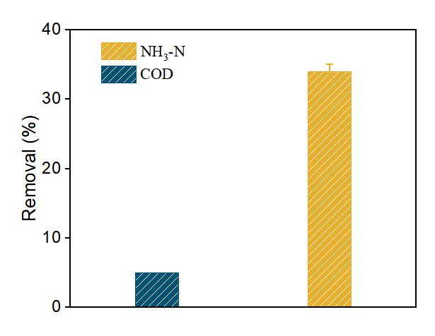
Fig. S5. Removal of COD and NH₃-N through the RuO₂-M electro-filtration process

As shown in Fig. S5, we investigated the removal rate of COD and TN by RuO₂-M, and the experimental results showed that The RuO₂-M , under chloride ion-mediated conditions, removes NH₃-N through the action of free chlorine and chlorine radicals, but it is not efficient in degrading organic pollutants.

