Supplementary data for

Co-Benefits of Antimicrobial Resistance Mitigation from China’s PM_{2.5} Air Pollution Reduction Between 2014–2020
Zhenchao Zhou^{a,}*, Zejun Linª, Xinyi Shuaiª, Xiaoliang Ba^{b}, Chioma Achi^{c}, Mark A. Holmes^{b}, Tong Xu^{d}, Yingru Lu^{e}, Yonghong Xiao^{f}, Jianming Xuª, Baojing Guª, Hong Chen^{a,g,}*
ª College of Environmental and Resource Sciences, Zhejiang University, Hangzhou 310058, China
^{b} Department of Veterinary Medicine, University of Cambridge, Cambridge CB3 0ES, United Kingdom
^{c} Ineos Oxford Institute of Antimicrobial Research, Department of Biology, University of Oxford, Oxford OX1 3RE, United Kingdom
^{d} Centre for Environment, Energy and Natural Resource Governance, Department of Land Economy, University of Cambridge, Cambridge CB3 0ES, United Kingdom
^{e} Department of Intensive Care Unit, The First Affiliated Hospital of Wenzhou Medical University, Wenzhou 325000, China
^{f} State Key Laboratory for Diagnosis and Treatment of Infectious Disease, The First Affiliated Hospital, Zhejiang University, Hangzhou 310003, China
^{g} International Cooperation Base of Environmental Pollution and Ecological Health, Science and Technology Agency of Zhejiang, Zhejiang University, Hangzhou 310058, China
* Corresponding authors.
E-mail addresses: zhouzc@zju.edu.cn (Z. Zhou); chen_hong@zju.edu.cn (H. Chen)

This file includes:
Supplemental Methods
Figure S1 to S6
Table S1 to S4

Supplemental Methods
Detailed Scenarios¹
Baseline
Baseline offers the reference point for other scenarios. Following the SSP4 highly inequal and isolated mode, the climate constraints are negligible under RCP6.0 and the environmental control would remain at the 2015 level.

Current-goals
Current-goals presumes China will achieve its National Determined Contributions (NDC) pledges and the national PM_{2.5} air quality standard (i.e. 35 μg/m³) by 2030 under RCP4.5 and SSP2, elucidating China's future air pollution mitigation pathway towards all the released and upcoming clean air policies since 2015.

Ambitious-pollution-NDC-goals
Ambitious-pollution-NDC-goals shares the same energy and socioeconomic developments with the Current-goals scenario, but would fully deploy the best available end-of-pipe control technologies across all sectors by 2050, and implement them consistently between 2050 and 2060 under RCP4.5 and SSP2.

Ambitious-pollution- Neutral-goals
Ambitious-pollution-Neutral-goals is designed to pursue China's carbon neutral commitment and the WHO PM_{2.5} guideline (i.e. 10 μg/m³) in long-term air quality improvement by 2060. It shares the same end-of-pipe control with the Ambitious-pollution-NDC-goals scenario, but more ambitious climate policies would be implemented to ensure China's net-zero CO2 emissions in 2060 under SSP1.

Ambitious-pollution-2°C-goals
Ambitious-pollution-2°C-goals is designed to pursue the 2°C temperature limits and the WHO PM_{2.5} guideline (i.e. 10 μg/m³) in long-term air quality improvement by 2060. It shares the same end-of-pipe control with the Ambitious-pollution-NDC-goals scenario, but more ambitious 2°C-consistent climate policies would be implemented under RCP2.6 and SSP1.

Ambitious-pollution-1.5°C-goals
Ambitious-pollution-1.5°C-goals is designed to pursue the 1.5°C temperature limits and the WHO PM2.5 guideline (i.e. 10 μg/m³) in long-term air quality improvement by 2060. It shares the same end-of-pipe control with the Ambitious-pollution-NDC-goals scenario, but more ambitious 1.5°C-consistent climate policies would be implemented under RCP1.9 and SSP1.

Code availability for the structural equation model in Stata 16 (StataCorp LP, USA)

sem (Aggregateresistance -> Antibioticusagedensity, ) (PM252 -> Aggregateresistance, ) (PM252 -> Antibioticusagedensity, ) (Antibioticusagedensity -> Aggregateresistance, ) (Temperature -> Antibioticusagedensity, ) (Publictoiletsforevery10000 -> Aggregateresistance, ) (Healthtechniciansper10000pe -> Aggregateresistance, ) (Villageclinicsnumber -> Aggregateresistance, ) (Villageclinicsnumber -> Antibioticusagedensity, ) (Meatconsumption -> Antibioticusagedensity, ) (Allresidentsincome -> Aggregateresistance, ) (Allresidentsincome -> Antibioticusagedensity, ) (Lambproduction -> Aggregateresistance, ) (Porkproduction -> Antibioticusagedensity, ) (Educationindex -> Antibioticusagedensity, ) (Urbanpopulationdensity -> Aggregateresistance, ) (Urbanpopulationdensity -> Antibioticusagedensity, ), nocapslatent

estat gof, stats(all)

References
1 Cheng, J. et al. Pathways of China's PM2.5 air quality 2015–2060 in the context of carbon neutrality. National Science Review 8, doi:10.1093/nsr/nwab078 (2021).

Supplemental Tables and Figures

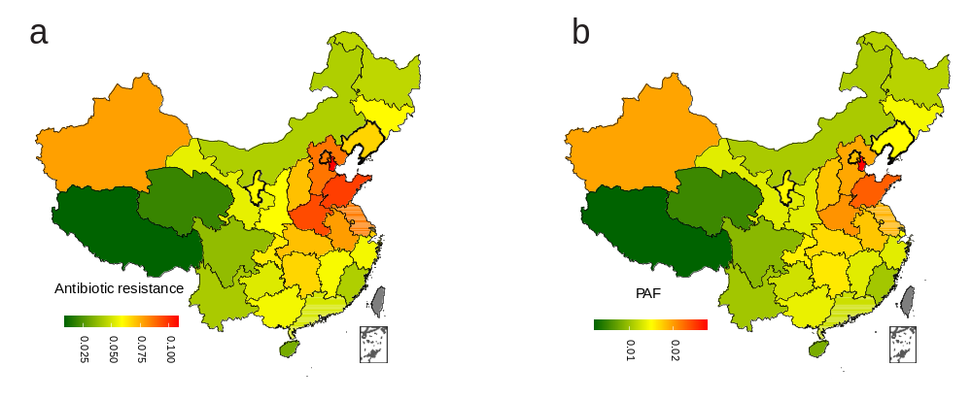
Figure S1. Change in aggregate resistance (a) and PAF (b) with the 1% shift of PM_{2.5}.

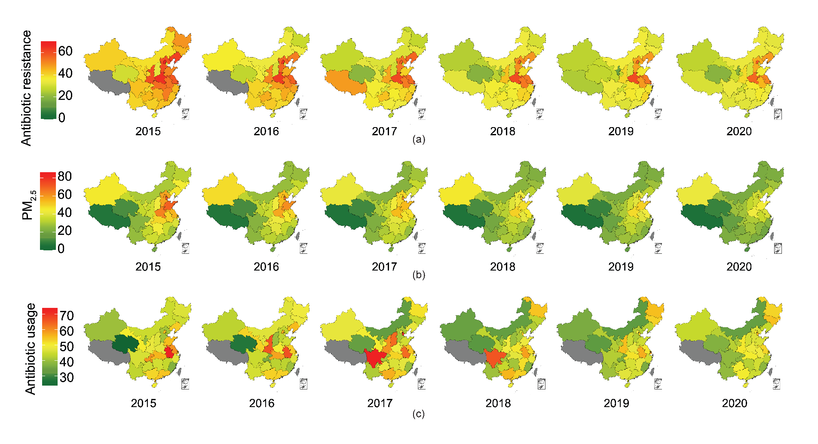
Figure S2. Trends of (a) antibiotic resistance (%), (b) PM_{2.5} (µg·m⁻³), and (c) antibiotic usage density (DDDs per 100 inhabitants per day) in China from 2015 to 2020.

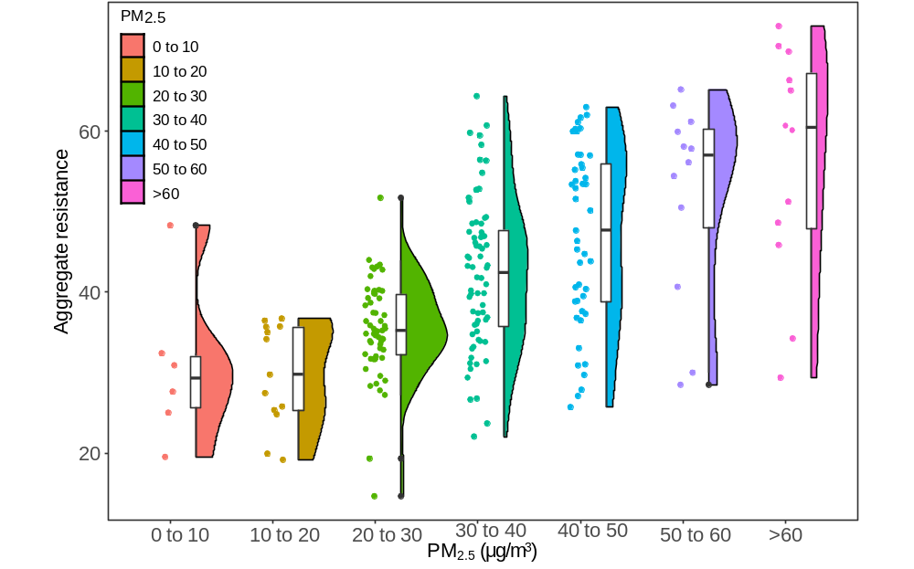
Figure S3. Patterns of aggregate antibiotic resistance under different PM_{2.5} concentrations.

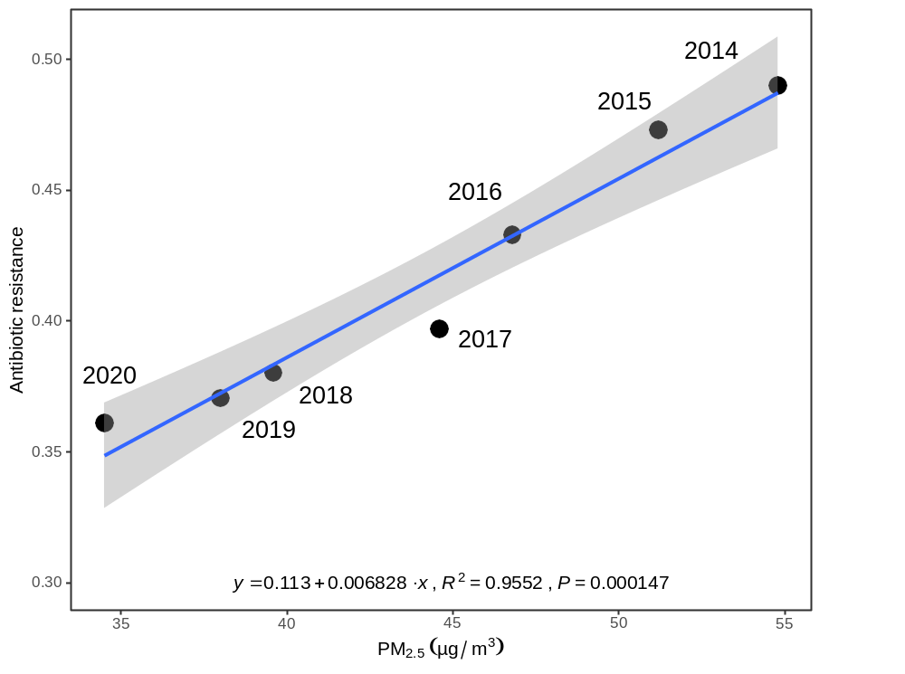
Figure S4. Liner correlation between antibiotic resistance and PM_{2.5}.

Figure S5. Correlations for univariate analysis. AMR, aggregate antibiotic resistance; ***p <0.0001; **p <0.001; *p<0.01. Axes represent the value of each factor.

Figure S6. Premature death and welfare loss caused by antimicrobial resistance derived from PM_{2.5}. (a) Premature death in 2020; (b) marginal premature death (deaths per µg·m⁻³ PM_{2.5}) in 2020; (c) welfare loss (at constant USD 2011 prices) in 2020; (d) marginal welfare loss (USD per µg·m⁻³ PM_{2.5}) in 2020; (e) change in premature death between 2014 and 2020; (f) change in marginal premature death between 2014 and 2020; (g) change in welfare loss between 2014 and 2020; (h) change in marginal welfare loss between 2014 and 2020.

Table S1. Information of antibiotic resistance and factors.
 | N | Mean | SD | Sum | Min | Max
Antibiotic resistance
Aggregate resistance (%) | 214 | 41.4 | 11.3 | 8866.0 | 14.6 | 70.6
MRCNS (%) | 213 | 76.0 | 5.2 | 16178.0 | 56.9 | 84.5
VREFM (%) | 213 | 0.5 | 0.5 | 108.6 | 0.0 | 2.4
VREFS (%) | 213 | 1.5 | 1.7 | 314.3 | 0.0 | 11.2
PRSP (%) | 211 | 3.0 | 2.8 | 630.7 | 0.0 | 19.0
ERSP (%) | 213 | 93.4 | 4.7 | 19892.5 | 67.4 | 98.8
3GCRKP (%) | 213 | 32.9 | 9.5 | 6998.5 | 10.2 | 58.1
MRSA (%) | 214 | 31.9 | 8.6 | 6832.5 | 15.2 | 52.0
3GCREC (%) | 214 | 55.1 | 5.4 | 11784.3 | 44.9 | 74.4
CREC (%) | 214 | 1.6 | 0.8 | 338.1 | 0.1 | 5.7
QREC (%) | 214 | 52.8 | 6.5 | 11306.7 | 34.4 | 67.6
CRPA (%) | 214 | 19.8 | 6.5 | 4232.3 | 5.7 | 36.4
CRKP (%) | 214 | 8.1 | 6.8 | 1743.9 | 0.2 | 32.8
CRAB (%) | 214 | 54.8 | 12.0 | 11723.0 | 18.2 | 82.1
Air pollution
Annual SO₂ (ug/m³) | 214 | 19.8 | 15.6 | 4229.0 | 4.0 | 82.0
Annual NO₂ (ug/m³) | 214 | 40.4 | 10.2 | 8641.0 | 11.0 | 59.0
Annual PM₁₀ (ug/m³) | 214 | 85.0 | 31.7 | 18188.0 | 29.0 | 206.0
Annual CO (mg/m³) | 214 | 1.8 | 0.8 | 395.1 | 0.8 | 4.9
Annual O₃ (ug/m³) | 214 | 150.8 | 26.7 | 32265.0 | 69.0 | 211.0
Annual PM_{2.5} (ug/m³) | 217 | 35.2 | 13.9 | 7636.4 | 4.4 | 85.6
Antibiotic usage
Antibiotic usage density (DDD/100 people/day) | 179 | 47.4 | 7.8 | 8493.3 | 24.3 | 73.9
Health services
Beds in medical and health institutions (10 thousand) | 217 | 25.5 | 16.3 | 5527.9 | 1.2 | 66.7
Health technicians per 10,000 people | 217 | 66.4 | 13.4 | 14404.0 | 41.0 | 126.0
Urban basic medical insurance | 217 | 3338.2 | 2817.0 | 724398.3 | 58.9 | 10991.4
Village clinics number | 217 | 20293.8 | 16778.6 | 4403750.0 | 1162.0 | 61450.0
Medical and health institutions | 217 | 32087.3 | 22450.2 | 6962940.0 | 4254.0 | 86939.0
Public services
Urban water penetration rate (%) | 217 | 97.8 | 3.0 | 21231.0 | 67.6 | 100.0
Daily treatment capacity of urban sewage(10 thousand m3) | 217 | 565.6 | 485.6 | 122727.1 | 6.2 | 2748.6
Public toilets per 10,000 people | 217 | 3.1 | 1.2 | 664.3 | 1.1 | 8.2
Domestic waste harmless treatment (%) | 215 | 96.1 | 7.0 | 20669.0 | 58.9 | 100.0
Daily domestic water consumption (Litre) | 217 | 174.3 | 50.5 | 37813.9 | 97.8 | 403.6
Park green space (m²/person) | 217 | 13.5 | 2.8 | 2922.0 | 5.9 | 21.1
Education
Students in higher education institutions | 217 | 2690.2 | 770.4 | 583765.0 | 1220.0 | 5429.0
Students in high school | 217 | 2871.5 | 728.3 | 623105.0 | 1070.0 | 4683.0
Students in junior high school | 217 | 3235.3 | 878.5 | 702050.0 | 1226.0 | 5906.0
Students in primary school | 217 | 7131.1 | 1982.3 | 1547460.0 | 3243.0 | 11019.0
Students in kindergarten | 217 | 3154.8 | 888.0 | 684585.0 | 1280.0 | 6371.0
Husbandry
Pork production (10 thousand tons) | 217 | 164.4 | 137.7 | 35681.2 | 0.8 | 527.2
Beef production (10 thousand tons) | 217 | 21.8 | 20.2 | 4724.5 | 0.0 | 83.0
Lamb production (10 thousand tons) | 217 | 15.0 | 20.4 | 3254.3 | 0.2 | 113.0
Climate
Annual temperature (℃) | 217 | 14.6 | 5.1 | 3167.8 | 5.0 | 25.8
Annual sunshine (hours) | 217 | 2058.2 | 584.7 | 446621.6 | 598.4 | 3544.7
Annual Humidity (%) | 217 | 65.8 | 12.3 | 14274.0 | 34.0 | 84.0
Population
Resident population(10 thousand) | 217 | 4499.6 | 2936.2 | 976424.0 | 325.0 | 12624.0
Urban population density (person/km²) | 216 | 2890.3 | 1107.6 | 624307.0 | 1136.0 | 5515.0
Economy
All residents income (RMB) | 217 | 26089.0 | 11335.4 | 5661300.0 | 10730.0 | 72232.0
GDP(100 million RMB) | 217 | 26872.7 | 22349.0 | 5831370.0 | 939.7 | 111151.6
Diet
Meat consumption (kg/person) | 186 | 26.2 | 7.0 | 4871.6 | 12.7 | 45.4
CREC= carbapenem resistant Escherichia coli, CRPA= carbapenem resistant Pseudomonas aeruginosa, CRAB= carbapenem resistant Acinetobacter baumannii, CRKP= carbapenem resistant Klebsiella pneumoniae, ERSP= erythromycin resistant Streptococcus pneumoniae, MRSA= methicillin resistant Staphylococcus aureus, MRCNS= methicillin resistant coagulase negative staphylococci, PRSP= penicillin resistant Streptococcus pneumoniae, QREC= quinolones resistant Escherichia coli, 3GCREC= third-generation cephalosporin resistant Escherichia coli, 3GCRKP= third-generation cephalosporin resistant Klebsiella pneumoniae, VREFS= vancomycin resistant Enterococcus faecalis; VREFM= vancomycin resistant Enterococcus faecium.

Table S2. Stepwise correlations between predictors and antibiotic resistance.
Factors | Coef. | p value
Air pollution
PM_{2.5} | 0.253 | <0.001
Economy
Residents income | 0.000775 | <0.001
GDP | N/A | N/A
Antibiotic usage
Antibiotic usage density | 0.342 | <0.001
Husbandry
Pork production | 0.0168 | <0.05
Lamb production | -0.140 | <0.001
Beef production | N/A | N/A
Public services
Public toilets per 10000 people | 4.513 | <0.001
Park green space | -0.676 | <0.01
Urban water penetration rate | N/A | N/A
Domestic waste treatment | N/A | N/A
Health services
Village clinics number | 0.000223 | <0.001
Health technicians per 10000 people | -0.208 | <0.01
Urban basic medical insurance | N/A | N/A
Education
Education index (standardized) | 5.179 | <0.001
Diet
Meat consumption | N/A | N/A
Climate
Temperature | -0.577 | <0.001
Sunshine | N/A | N/A
Humidity | N/A | N/A
Population
Urban population density | -0.00242 | <0.001
Dummy
Year 2016 | 6.537 | <0.001
Year 2018 | 10.12 | <0.001
R² | 0.7096
N | 178

Table S3. The dominance of predictors in 13 antibiotic resistant pathogens.
Factors | MRCNS | VREFM | VREFS | PRSP | ERSP | 3GCRKP | MRSA | 3GCREC | CREC | QREC | CRPA | CRKP | CRAB
PM_{2.5} | 6.9% | 2.4% | 6.4% | 4.5% | 3.1% | 7.2% | 2.4% | 9.8% | 8.5% | 2.9% | 7.3% | 4.9% | 6.2%
Antibiotic usage density | 3.5% | 0.5% | 2.4% | 2.2% | 0.3% | 3.4% | 2.4% | 3.9% | 2.0% | 3.0% | 1.4% | 1.4% | 4.5%
Residents income | 3.0% | 0.8% | 5.1% | 1.7% | 3.6% | 11.3% | 5.2% | 2.2% | 8.5% | 2.0% | 13.0% | 24.5% | 1.9%
GDP | 2.8% | 1.1% | 1.0% | 3.2% | 4.8% | 4.8% | 6.8% | 1.7% | 2.8% | 1.0% | 5.7% | 5.1% | 3.3%
Pork production | 1.6% | 0.6% | 2.0% | 0.4% | 1.7% | 7.5% | 0.8% | 5.5% | 2.7% | 0.9% | 3.1% | 5.2% | 12.3%
Lamb production | 0.8% | 0.2% | 0.6% | 1.9% | 2.2% | 0.7% | 2.3% | 0.9% | 0.8% | 2.1% | 2.1% | 0.7% | 1.3%
Beef production | 0.4% | 0.8% | 0.6% | 2.0% | 0.6% | 1.8% | 2.6% | 1.7% | 0.8% | 7.8% | 0.7% | 1.1% | 1.9%
Public toilets per 10000 people | 2.8% | 0.5% | 1.0% | 1.5% | 3.2% | 1.6% | 2.0% | 3.4% | 0.7% | 4.5% | 6.4% | 4.2% | 0.9%
Urban water penetration rate | 1.5% | 1.0% | 0.4% | 0.3% | 1.8% | 0.7% | 0.9% | 0.7% | 2.0% | 0.6% | 3.9% | 1.9% | 0.6%
Domestic waste treatment | 0.8% | 6.4% | 3.9% | 0.9% | 8.6% | 0.8% | 0.5% | 0.7% | 0.4% | 0.7% | 0.9% | 1.9% | 0.5%
Park green space | 1.1% | 0.4% | 1.4% | 0.6% | 0.8% | 3.9% | 0.7% | 1.1% | 1.2% | 0.3% | 6.7% | 3.3% | 0.6%
Village clinics number | 1.7% | 1.9% | 1.5% | 0.4% | 3.8% | 4.2% | 0.8% | 6.8% | 3.0% | 1.3% | 1.0% | 1.6% | 5.8%
Health technicians per 10000 people | 0.8% | 0.9% | 13.9% | 2.0% | 4.7% | 1.9% | 1.2% | 3.1% | 2.1% | 1.5% | 2.0% | 4.1% | 0.6%
Urban basic medical insurance | 1.9% | 4.4% | 2.4% | 1.8% | 4.4% | 2.5% | 1.8% | 2.6% | 1.4% | 0.6% | 1.7% | 2.4% | 2.9%
Education index (standardized) | 0.9% | 1.1% | 2.2% | 4.7% | 1.1% | 2.8% | 2.1% | 1.0% | 1.2% | 7.8% | 3.3% | 3.5% | 0.5%
Meat consumption | 2.5% | 0.3% | 2.0% | 0.6% | 2.1% | 1.9% | 4.4% | 6.8% | 2.5% | 6.5% | 1.1% | 2.5% | 3.0%
Temperature | 1.2% | 0.8% | 0.5% | 0.5% | 3.1% | 4.6% | 2.5% | 1.0% | 0.9% | 6.9% | 2.0% | 2.6% | 1.3%
Sunshine | 4.8% | 0.3% | 0.9% | 0.7% | 1.4% | 3.0% | 8.5% | 1.4% | 0.9% | 5.1% | 0.6% | 2.2% | 1.9%
Humidity | 1.5% | 0.4% | 1.5% | 0.8% | 1.4% | 3.5% | 2.2% | 1.5% | 0.7% | 6.6% | 1.5% | 1.2% | 1.2%
Urban population density | 4.0% | 5.1% | 5.1% | 0.2% | 0.7% | 1.0% | 0.6% | 0.7% | 0.6% | 1.1% | 0.8% | 1.8% | 0.6%
Year | 9.8% | 16.9% | 14.7% | 9.7% | 4.6% | 5.3% | 10.5% | 14.5% | 4.6% | 2.4% | 7.0% | 1.5% | 2.4%
R² | 0.5420 | 0.4650 | 0.6959 | 0.4065 | 0.5808 | 0.7439 | 0.6125 | 0.7077 | 0.4816 | 0.6544 | 0.7191 | 0.7723 | 0.5376
N | 178 | 178 | 178 | 176 | 178 | 178 | 178 | 178 | 178 | 178 | 178 | 178 | 178

Table S4. Standardized direct effects coefficients of structural equation model.
Endogenous variables | Exogenous variables | Coef. | OIM Std. Err. | z | P > |z| | 95% Conf. Interval
Aggregate resistance
 | Antibiotic usage density | 0.34 | 0.089 | 3.8 | 0.0001 | 0.16-0.51
 | PM_{2.5} | 0.38 | 0.058 | 6.51 | 0.0001 | 0.27-0.49
 | Temperature | 0 | no path
 | Public toilets per 10000 people | 0.47 | 0.062 | 7.52 | 0.0001 | 0.34-0.59
 | Health technicians per 10000 people | -0.28 | 0.072 | -3.91 | 0.0001 | -0.42- -0.14
 | Village clinics number | 0.40 | 0.054 | 7.38 | 0.0001 | 0.29-0.50
 | Meat consumption | 0 | no path
 | Residents income | 0.46 | 0.069 | 6.68 | 0.0001 | 0.33-0.60
 | Education index | 0 | no path
 | Pork production | 0 | no path
 | Lamb production | -0.26 | 0.065 | -3.95 | 0.0001 | -0.38 - -0.13
 | Urban population density | -0.23 | 0.055 | -4.2 | 0.0001 | -0.34- -0.12
Antibiotic usage density
 | Aggregate resistance | -0.30 | 0.15 | -2.0 | 0.045 | -0.59 - -0.0066
 | PM_{2.5} | 0.38 | 0.097 | 3.9 | 0.0001 | 0.19-0.57
 | Temperature | 0.46 | 0.093 | 4.93 | 0.0001 | 0.28-0.64
 | Village clinics number | -0.35 | 0.13 | -2.8 | 0.005 | -0.60- -0.11
 | Meat consumption | -0.25 | 0.098 | -2.56 | 0.01 | -0.44- -0.059
 | Residents income | 0 | no path
 | Pork production | 0.47 | 0.13 | 3.65 | 0.0001 | 0.22-0.73
 | Education index | -0.36 | 0.089 | -4.08 | 0.0001 | -0.54- -0.19
 | Urban population density | 0.11 | 0.071 | 1.6 | 0.11 | -0.026-0.25

