Supplementary Data for

A Hierarchical Task Graph Parallel Computing Framework for Chemical Process Simulation
Shifeng Qu ª, Shaoyi Yang ª, Zhaoyang Duan ª, Wenli Du ^{a,}*, Feng Qian ^{a,}*, Meihong Wang ^{b}
ª Key Laboratory of Smart Manufacturing in Energy Chemical Process, Ministry of Education, East China University of Science and Technology, Shanghai 200237, China
^{b} Department of Chemical and Biological Engineering, The University of Sheffield, Sheffield S1 3JD, UK

* Corresponding authors.
E-mail addresses: wldu@ecust.edu.cn (W. Du), fqian@ecust.edu.cn (F. Qian)

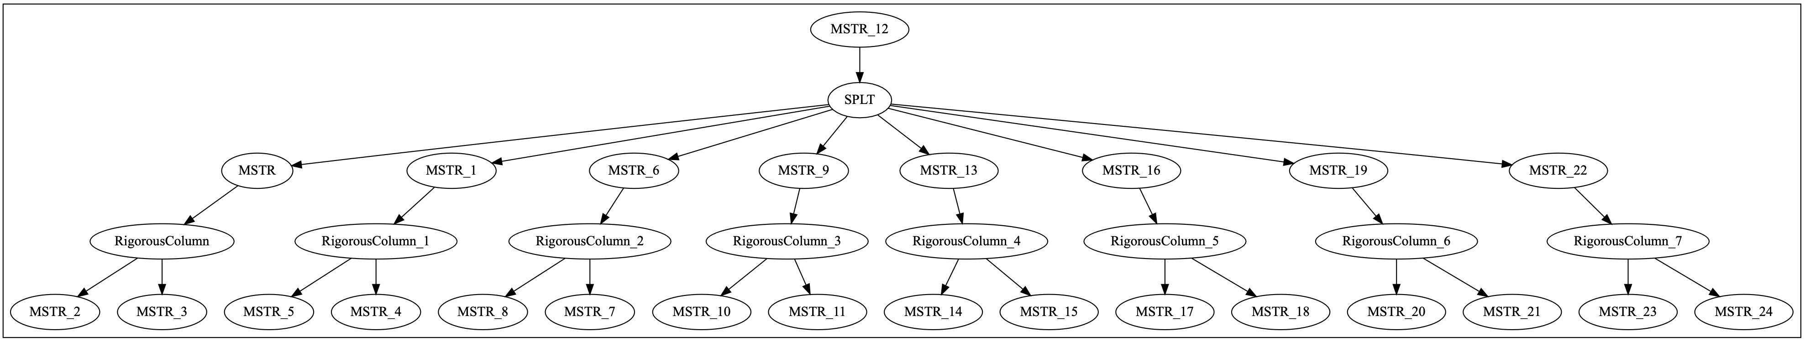
Fig. S1. Task graph for eight parallel distillation columns.

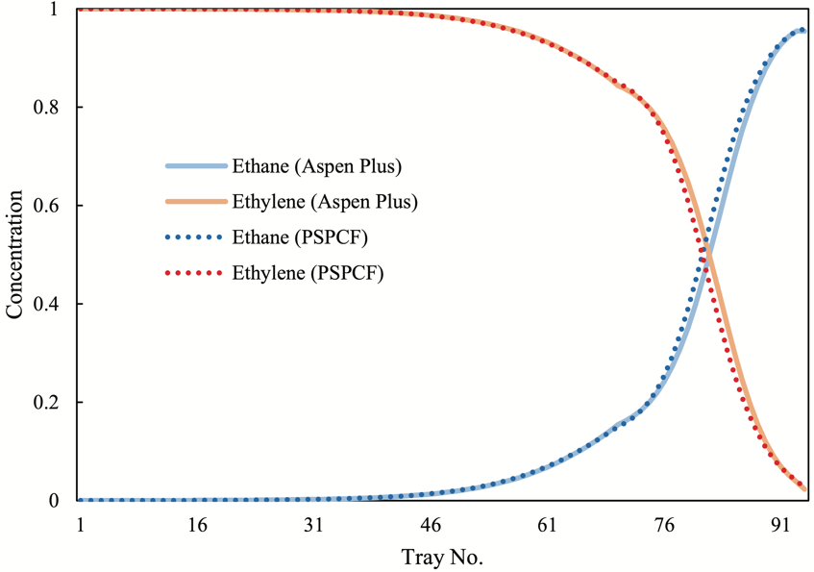

Fig. S2. Concentration profiles of heavy key component (ethane) and light key component (ethylene) in the liquid phase.

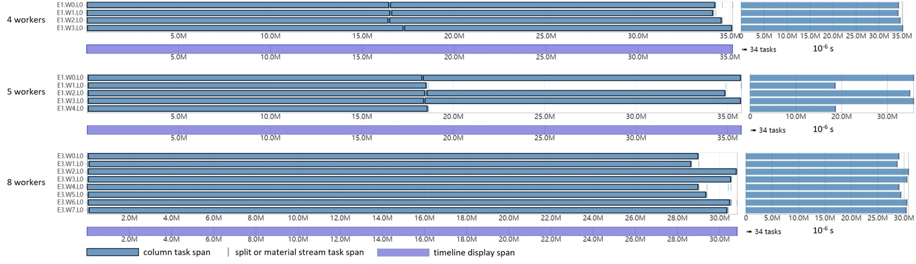

Fig. S3. Execution of eight parallel columns with four, five, and eight workers.
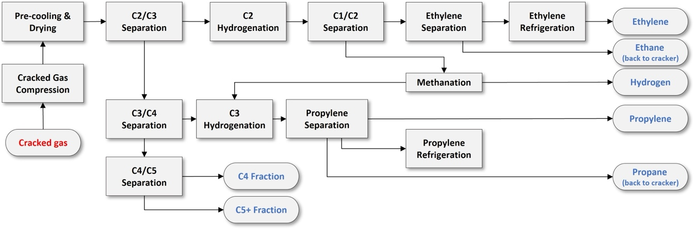
Fig. S4. Process flow diagram for the separation of cracked gas.
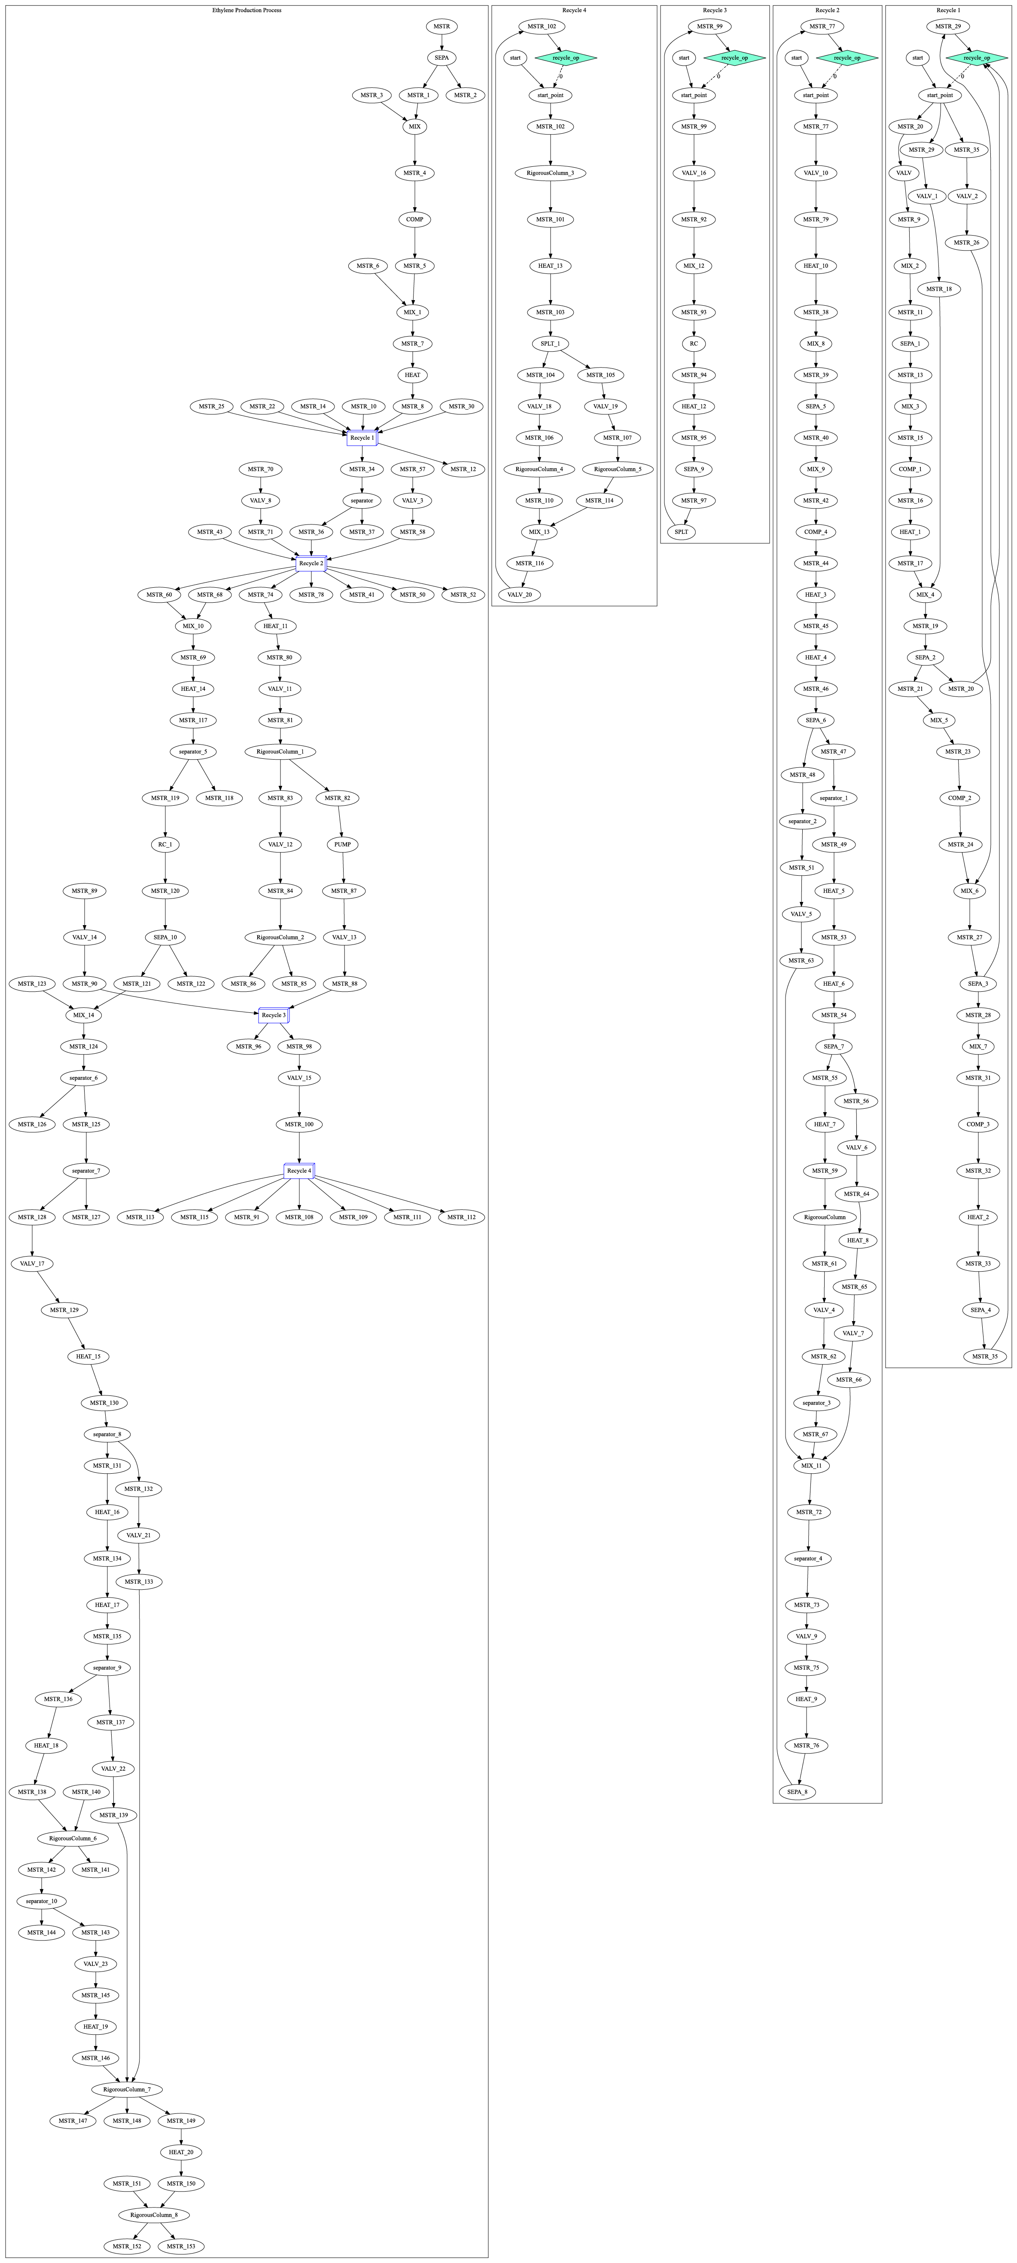
Fig. S5. Task graph for cracked gas separation process simulation.

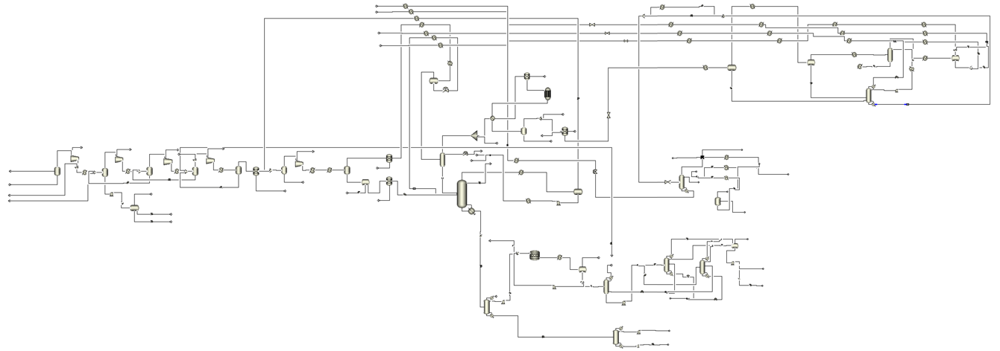
Fig. S6. Aspen Plus flowsheet of the cracked gas separation process.

Process description: The separation of cracked gas is a multi-step industrial sequence employed in petrochemical plants to extract ethylene from cracked gas. Initially, the cracked gas undergoes compression to prepare for subsequent separation and treatment. The C2/C3 separation step isolates C2 fractions from C3+ fractions. C3 and C4+ fractions are likewise separated by the C3/C4 separation step. Following this, C2 and C3 streams undergo hydrogenation to potentially convert any remaining ethylene to ethane and propylene to propane, respectively. After hydrogenation, ethylene separation ensues to purify the ethylene, which is then subjected to refrigeration for storage or transport. Any unconverted ethane and propane are recycled back to the cracker to enhance conversion rates. Further downstream, C4/C5 separations take place to yield C4 and C5+ fractions.

