Research

Material Science and Engineering—Article

Self-Adaptive Core-Shell Dry Adhesive with a “Live Core” for High-Strength Adhesion under Non-Parallel Contact
Duorui Wang ^{a,b}, Hongmiao Tian ^{a,*}, Jinyu Zhang ª, Haoran Liu ª, Xiangming Li ^{a,b}, Chunhui Wang ª, Xiaoliang Chen ^{a,b}, Jinyou Shao ^{a,b,*}
ª Micro- and Nano-Technology Research Center, State Key Laboratory for Manufacturing Systems Engineering, Xi’an Jiaotong University, Xi’an 710049, China.
^{b} Frontier Institute of Science and Technology (FIST), Xi’an Jiaotong University, Xi’an 710049, China.
* Corresponding authors.
E-mail addresses: hmtian@xjtu.edu.cn (H. Tian); jyshao@xjtu.edu.cn (J. Shao)

This PDF file includes:

Supplementary Text
Figs. S1 to S20
Captions for Supplementary Videos S1 to S3

Other Supplementary Materials for this manuscript include the following:
Movies S1 to S3

Supporting Information Text
Numerical Analysis
1. Geometric modeling:
To simulate dry adhesion, a cohesive zone model based on cohesive surface is used. In the down pressing phase, we use general contact to simulate contact, and in the pull-up phase, we introduce cohesive contact Property. The formula of the cohesive constitutive law is as follows:
$F=\left\{\begin{matrix}F_{n} \\ F_{S} \\ F_{t}\end{matrix}\right\}=A\left[\begin{matrix}K_{nn} & K_{ns} & K_{nt} \\ K_{ns} & K_{ss} & K_{st} \\ K_{nt} & K_{st} & K_{tt}\end{matrix}\right]\left\{\begin{matrix}δ_{n} \\ δ_{s} \\ δ_{t}\end{matrix}\right\}=AKδ$ (1)
Among them, F_{n} represents the normal separation force on the interface during the separation process, F_{s} and F_{t} are two shear separation forces. δ_{n}、δs、δ_{t} represent the opening displacement of the cohesive interface in three directions, A represents the total area of the interface; K represents the interface stiffness matrix. The initial damage criterion of the interface adopts the maximum nominal stress damage criterion, and its constitutive formula is:
$Max\left\{\frac{σ_{n}}{σ_{Nmax}}, \frac{δ_{s}}{δ_{smax}},\frac{δ_{t}}{δ_{tmax}}\right\}=1$ (2)
Considering the biomimetic adhesive materials inspired by reptiles are often based on the action mechanism of van der Waals forces, a zero-thickness cohesive surface was used for finite element simulation in this paper. The geometric model was a two-dimensional form as follows, which mainly includes flat probe and adhesive structure. The length of flat probe (l₂) is 20 mm, and the thickness of flat probe (h₂) is 1 mm. The angle between probe and adhesive (θ) is 1°. The adhesive are simplified as a rectangle with length of 16 mm (l₁). For soft adhesives, the backing layer is a homogeneous material with thickness (h₁) of 3 mm. For rigid adhesives, the backing layer consists of two layers with thickness of 3 mm (h₃) and 0.1 mm (h₄), respectively. For core-shell adhesives, the backing layer consists of three layers with thickness of 2.1 mm (h₅), 0.8 mm (h₆), and 0.1 mm (h₇) respectively.
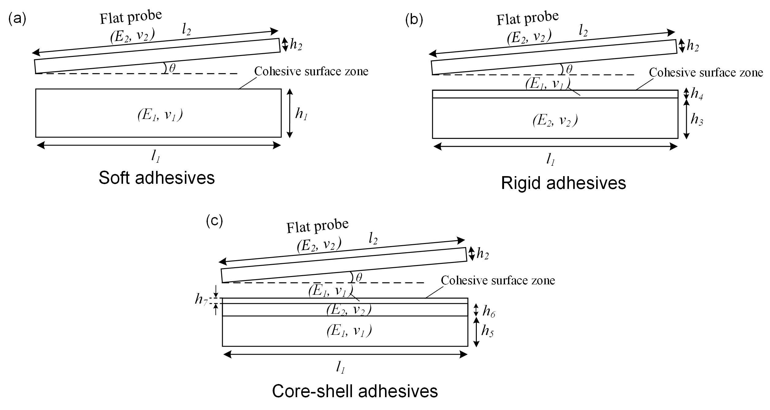
2. Boundary condition and interaction:
When exploring the numerical simulation of this separation process, the bottom of the substrate is fully immobilized. In the actual test, the test object first moved downward at a constant speed to contact the adhesive layer, and then moved upward at a constant speed until it was completely separated, so a constant displacement speed along the Y direction was applied on the upper surface of the spherical probe. In order to obtain the separation force-displacement curve more conveniently, a reference point is set at the center of the upper surface of the probe when the simulation model is established, and the upper surface of the probe is coupled with the reference point. At this time, applying a constant pulling speed at this point is equivalent to applying it to the entire upper surface.
In the ABAQUS/Standard contact analysis, the contact pair is often composed of the master surface and the slave surface, and the contact direction is always the normal direction of the master surface. Since the stiffness of the elastic backing is relatively small relative to the test probe, surface of the spherical probe was selected as the main surface, and the upper surface of the backing layer was the secondary surface. At the same time, due to the relative sliding or rotation between the two contact surfaces is small, small-slip contact is selected when defining the contact. The criterion of interface fracture damage is the maximum nominal stress, the specific parameters are 0.02, 0.04, 0.04, the interface stiffness is 5000 N/mm, and the fracture energy is 1E-5 mJ. In order to improve the convergence of the model, the viscosity coefficient of the interface is set to 1E-30, the triangle diagram for cohesive mode is as follows:
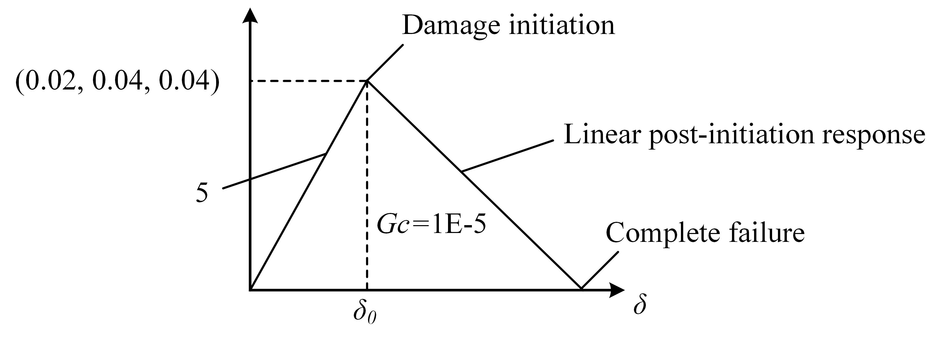
3. Simulation of adhesive behavior with different structure
In the finite element simulation, the same preload application can be achieved by adjusting the displacement of the loading stage to simulate the test situation in the experiment. The material property of the elastomer layer (E₁) is set to the Neo-Hookean model: C₁₀=0.17, D₁=0.24. The material property of the flat probe, as well as the stiff piece inside the composite adhesive (E₂), was all set to the linear elastic model: E₂=55 GPa, ν₂=0.25. For a systematic analysis of the simulation results, the reaction force, fracture energy, and contact area are set in the history output variables, and the normal contact stress and tangential contact stress are set in the field output variables. The stress distribution of the interface can be derived by setting the path on the contact interface.

Figure S1. Description of the adhesion mechanism of gecko’s core-shell structure (soft muscle and rigid bone). When there is an angle error between the foot and the target surface (smooth or rough), the non-parallel contact state can be rapidly regulated by the rigid bone’s rotation and soft muscle’s deformation, so as to achieve an improved conformal contact under angle error. Moreover, the rigid bone embedded in the soft muscle as a supporting layer can optimal the equal loading sharing at the interface and inhibit the cracks at the interface, thus achieving a robust adhesion state.

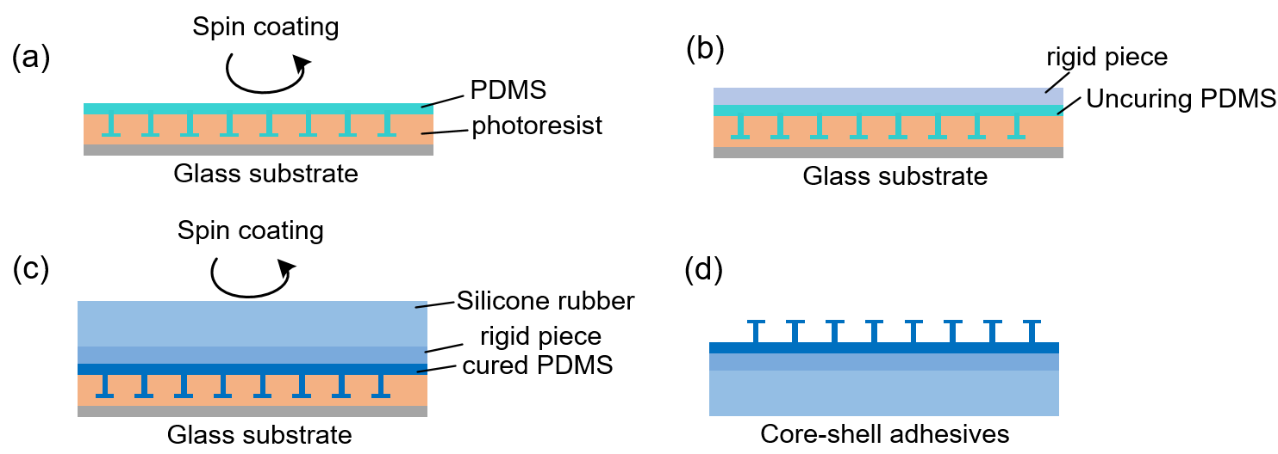

Figure. S2. The fabrication process of core-shell adhesives. The fabrication of the composite adhesives is mainly based on the molding process: (a) First, PDMS is poured on the surface of the mold which is prepared by double-sided exposure process, placed in a vacuum chamber for 10 mins, and then spin-coated at a speed of 2000 r/min for 40 s; (b) Subsequently, a rigid glass piece was placed on the uncured PDMS surface, and placed in a 90 ℃ oven for 1 hour to solidify the PDMS. (c) Then, uncured silicone rubber was poured on the surface of the glass piece. Here, in order to control the thickness of the silicone rubber layer to the millimeter level, a box was placed around the sample. By pouring silicone rubber prepolymers of different qualities into the box, corresponding silicone rubber layers of different thicknesses can be obtained; (d) Finally, the sample was placed in a 90 ℃ oven for 1 hour, then remove the box and demoulded to obtain core-shell adhesives.

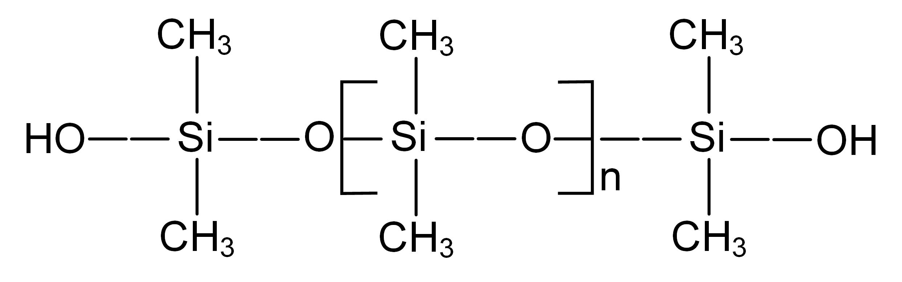
Figure S3. The chemical structure of PDMS. Polydimethylsiloxane (PDMS) is a common silicone compound consisting of multiple methylsilicon (MeSiO1.5) units connected by silicon-oxygen bonds.

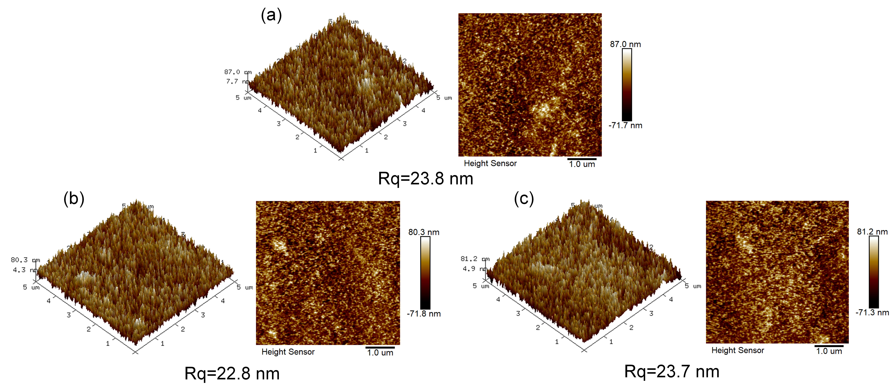
Figure S4. The roughness of the adhesive structure. Surface roughness testing is performed by Atomic Force Microscope (Bruker Dimension Icon), and the scanning mode is ScanAsyst in Air with a scanning frequency of 1 Hz, the scanning area is 5μm × 5μm. The test procedure was performed by scanning three different areas randomly on the surface of a single mushroom-shaped pillar, as shown in (a), (b), and (c), and the images were finally processed to obtain the RMS roughness of the microstructure surface.

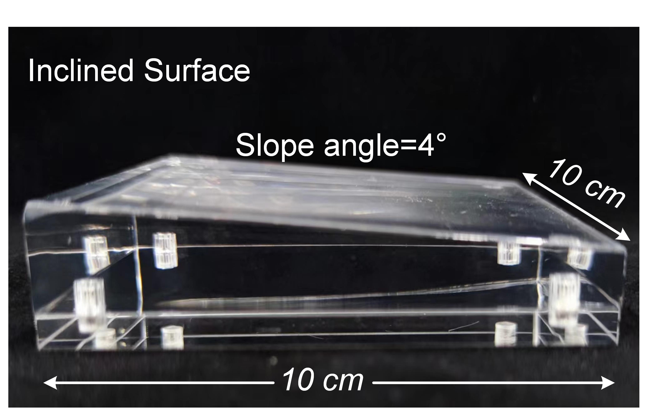
Figure. S5. The size characterization of the inclined plane. The length and width of the incline plane is 10 cm and 10 cm, respectively. The slope angle of the incline surface is 4°. During the test, the inclined plane was placed on the optical table, and the adhesive sample bonded on robot move slowly along the vertical direction by control system to achieve contact, and then the reverse movement was conducted to complete the grasping.

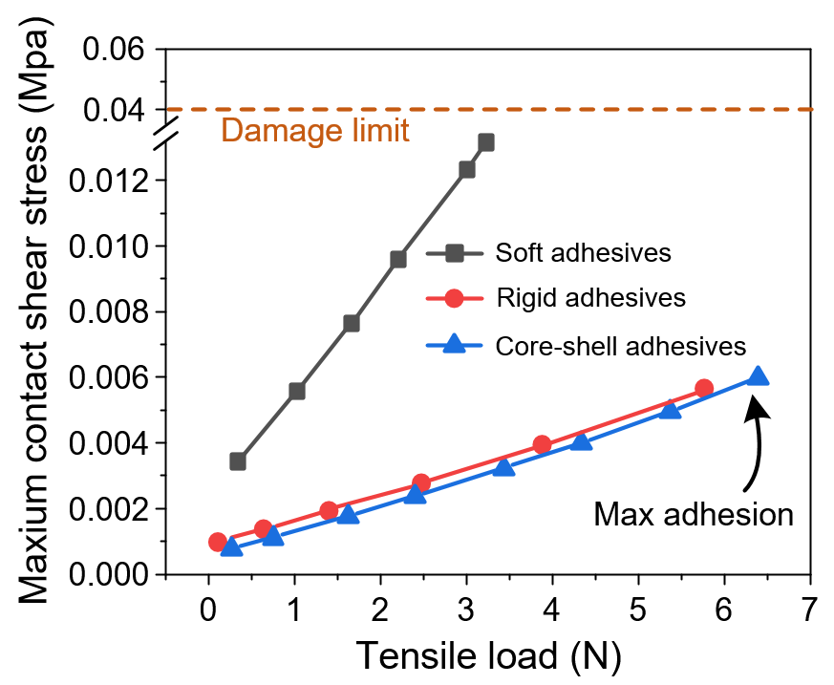
Figure. S6. The change of maximum shear stress on the contact interface versus tensile load of different adhesive structures under alignment situation. The soft adhesives had the highest shear stress under the same tensile load and quickly reached the damage threshold value (0.04 MPa), which triggers the separation of the contact surface and produced the corresponding adhesive force (X-axis: 3N). On the contrary, thmaximum contact shear stress of the core-shell adhesives kept increasing linearly at low levels, implying a hindering effect on separation, thus producing a high corresponding adhesive force (X-axis: 6.5N).

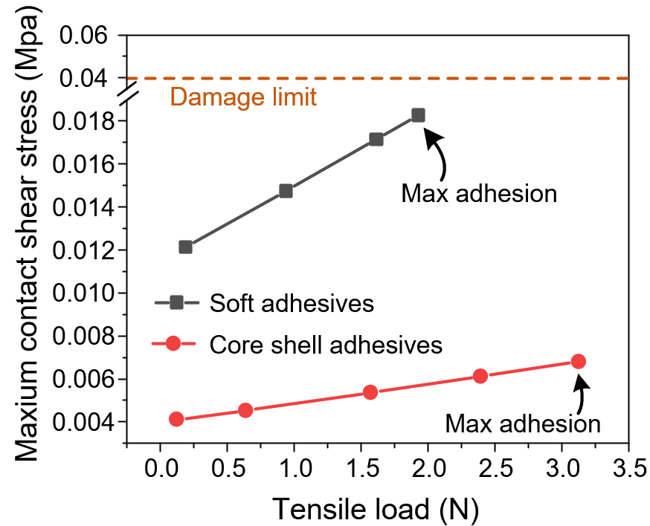
Figure. S7. The change of maximum shear stress on the contact interface versus tensile load of different adhesive structures under misalignment situation. The soft adhesives had the highest shear stress under the same tensile load and quickly reached the damage threshold value (0.04 MPa), which triggers the separation of the contact surface and produced the corresponding adhesive force (X-axis: 2N). On the contrary, the maximum contact shear stress of the core-shell adhesives kept increasing linearly at low levels, implying a hindering effect on separation. Here, since the maximum shear contact stress of core-shell adhesives is not reach the damage limit, the normal stress dominates the whole desorption process.

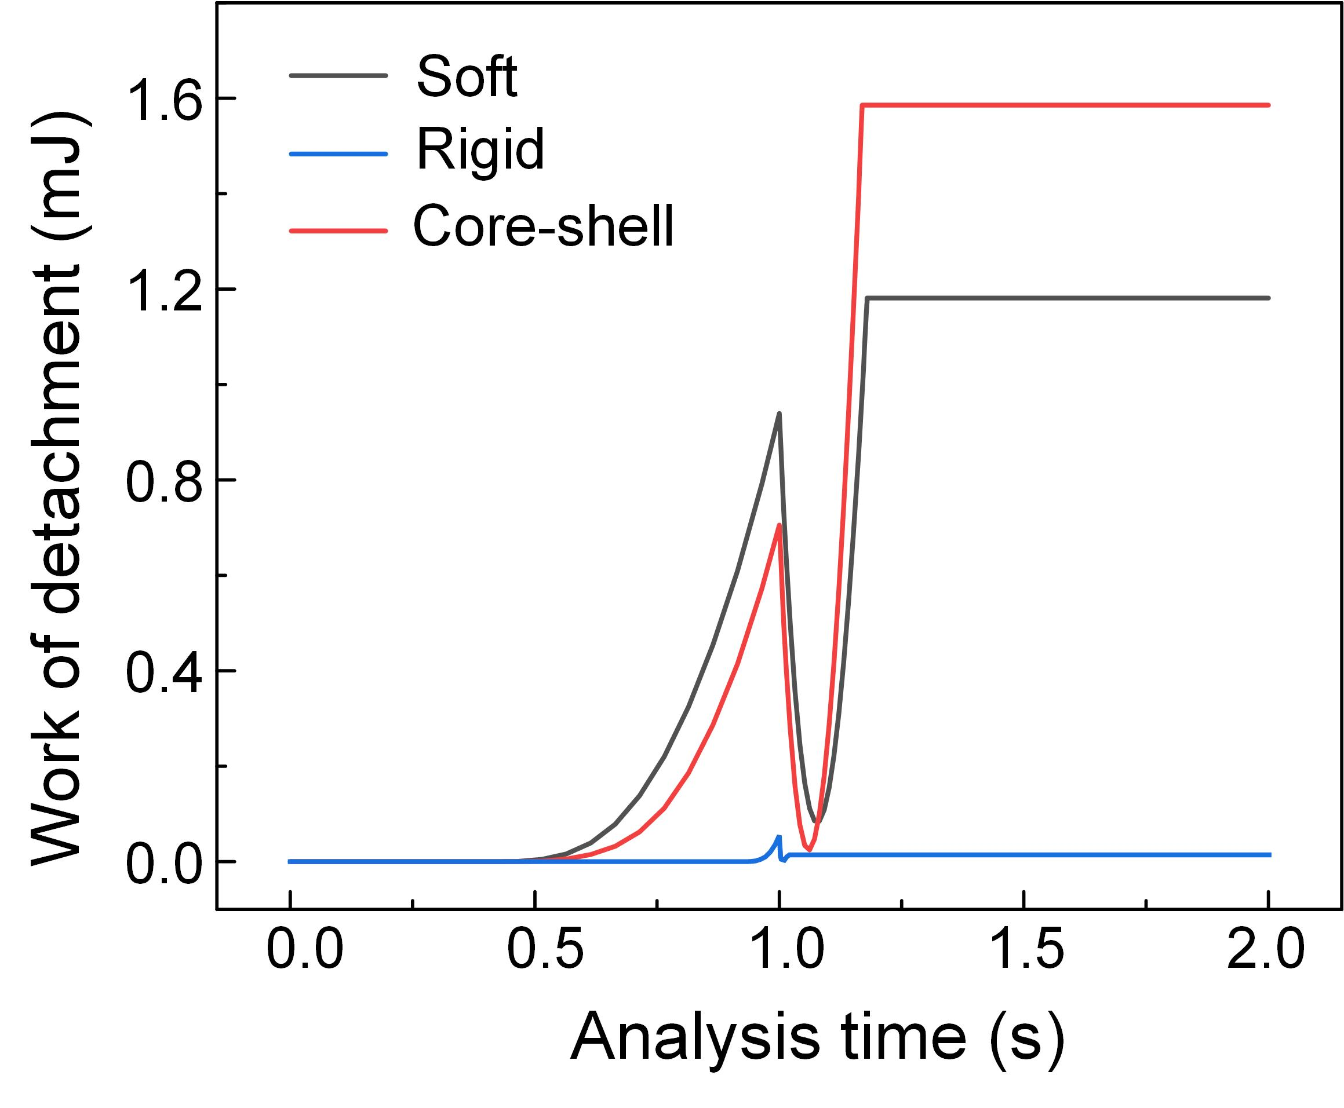
Figure S8. Work of attachment/detachment as a function of the processing time for different adhesive structures. Here, core–shell, soft, and rigid represent a mushroom-shaped structure with a rigid core and a soft shell, mushroom-shaped structure with soft material, mushroom-shaped structure with rigid material, respectively.

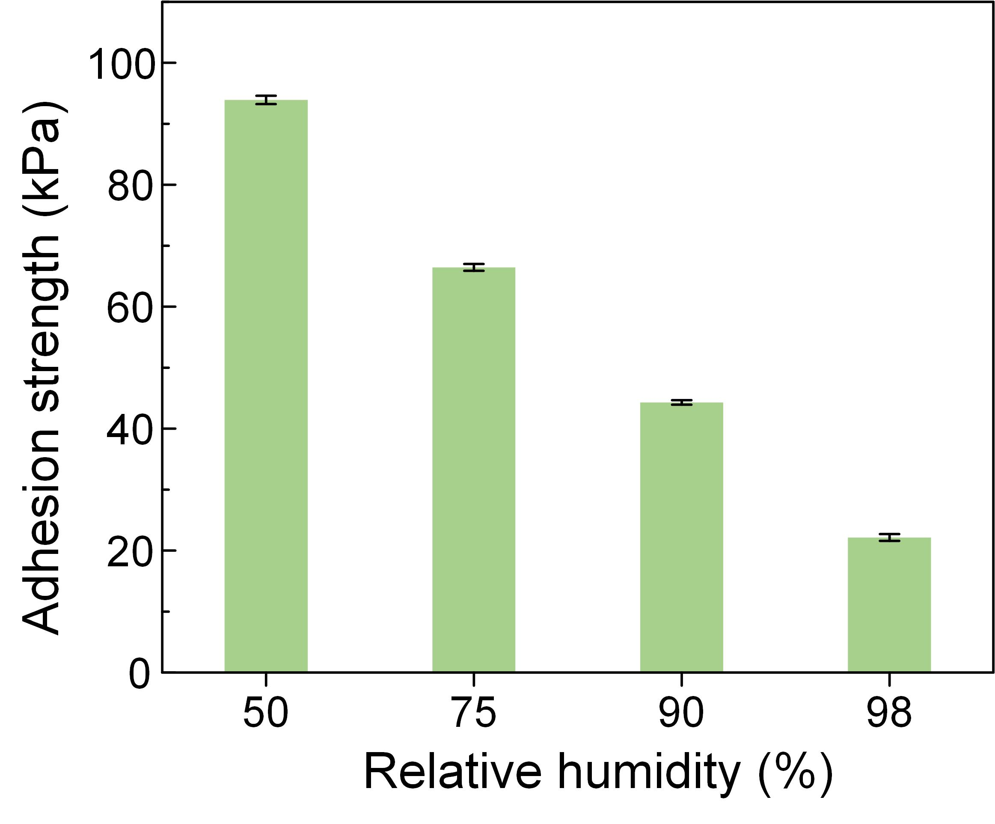
Figure S9. The adhesion performance of the core-shell adhesive structures under different relative humidity environment (50%~98 ℃). The preload in the test was set at 3 N, and the downward and upward pulling speeds were set at 3 mm/min. As shown in results, the adhesion performance experienced a significant decrease with the increase of ambient relative humidity.

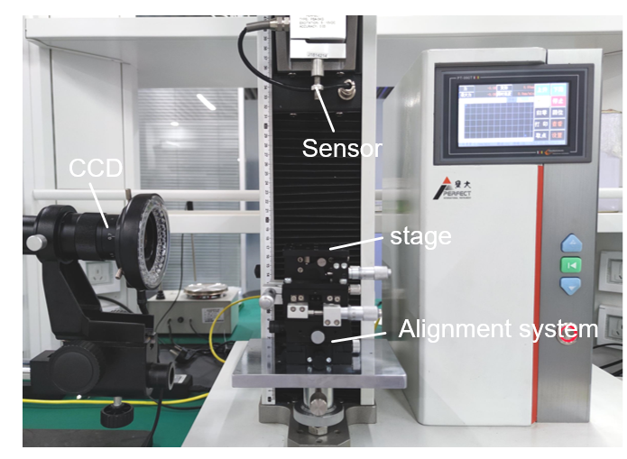
Figure. S10. The physical map of the adhesion performance testing equipment. The testing system includes a mechanical sensor, a load stage, an angular displacement platform for alignment and a CCD. During the test process, the adhesive sample was fixed on the stage, and the object target was connected with the mechanical sensor. The probe was pressed against the sample with a defined preload and retracted in a standard load-displacement experiment. The pull-off force was defined as the maximum tensile force. The contact-separation state of the interface can be observed in real time through CCD.

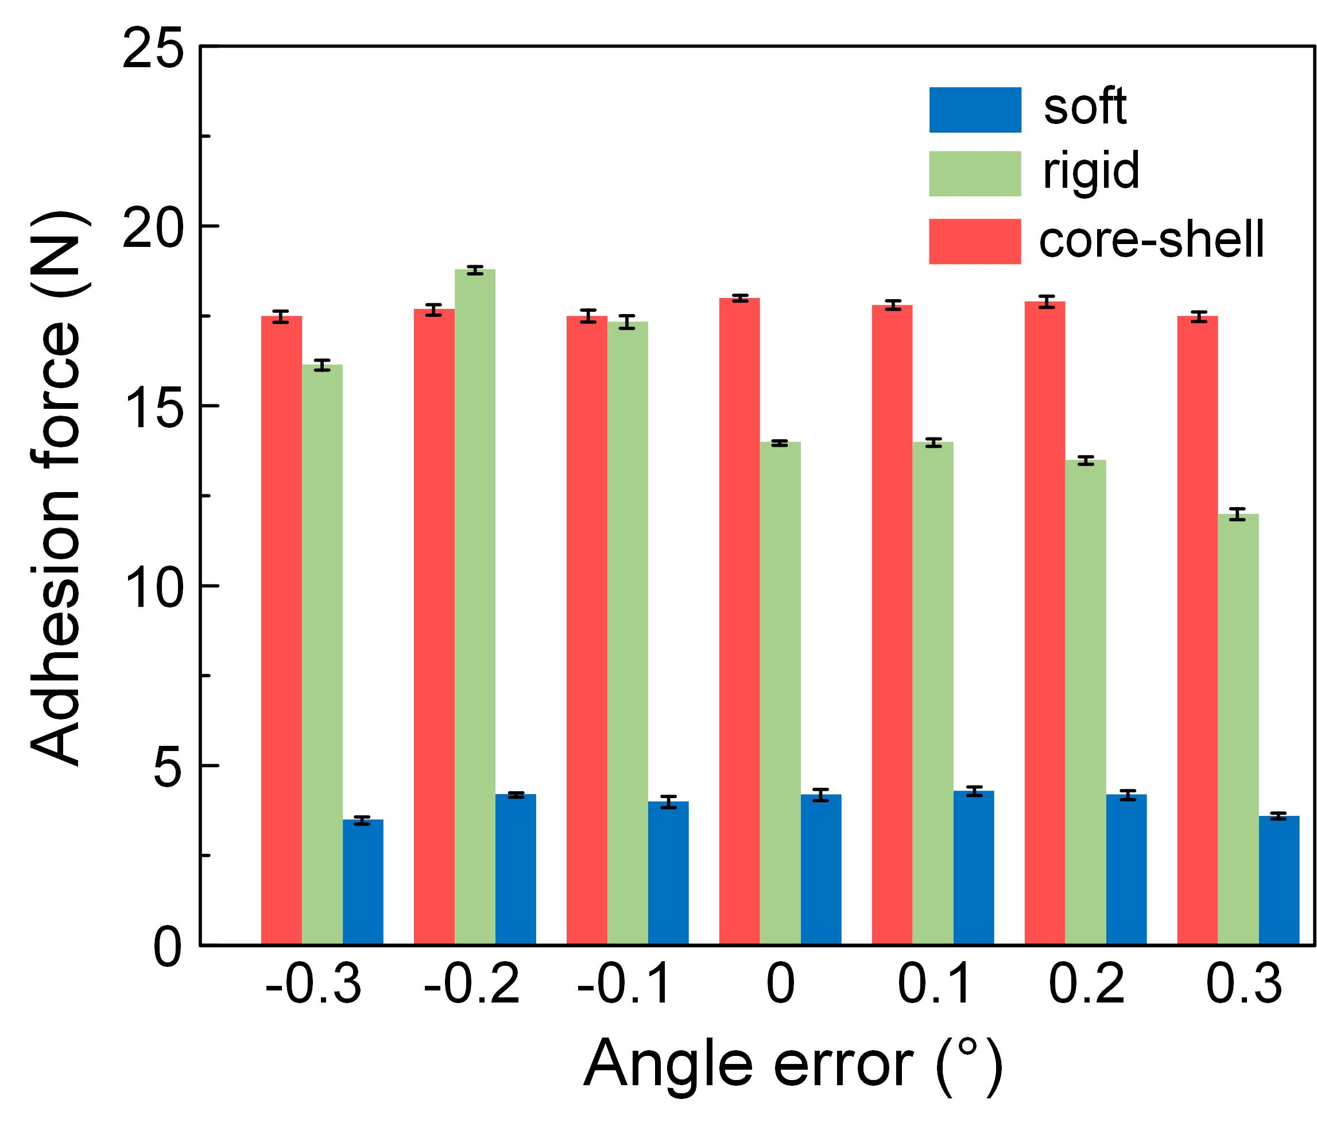
Figure S11. The adhesion performance of different adhesive structures under -0.3°~0.3°. The adhesion properties of both rigid and soft structures show a normal distribution around 0°, and the maximum value for rigid structures appears at -0.2°. The results show that the adhesion performance under ideal parallel contact is indeed proportional to the structural modulus, however, when a weak angular error occurs, the adhesion performance of the rigid structure fluctuates or decreases significantly, and on the contrary, the core-shell structure can be stabilized to maintain at a high adhesion performance.

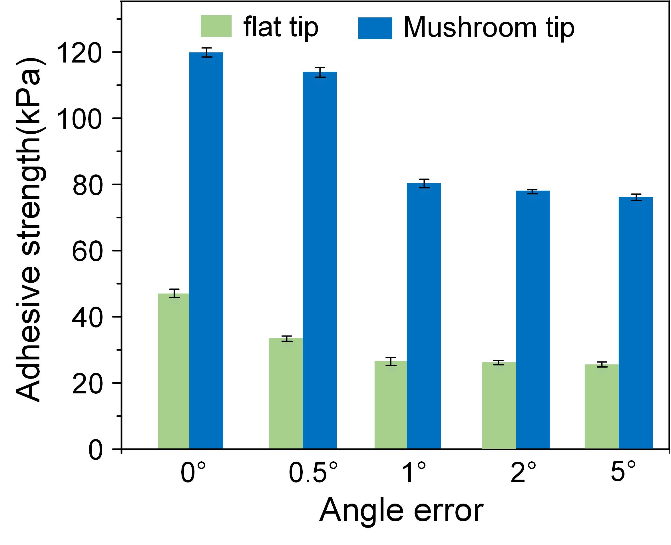
Figure S12. The adhesion performance of adhesive structures with/without mushroom shaped tip under angle error. From the results, it can be seen that an increasing angle error weakens the adhesion strength, regardless of whether or not it has a mushroom-shaped end. However, the mushroom-structured end improves about 2.5 times compared to the flat film, which proves the advantage of the mushroom shape structure.

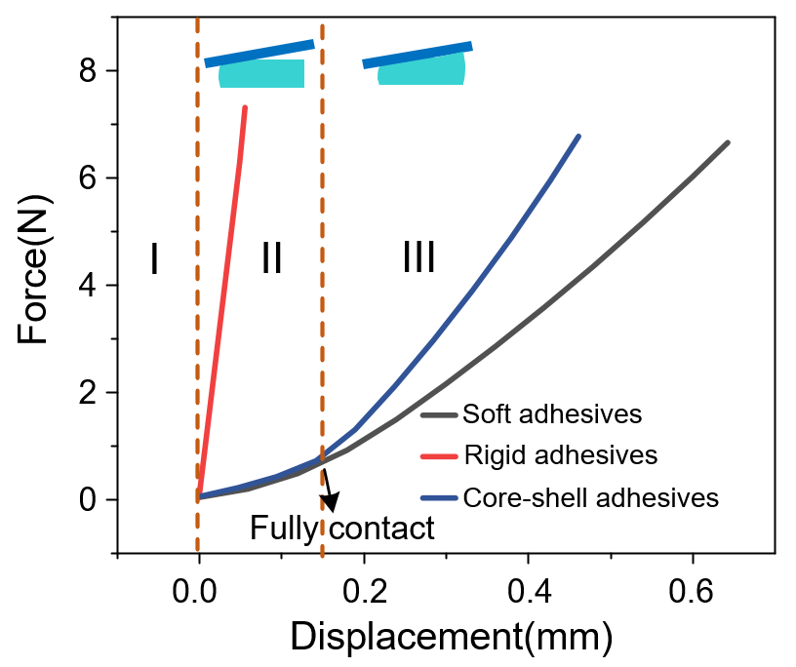
Figure. S13. The compression stiffness under misalignment of the different adhesive structures. The compression stiffness was tested by a computerized servo tension-compression testing machine, the pressing speed was set to 2 mm/min, and the angle between the plane probe and the adhesive sample was controlled to 0.5° by an angular displacement platform during the test. The displacement-force curve can be divided into three stages. In stage I, the adhesive sample and the probe are not in contact; when stage II is reached, the probe begins to contact the sample and generates an interaction force; due to the angular error, the contact area between the probe and the adhesive sample will gradually increase until complete contact; at this stage, the curves of soft adhesives and core-shell adhesives basically coincide, indicating that the compressive stiffness of the two is basically the same; in stage III, the probe after achieving full contact further compresses the sample, at this time, the equivalent stiffness of the overall structure dominates, so the core-shell adhesives curve exhibits a higher slope.

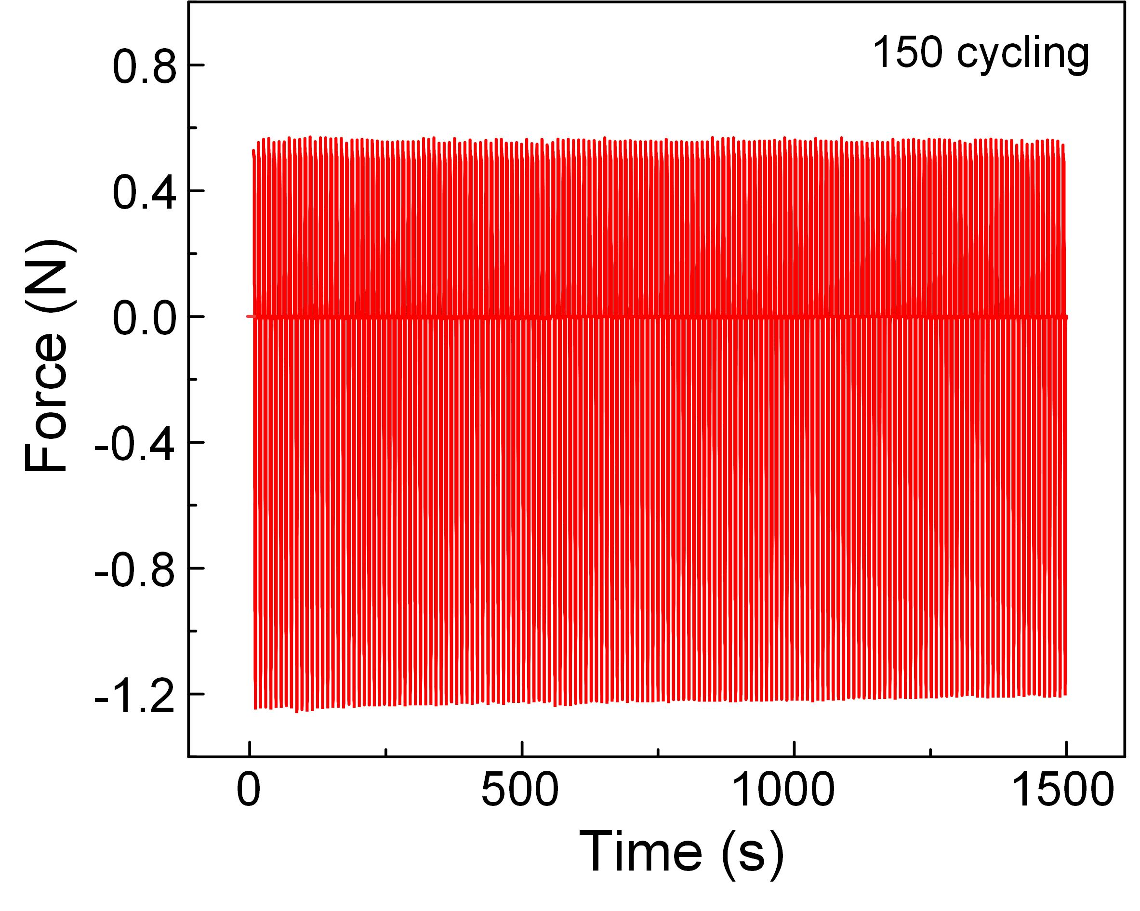
Figure S14. The cycling performance of the core-shell adhesive structures (150 cycling). The preload in the cyclic test was set at 0.5 N, and the downward and upward pulling speeds were set at 3 mm/min. As shown in results, the adhesion properties of the core-shell structure remained stable over 150 cycles, with the difference fluctuating nearly to about 3.5%.

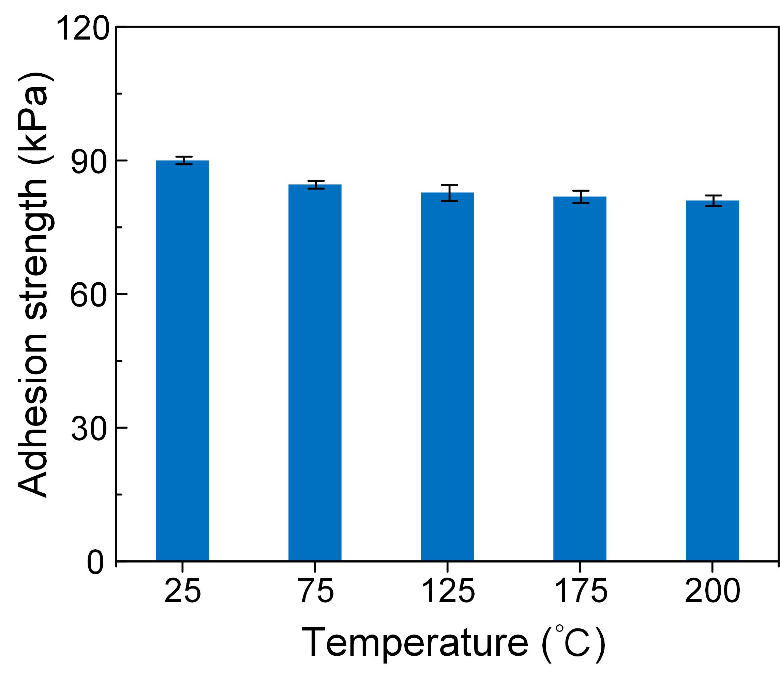
Figure S15. The adhesion performance of the core-shell adhesive structures under high temperatures (25 ℃~200 ℃). The preload in the cyclic test was set at 3 N, and the downward and upward pulling speeds were set at 3 mm/min. As shown in results, the adhesion properties of the core-shell structure remained stable under high temperatures, due to the stable thermal stability of the fabricating materials.

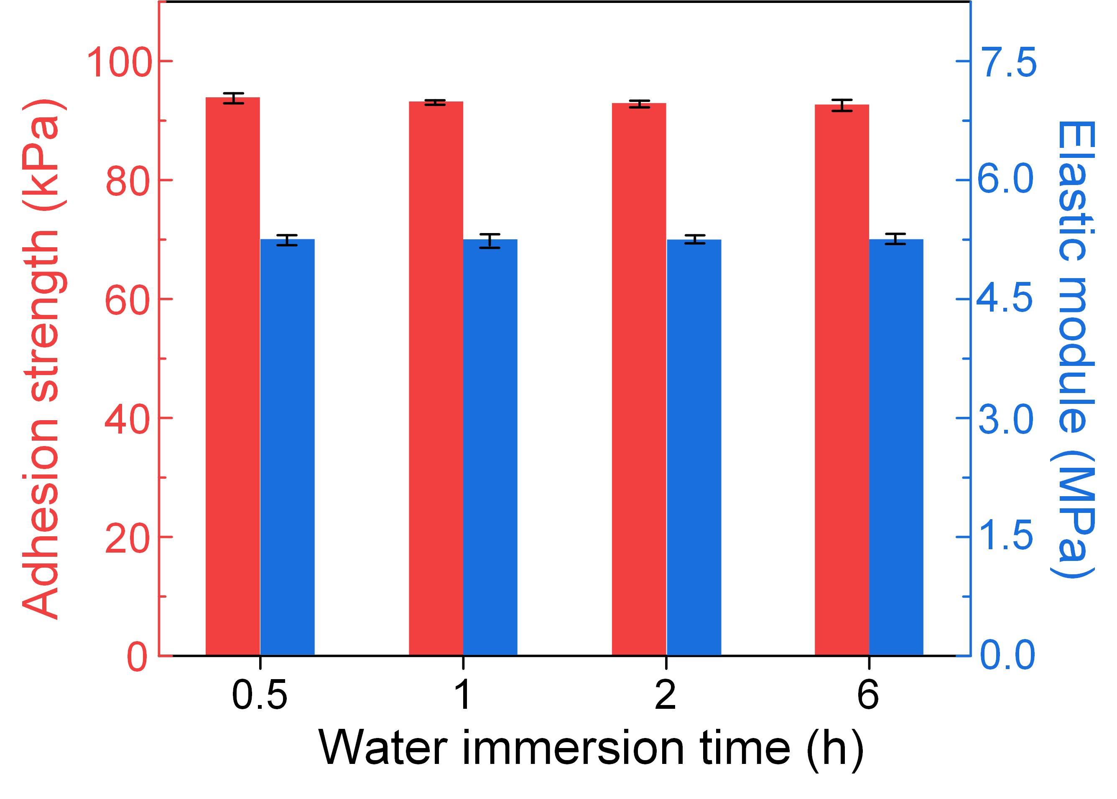
Figure S16. The demonstration of water tolerance of the core-shell adhesive structure. Here, the adhesive structure was first immersed in deionized water for a certain period of time, then taken out to dry and tested for elastic modulus and adhesion strength. The preload in the test was set at 3 N, and the downward and upward pulling speeds were set at 3 mm/min. The results showed that the elastic modulus of the adhesive structure did not change significantly after immersion in water, which led to the adhesion properties remaining stable.

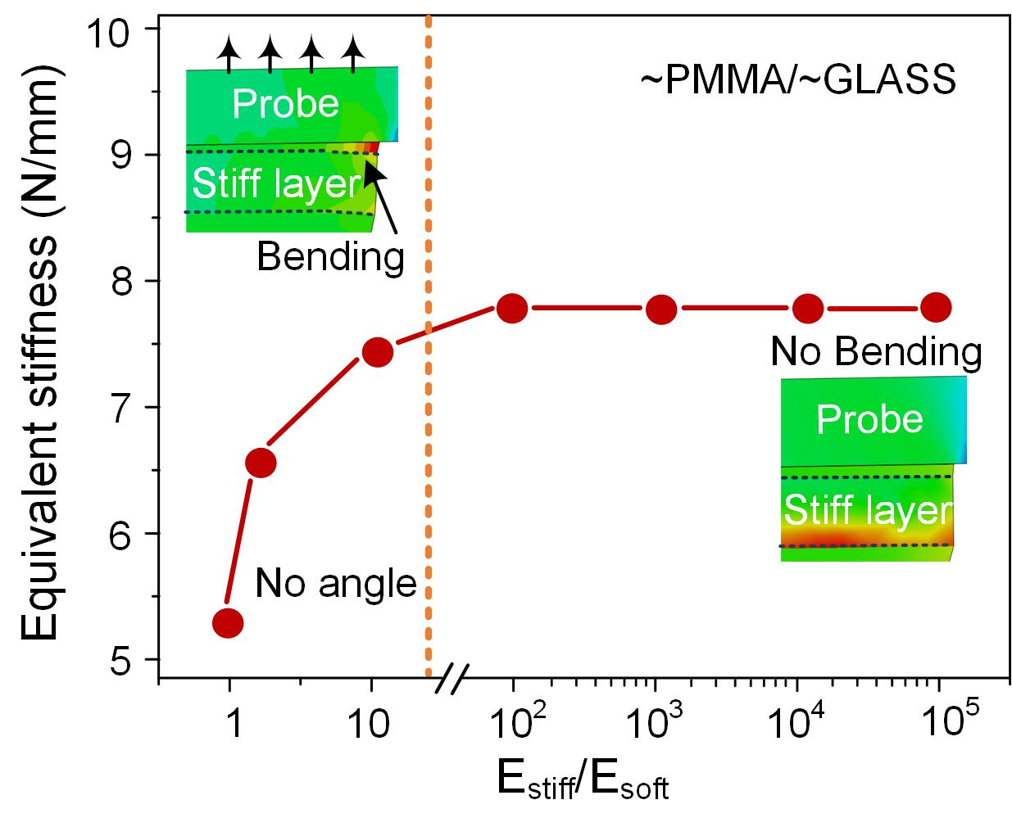
Figure. S17. The equivalent stiffness of the adhesive structure with different E_{stiff}/E_{soft} from FEA model. Here, the value of E_{stiff}/E_{soft} is adjusted by changing the modulus of the embedded stiff piece. When the ratio is within an order of magnitude, the equivalent stiffness increases along with the ratio. However, when the modulus of the hard sheet is more than two orders of magnitude higher than that of the elastomer, the equivalent stiffness remains basically the same and no longer increases along with the ratio. Therefore, the change of the ratio at this time does not affect the overall mechanical properties.

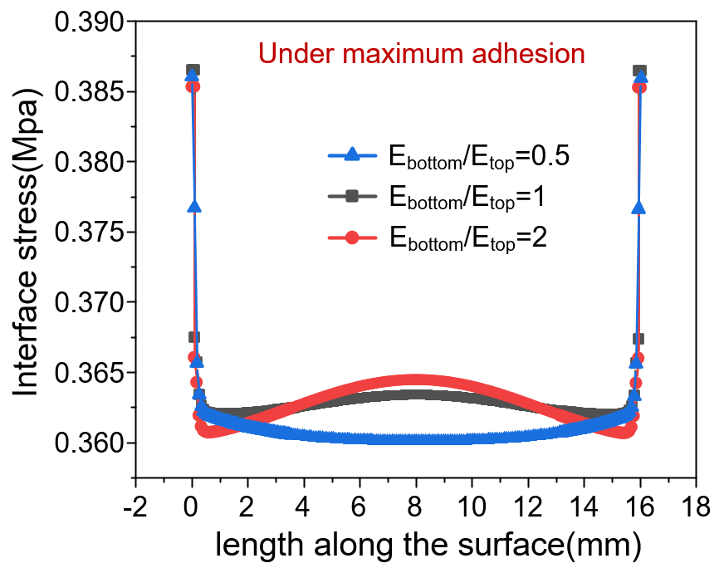
Figure. S18. The value of the stress distribution on the entire interface of adhesives with different E_{bottom}/E_{top} under maximum adhesion. The range of x-axis contained under the curve reflects the actual contact length, and there is no difference among the different structures. Moreover, the interface stress distribution of different adhesive structures is basically the same, and the value of the stress concentration at the edge is basically close.

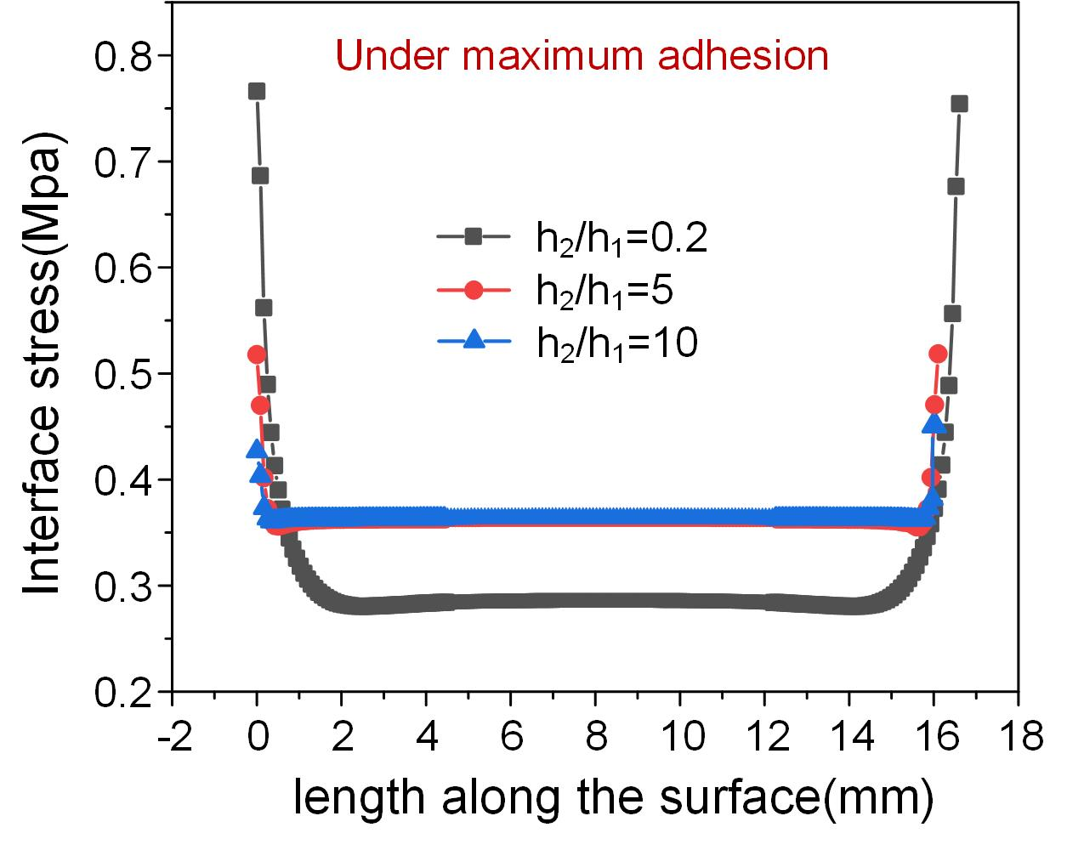
Figure S19. The value of the stress distribution on the entire interface of adhesives with different h₂/h₁ under maximum adhesion. The range of x-axis contained under the curve reflects the actual contact length, and there is no difference among the different structures. Moreover, the contact edge of higher h₂/h₁ produces extremely high value of stress concentration, which will quickly induce cracks and lead to peeling effect. Therefore, the decrease of the value of h₂/h₁ can improve the adhesion by promoting equal loading sharing.

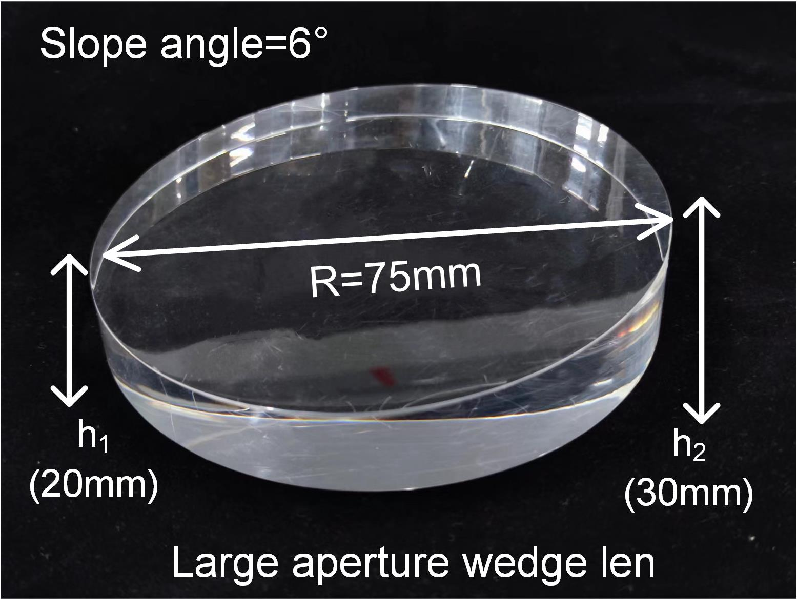
Figure. S20. The size characterization of the large aperture wedge lens. The radius of the wedge lens is 75 mm, and the height of the two sides are 20 mm and 30 mm. The slope angle of the wedge surface is 6.

Captions for Supplementary Videos

Movie S1 | Numerically dynamic contacting-separating behavior of the different adhesives under alignment situation.
Movie S2 | Numerically dynamic contacting-separating behavior of the different adhesives under misalignment situation.
Movie S3 | Demonstration of the highly adaptable and anti-overturning grasping of large aperture wedge lens.

