Supporting Information for
Air Pollution Control―Article

Spatial and Temporal Variations in the Atmospheric Age Distribution of Primary and Secondary Inorganic Aerosols in China
Xiaodong Xieª, Qi Ying^{b}, Hongliang Zhang^{c}, Jianlin Hu^{a,*}
ª Jiangsu Key Laboratory of Atmospheric Environment Monitoring and Pollution Control, Collaborative Innovation Center of Atmospheric Environment and Equipment Technology, Nanjing University of Information Science & Technology, Nanjing 210044, China
^{b} Zachry Department of Civil Engineering, Texas A&M University, College Station, TX 77843, USA
^{c} Department of Environmental Science and Engineering, Fudan University, Shanghai 200438, China
* Corresponding author.
E-mail address: jianlinhu@nuist.edu.cn (J. Hu)
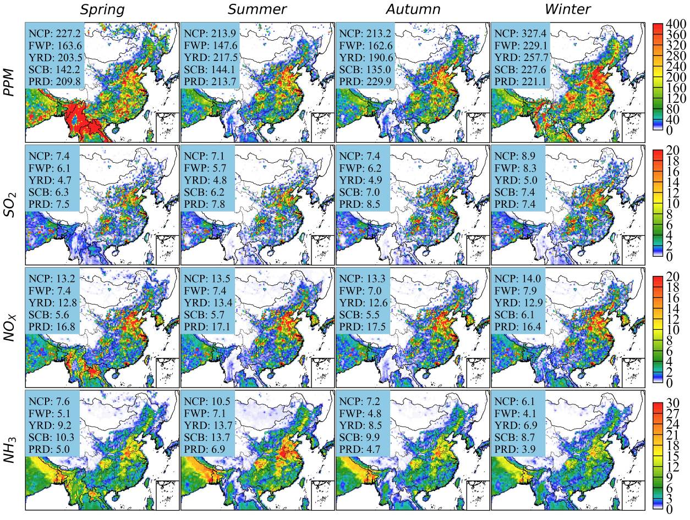
Fig. S1. Seasonal mean emission rates of PPM, SO₂, NO_{X}, and NH₃. Units are g/s/grid for PPM and molecules/s/grid for SO₂, NO_{X}, and NH₃. Numbers inset each panel are the mean emission rates in different regions.

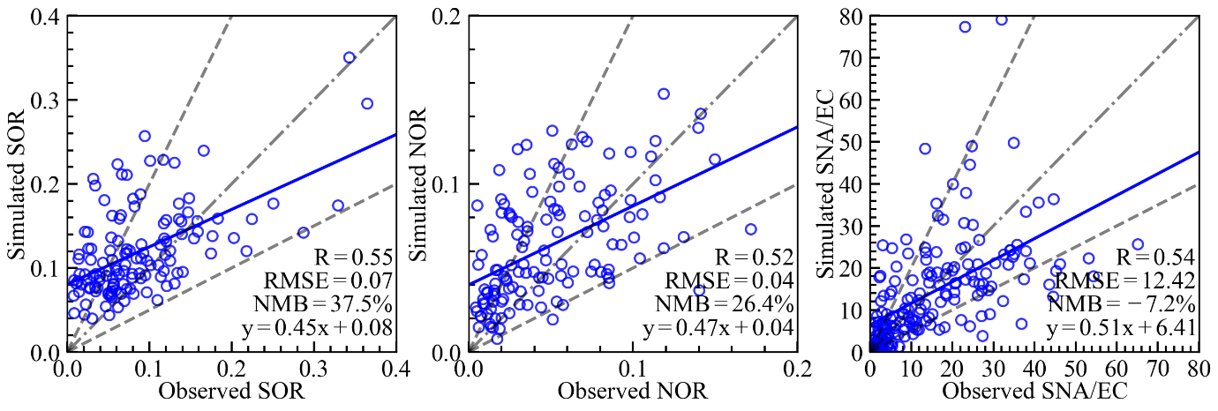
Fig. S2. Comparison of predicted and observed SOR, NOR, and SNA/EC ratio.
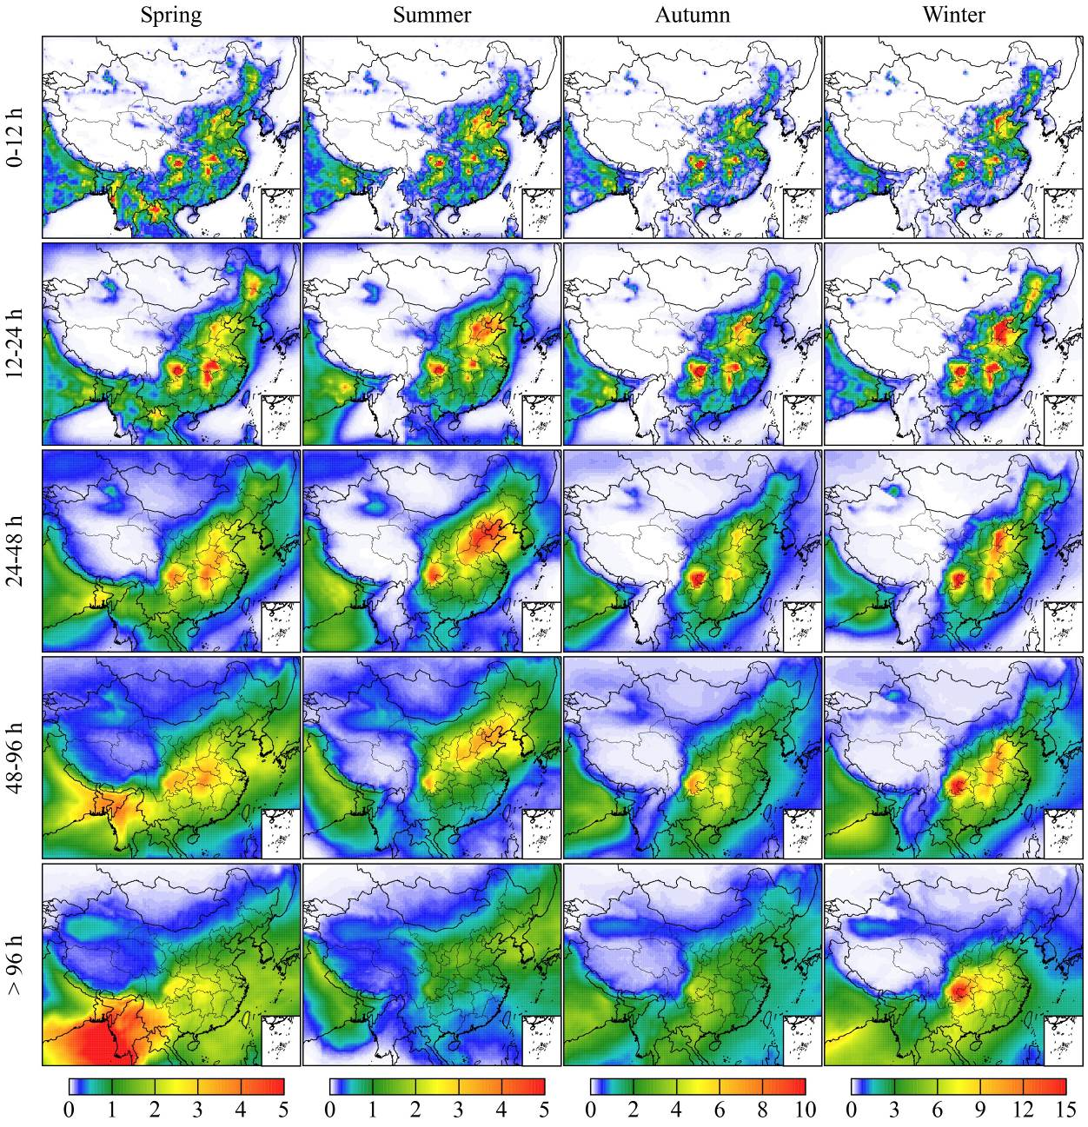
Fig. S3. Seasonal variation of sulfate concentrations (µg m⁻³) in different age bins.
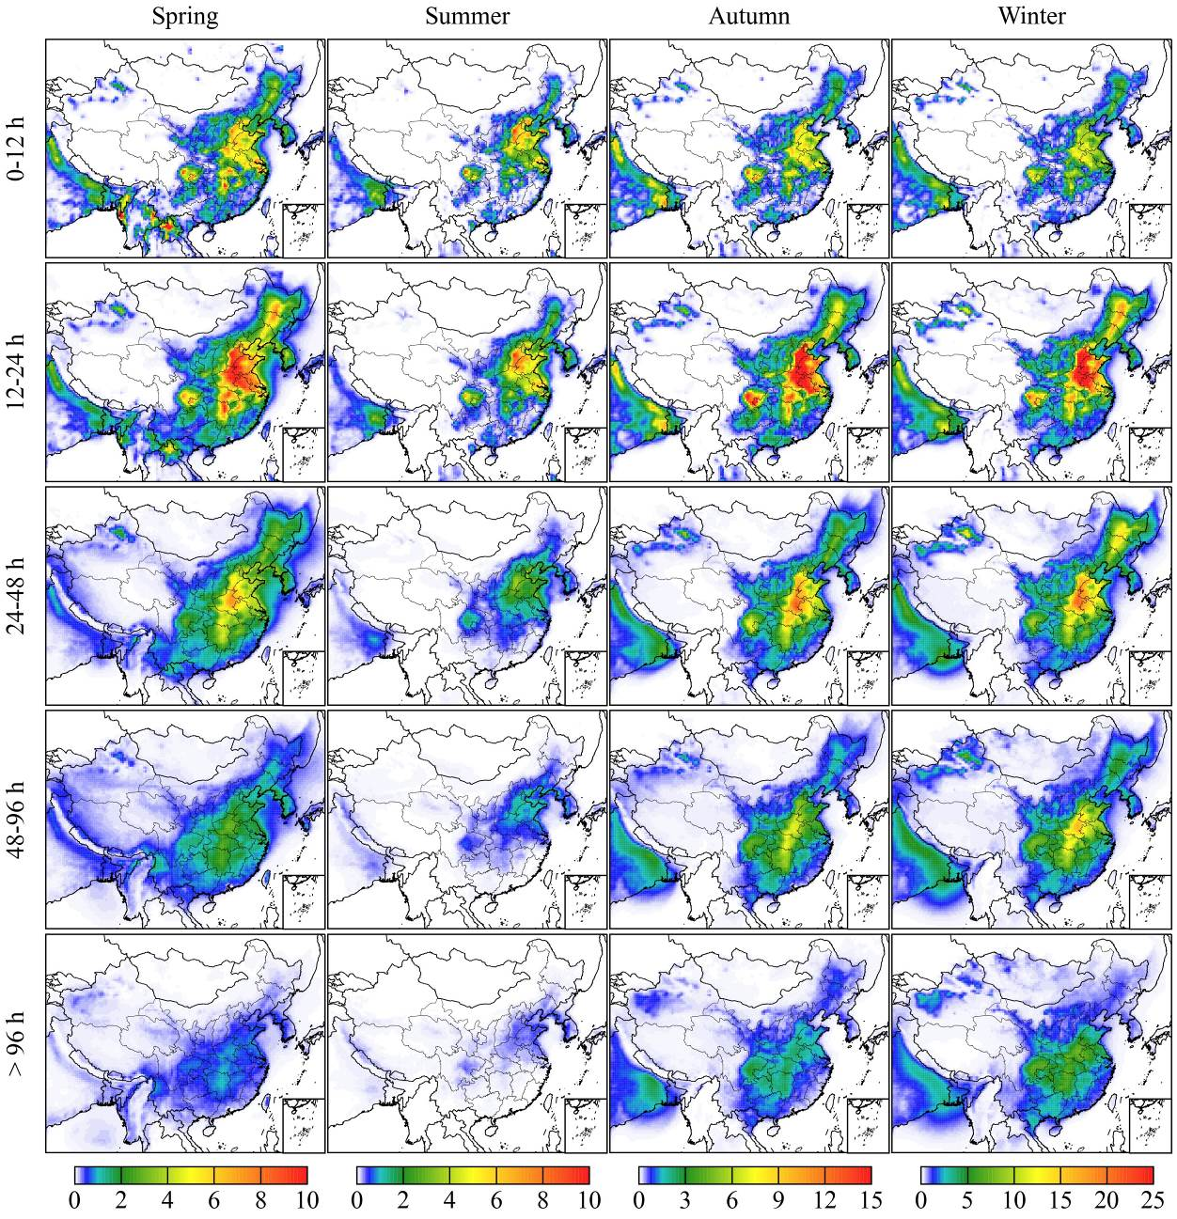
Fig. S4. Seasonal variation of nitrate concentrations (µg m⁻³) in different age bins.
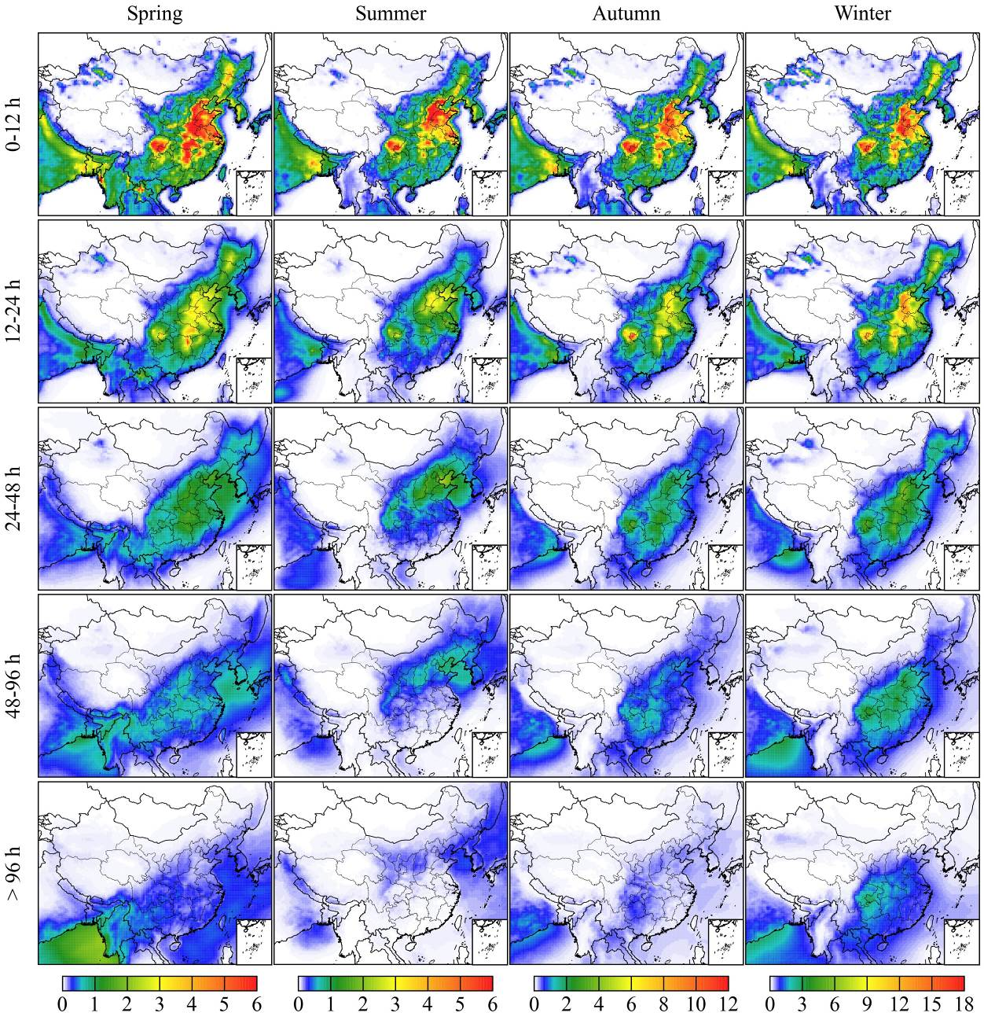
Fig. S5. Seasonal variation of ammonium concentrations (µg m⁻³) in different age bins.
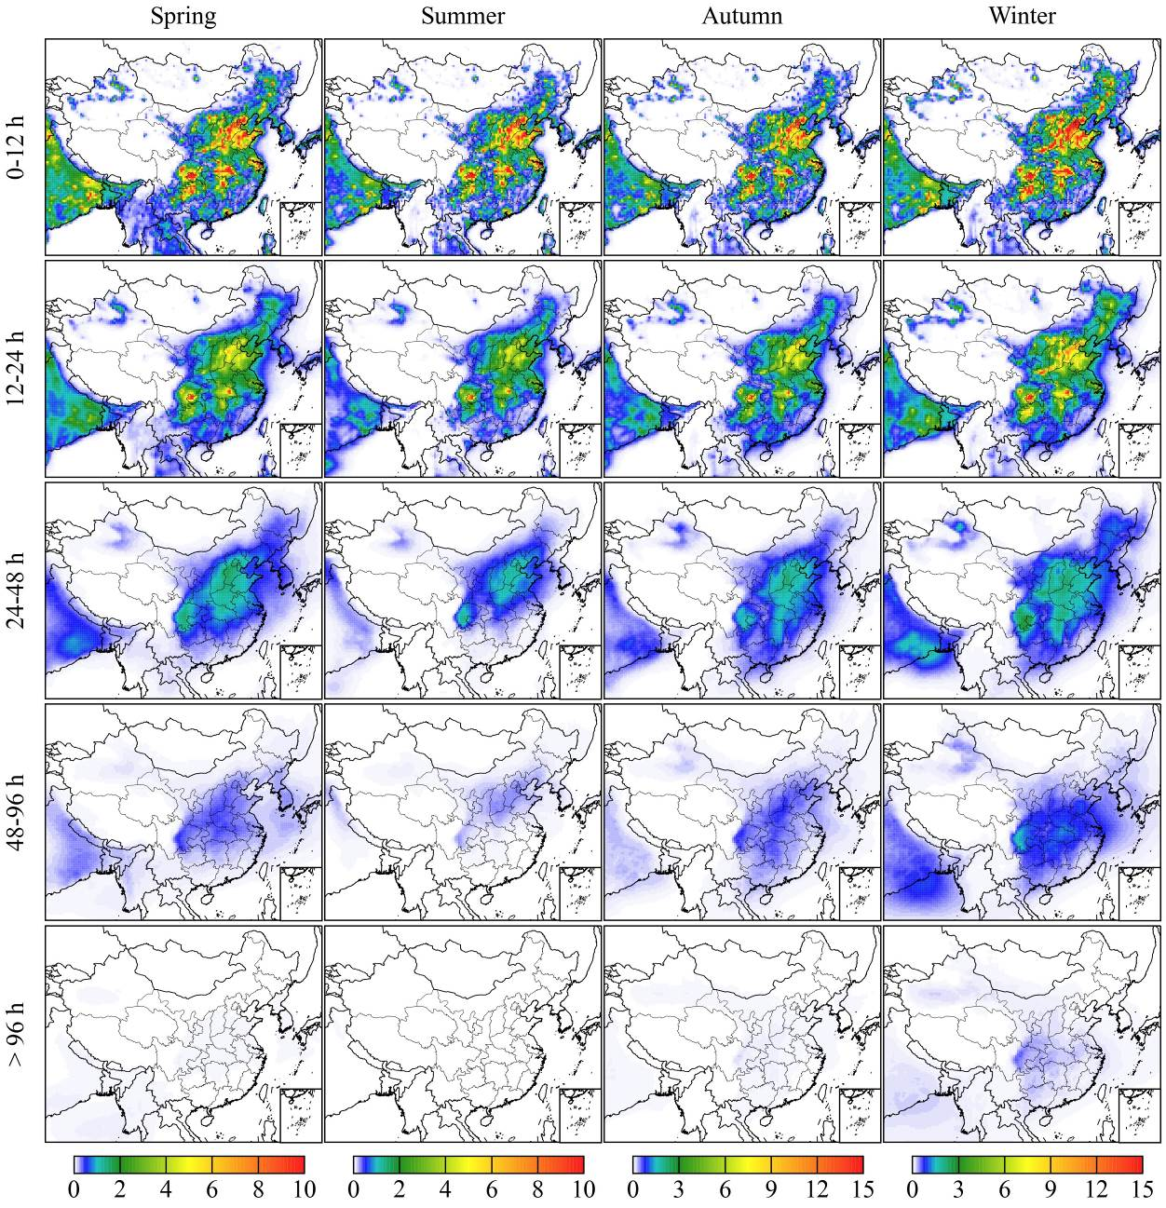
Fig. S6. Seasonal variation of SO₂ concentrations (ppb) in different age bins.
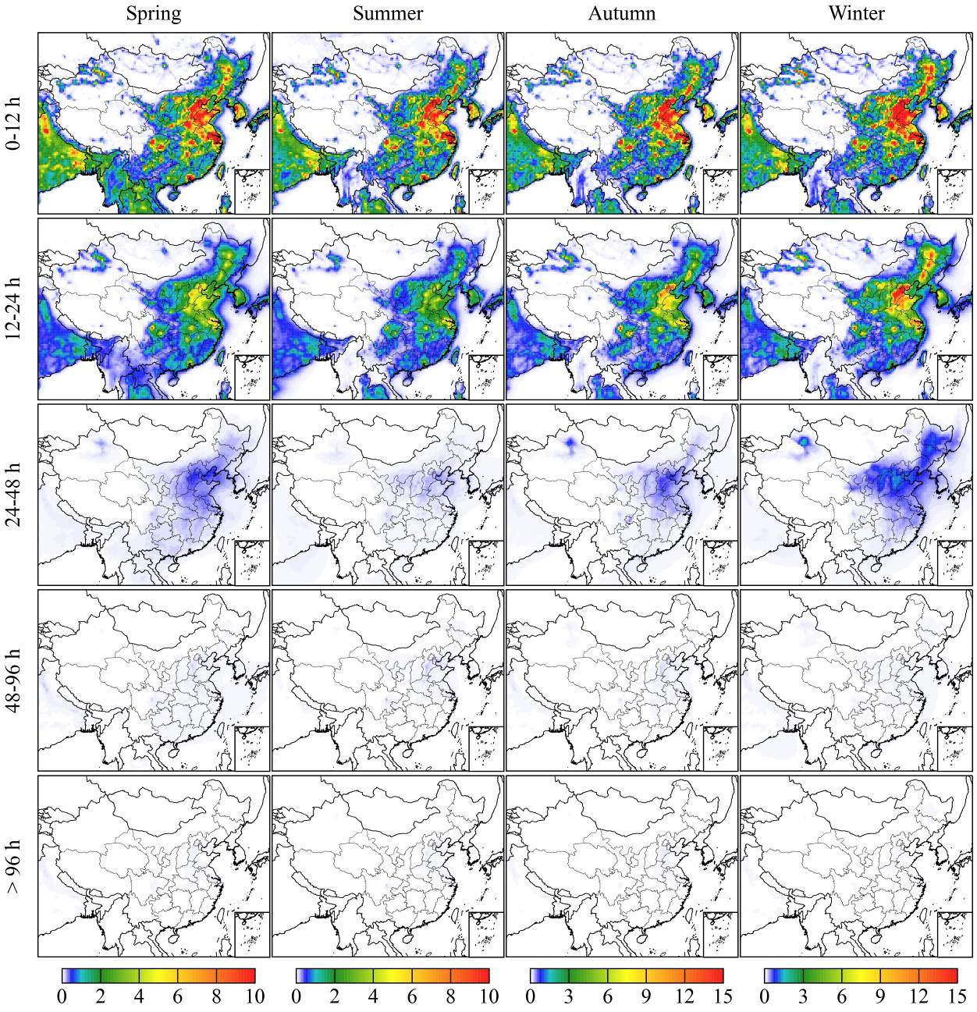
Fig. S7. Seasonal variation of NO_{x} concentrations (ppb) in different age bins.
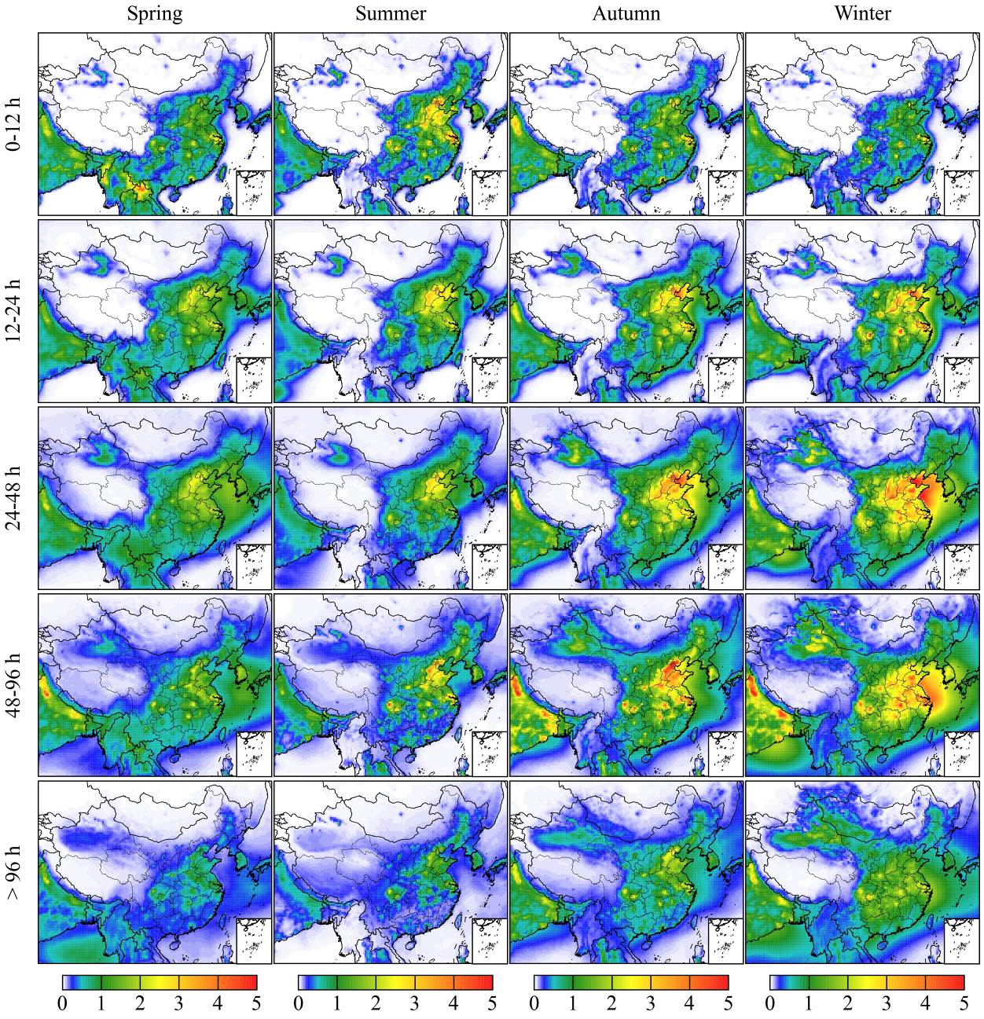
Fig. S8. Seasonal variation of NO_{z} (other nitrogen oxides, including HNO₃, HNO₄, PAN, PAN₂, HONO, and RNO₃) concentrations (ppb) in different age bins.
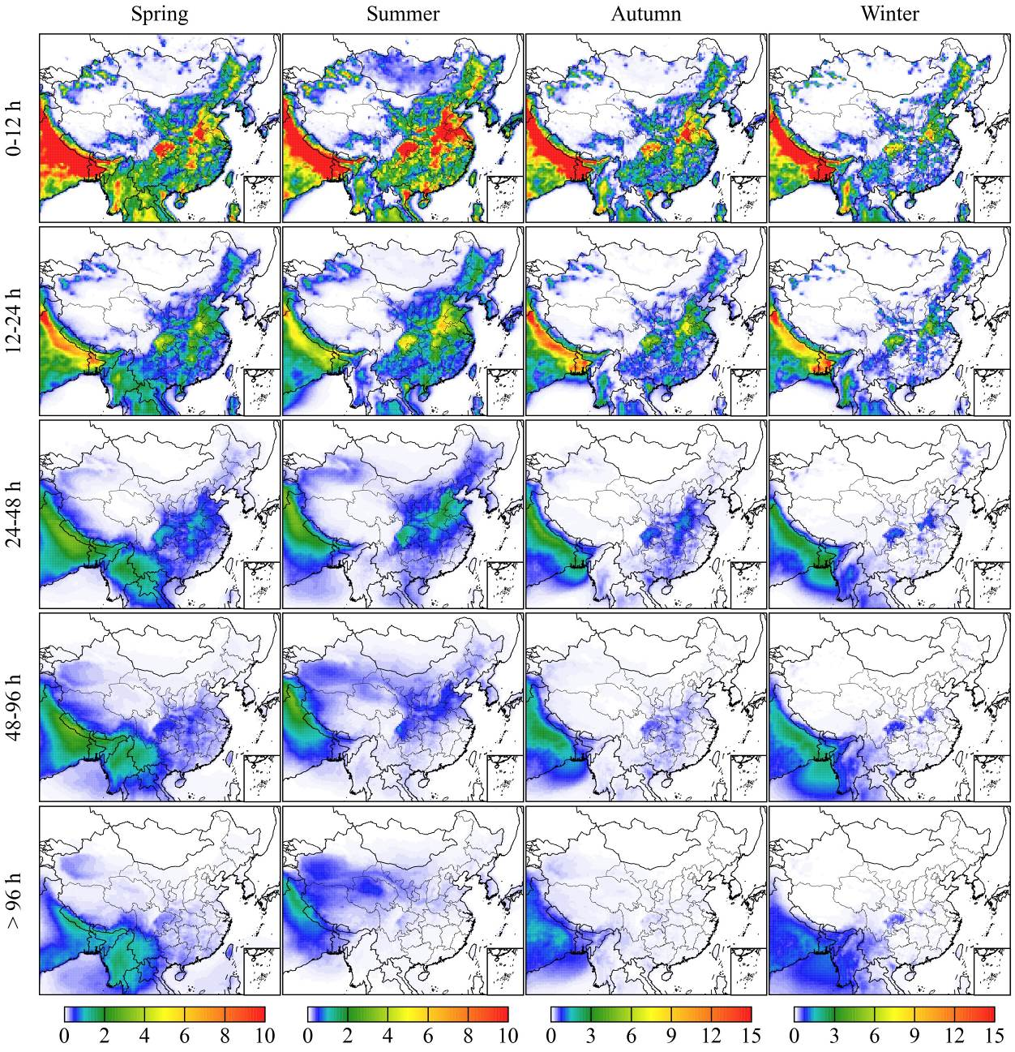
Fig. S9. Seasonal variation of NH₃ concentrations (ppb) in different age bins.
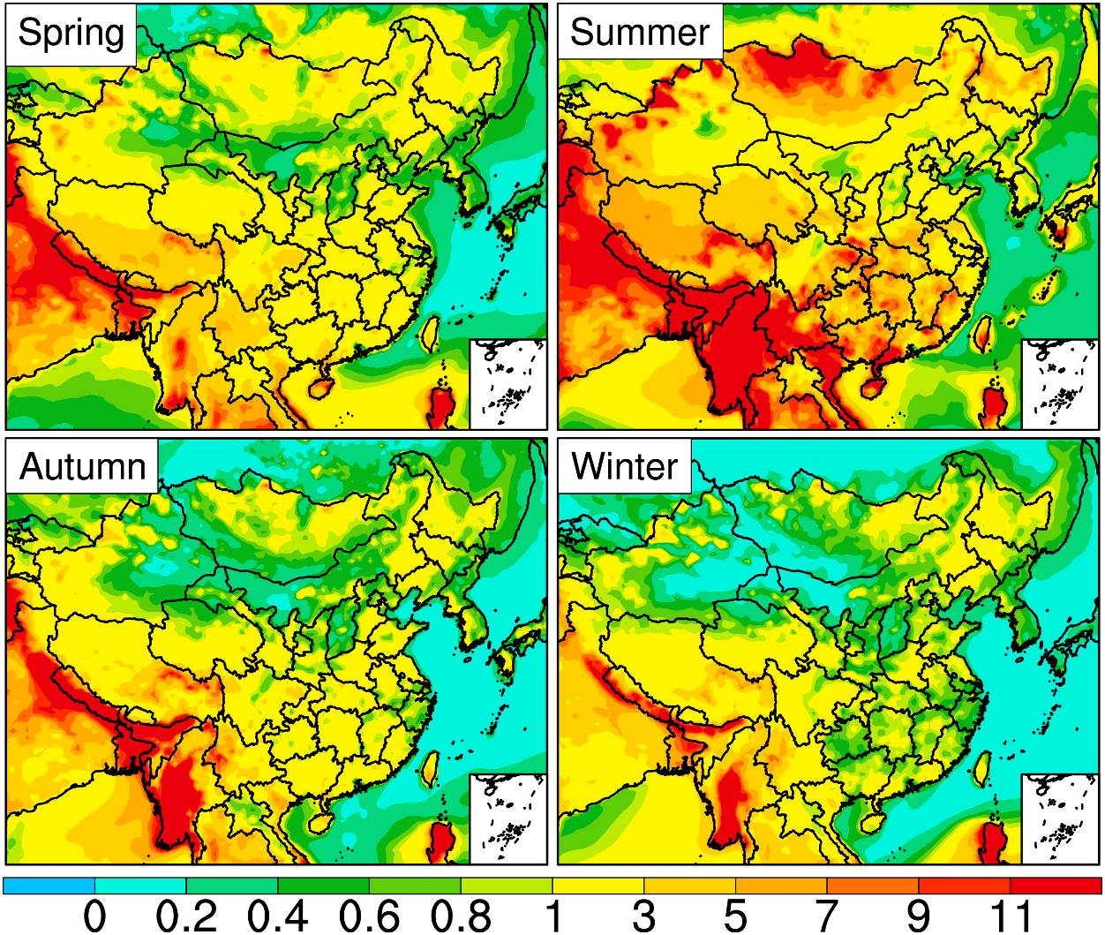
Fig. S10. The predicted seasonal mean adjusted gas ratio (adjGR). adjGR=$\frac{[{NH}_{3}](mol)+[{NO}_{3}^{-}](mol)}{[{NO}_{3}^{-}](mol)+[{HNO}_{3}](mol)}$.
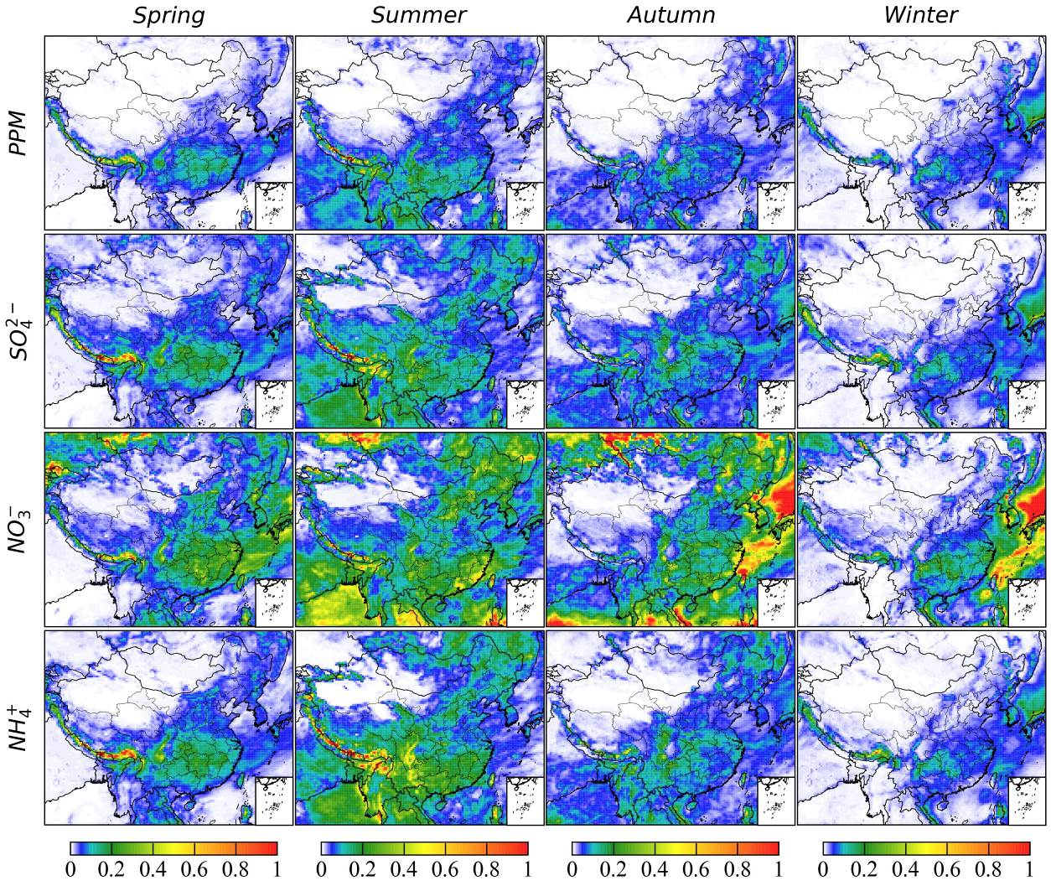
Fig. S11. Seasonal variation of the removal rates of deposition (deposition/burden, d⁻¹).
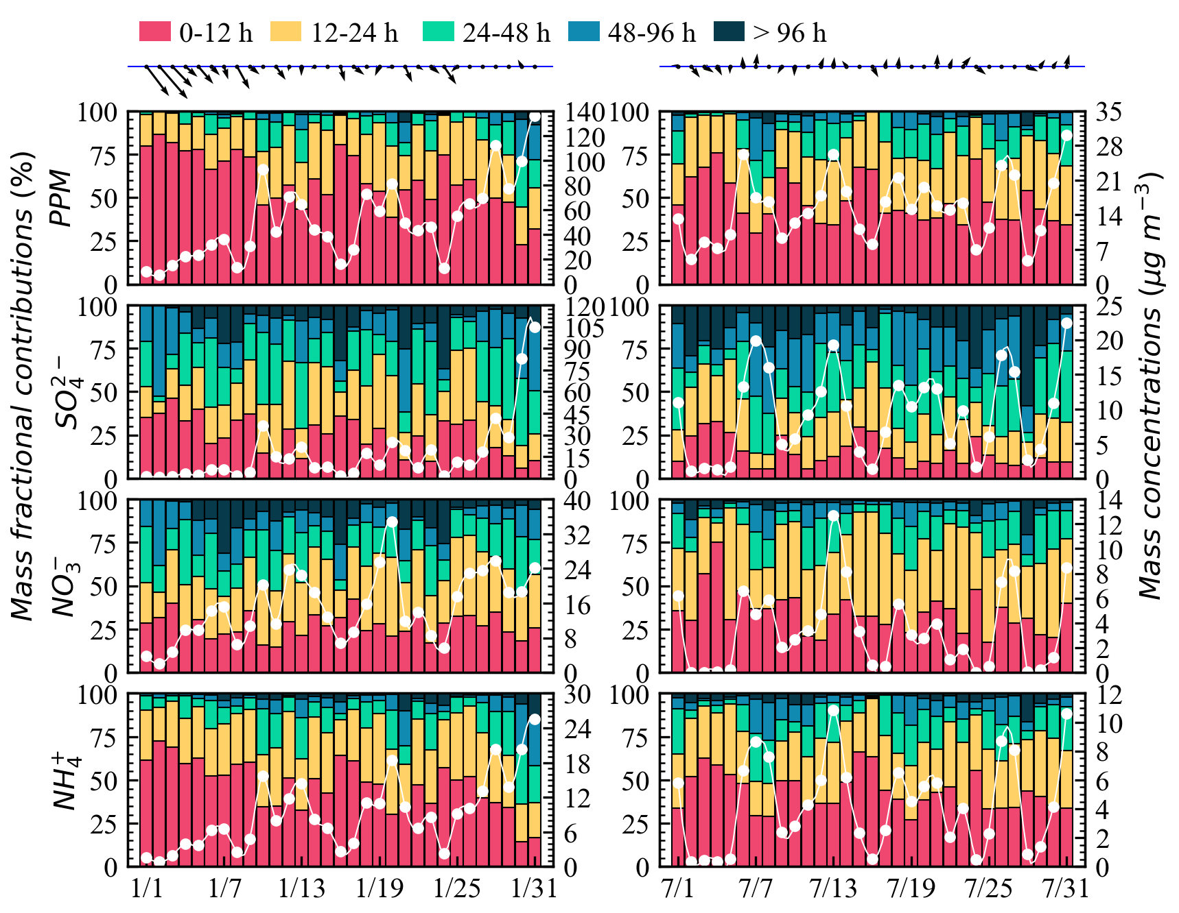
Fig. S12. Temporal variations of atmospheric age distribution in January (left column) and July (right column) at Beijing. White lines indicate the total concentrations (µg m⁻³, right y-axis). Daily wind vectors are also shown at the top of each column.

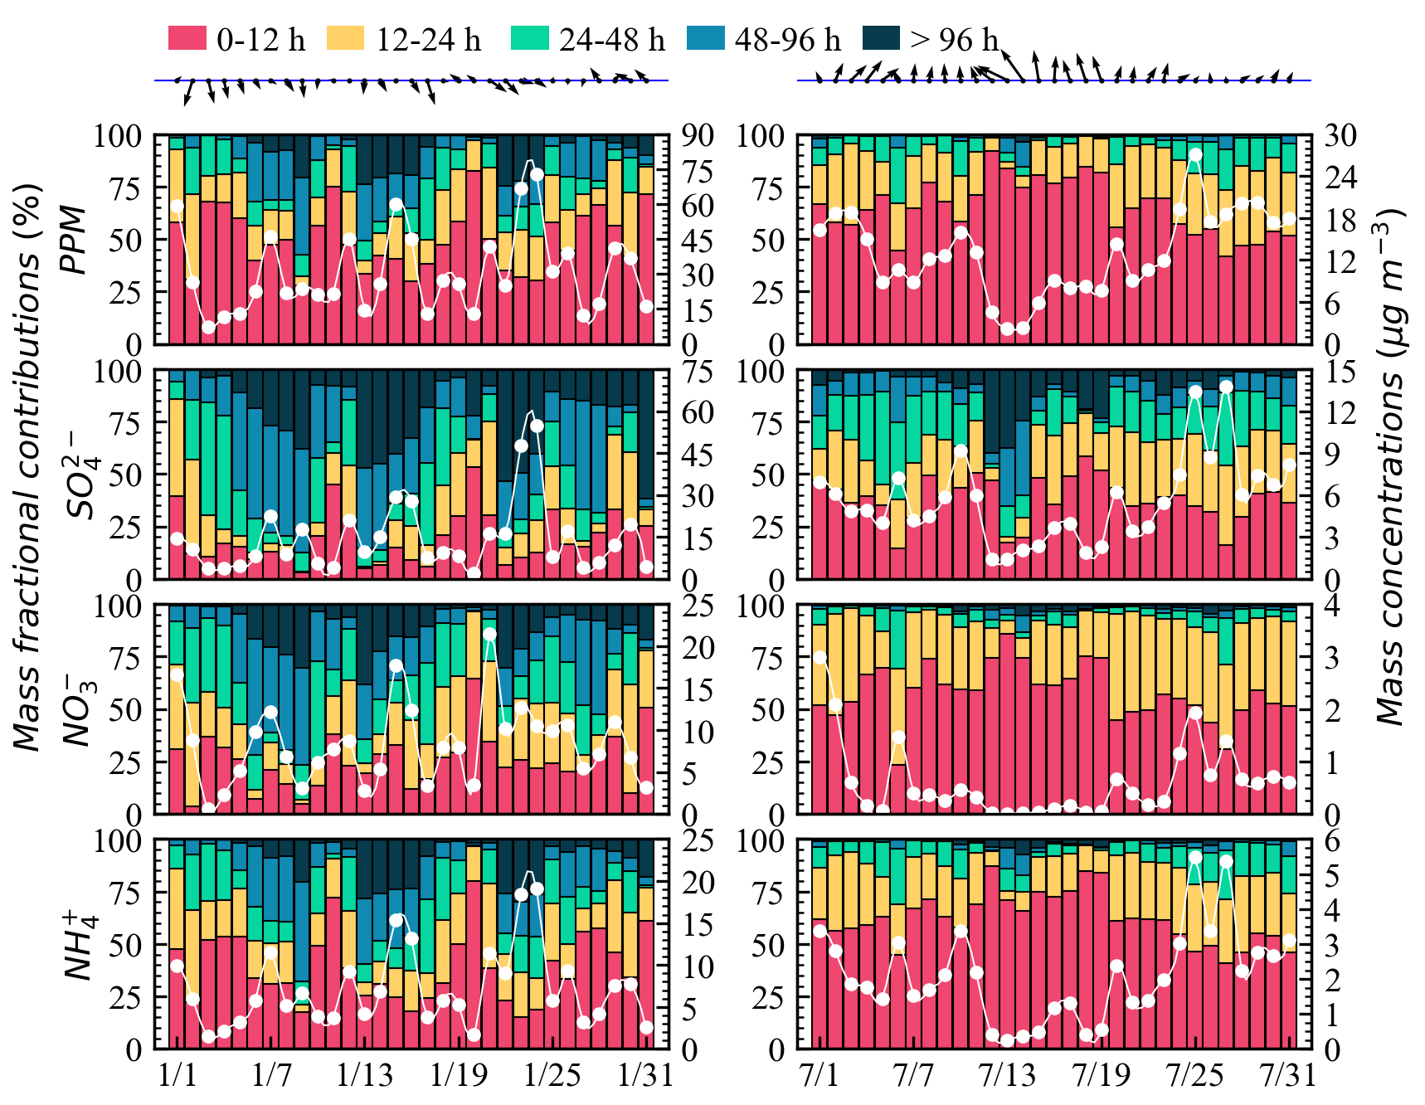
Fig. S13. Temporal variations of atmospheric age distribution in January (left column) and July (right column) at Shanghai. White lines indicate the total concentrations (µg m⁻³, right y-axis). Daily wind vectors are also shown at the top of each column.
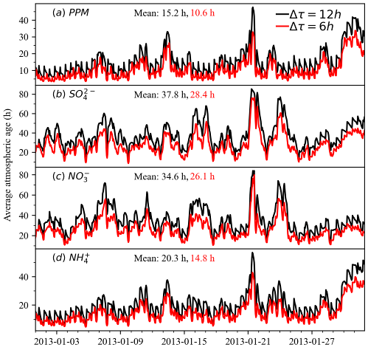
Fig. S14. Average atmospheric age of PPM, sulfate, nitrate, and ammonium in Beijing during January 2013 based on simulations with different age bin advance intervals.

