Supporting Information for

A CO₂/N₂-Responsive Pickering Emulsion Stabilized by Novel Switchable Surface-Active Alumina Nanoparticles
An Chen ^{a,b}, Duo Wang ^{b}, Jingsi Chen ^{b}, Jianhong Xu ^{a,}*, Hongbo Zeng ^{b,}*
ª State Key Laboratory of Chemical Engineering, Department of Chemical Engineering, Tsinghua University, Beijing 100084, China
^{b} Department of Chemical and Materials Engineering, University of Alberta, Edmonton, AB, T6G 1H9, Canada

* Corresponding authors.
E-mail addresses: xujianhong@tsinghua.edu.cn (J. Xu), hongbo.zeng@ualberta.ca (H. Zeng)

Fig. S1. Fourier-transform infrared spectroscopy (FTIR) spectra of superamphiphile [1,2] and precursor components of oleic acid and Jeffamine D-230; (b) enlarged FTIR spectra from 3500 to 3200 cm⁻¹ to show peaks of unreacted –NH₂ groups in the superamphiphile.

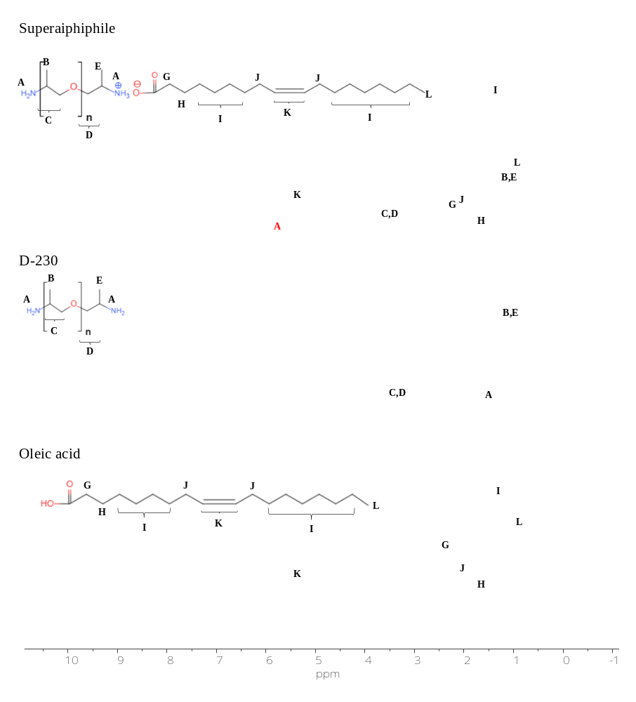
Fig. S2. Proton nuclear magnetic resonance spectroscopy (¹H NMR) spectra of superamphiphile [1,2] and precursor components of oleic acid and Jeffamine D-230 in CDCl₃.
Fig. S3. Size distribution of 0.1 wt% alumina nanoparticles dispersed ultrasonically in deionized water at 25 ℃.

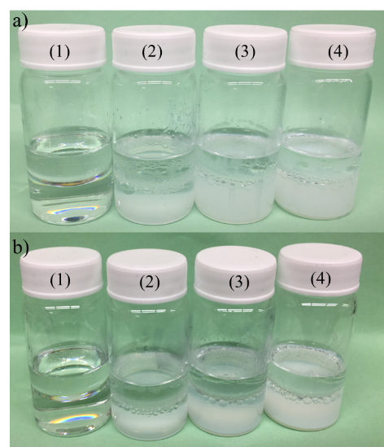
Fig. S4. Pictures of oil-in-water (O/W) Pickering emulsions with different concentrations of alumina nanoparticles at aging time of (a) 24 h and (b) 10 days. The alumina nanoparticles concentrations from (1) to (4) are 0, 0.1, 0.5, and 1.0 wt%, respectively.

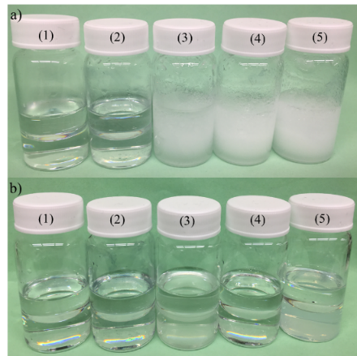
Fig. S5. Pictures of O/W emulsions with different concentrations of superamphiphiles at aging time of (a) 24 h and (b) 10 days. The superamphiphile concentrations from (1) to (5) are 0.1, 0.2, 0.3, 0.6, and 1.0 mmol∙L⁻¹, respectively.
References
[1] Xu P, Wang Z, Xu Z, Hao J, Sun D. Highly effective emulsification/demulsification with a CO₂-switchable superamphiphile. J Colloid Interface Sci 2016;480:198‒204.
[2] Chen X, Ma X, Yan C, Sun D, Yeung T, Xu Z. CO₂-responsive O/W microemulsions prepared using a switchable superamphiphile assembled by electrostatic interactions. J Colloid Interface Sci 2019;534:595‒604.

