Supplementary Materials

A Soft Tactile Unit with Three-Dimensional Force and Temperature Mathematical Decoupling Ability for Robots
Xiong Yang ª, Hao Ren ^{b}, Dong Guo ^{b}, Zhengrong Ling ª, Tieshan Zhang ^{b}, Gen Li ^{b}, Yifeng Tang^{b}, Haoxiang Zhao ª, Jiale Wang ª, Hongyuan Chang ª, Gao Tsz Ki ª, Jia Dong ª, Wu Ningxin ª, Yajing Shen ^{a,c,*}
ª Department of Electronic and Computer Engineering, The Hong Kong University of Science and Technology, Hong Kong 999077, China
^{b} Department of Biomedical Engineering, City University of Hong Kong, Hong Kong 999077, China
^{c} Center for Smart Manufacturing, The Hong Kong University of Science and Technology, Hong Kong 999077, China
Corresponding author.
E-mail address: eeyajing@ust.hk (Y. Shen)

This Supporting Materials including：
Section S1: Challenges in 3D force and temperature decoupling
Section S2: Architecture of F³T sensing unit
Section S3: Ion gel temperature sensing layer insensitive to external forces
Section S4: Floating-Mountain capacitance normal force sensing layer insensitive to temperature and tangential force
Section S5: Mathematical modeling of temperature sensing layer
Section S6: Mathematical modeling of normal force sensing layer
Section S7: Mathematical modeling of tangential force sensing layer
Section S8: The calculation of the tangential force orientation
Figure S1 The physical appearance of F³T sensing unit
Figure S2 The principle of F³T multi-signal sensing and decoupling relationships
Figure S3 The floating mountain capacitor structure used for normal force measurement can eliminate interference from tangential forces
Figure S4 The cycling test of the sensor in force sensing mode
Figure S5 The magnetic field distribution along the radius of the coaxial Halbach magnetic film.
Figure S6 The relationship between tangential force and tangential magnetic field strength under different normal force conditions
Figure S7 The relationship between the direction of the tangential force and the arctangent function of the tangential magnetic field before correction of the quadrant
Figure S8 The dynamic recovery time of F³T sensing unit
Figure S9 The ion gel temperature sensing layer monitors temperature change trends using a low-frequency acquisition mode
Figure S10 The ion gel temperature sensing layer before encapsuling responds rapidly to small temperature fluctuations under a high-frequency acquisition mode
Figure S11 The performance of the ion gel temperature sensing layer over 50 cycles within the measurement range 30-80 ℃
Figure S12. Stable force measurement in different humidity environments

Supporting Videos:
Video S1 Demonstration of F³T for automated chemical reaction procedure
Video S2 Demonstration of F³T for effective human-robot cooperation

Section S1: Challenges in 3D force and temperature decoupling
Despite recent advances in soft tactile sensor, a significant challenge remains in decoding normal force and omnidirectional tangential force using a single soft sensing unit due to signal coupling and interference. This challenge is exacerbated when considering temperature effects. Electrical signal-based force measurement methods, such as piezoelectric, capacitive and resistive, offer high sensitivity and scalability but struggle to distinguish force direction due to symmetrical response or single axis sensitivity. While multidimensional force can be measured by integrating multiple units in different directions, this approach significantly decreases sensor accuracy and stability, adding structure complex and high costs. Optical field measurement principles can achieve omnidirectional force sensing with high resolution but are sensitive to environmental noise and require complex structures and substantial computing resources. Magnetic fields naturally provide three-dimensional spatial signals, offering potential for representing forces in 3D. However, the mapping from magnetic field to force is often nonlinear and non-unique, complicating force calculation and reducing accuracy.

Section S2: Architecture of F³T sensing unit
Human skin consists of three layers, i.e., the epidermis, dermis, and hypodermis, and contains various receptors that allow humans to sense their environment, such as pressure, temperature, and pain. Inspired by that, we proposed the multi-layered flexible sensing unit with three types of receptors for decoupled normal force, full-directional tangential force and temperature sensing. Similar with human skin, the sensing unit mainly including three parts, i.e. ion gel based temperature sensing layer, capacitor based normal force sensing layer and magnetic field based tangential force sensing layer. By microfabrication and molding, all these functions are successfully integrated into a compact cylindrical unit with a radius of 6 mm and a height of 8 mm.
For each sensing unit, the temperature layer (thickness 1 mm) is fabricated with ion gel by molding and followed by curing under UV light. During which, porous mesh fabric is added for mechanical property enhancing and cyanoacrylate is adopted for encapsulation to keep sensing stability. The tangential force sensing layer contains a magnetic film (thickness 0.5 mm) under the temperature sensing layer and a hall sensor (thickness 0.5 mm) at the bottom PCB board (thickness 1 mm). The fabrication of circular Halbach pattern magnetic film is the key for full-directional tangential force sensing. We first fabricate a rectangular magnetic film with common Halbach array magnetization by conventional method, e.g. magnetization to the mixture of polydimethylsiloxane (PDMS) and neodymium (NdFeB) magnetic powders. Then, we use laser to cut it into small isosceles triangles according to the required magnetization pattern. Finally, an approximate circular Halbach magnetic film with ring magnetization can be assembled by these isosceles triangles. The normal force sensing layer (thickness 5 mm) is between the magnetic film and PCB board. To ensure the whole deformation and displacement of magnetic film when external tangential force is applied, we adopt the silicone elastomer as main body materials of the normal force sensing layer. Here, four circular electrodes with different sizes are embedded with a gap of 1 mm by repeating molding to form the normal force sensing capacitance. The diameters of the electrodes decrease from bottom to up, measuring 9 mm, 7.5 mm, 6 mm, and 4.5 mm, respectively. A silicone elastomer containing phosphate ions serves as the medium between the electrodes, molded to fit precisely. The signals from the temperature sensing layer, hall sensor and normal force layer are connected to the MCU by circuits on PCB. By monitoring the resistance, magnetic field and capacitance change, we can get the temperature, tangential force and normal force information accordingly.

Section S3: Ion gel temperature sensing layer insensitive to external forces
For temperature measurement, we utilize the temperature-sensitive properties of ion gels. Typically, ion gels contain two types of ions: non-free ions, which are bound and immobilized within polymer chains, and free ions that are unbound. When voltage is applied across the ends of the gel, the free ions move in response to the electric field, generating an electrical current. The greater the number of free ions, the lower the resistance exhibited by the gel to the external circuit. As temperature increases, the distance between polymer chains within the gel increases, leading to the conversion of more non-free ions into free ions. Ultimately, this results in the temperature-sensitive property of the gel, where its resistance decreases with increasing temperature.
Using an equivalent voltage divider circuit, we investigate the relationship between temperature and the current within the gel. In contrast to traditional temperature-sensitive materials, the apparent resistance of ion gel is solely related to the quantity of free ions within it and remains insensitive to external pressure or deformation. This property is advantageous for decoupled measurements of temperature and force, as confirmed in our comparative experiments. We recorded temperature measurements with and without a load (10N). As the environmental temperature increased from 20 to 80 ℃, the ratio of temperatures measured under the two conditions consistently remained between 0.99 and 1.01.
Furthermore, we validated the sensitivity and stability of ion gel in temperature measurement. Supporting Materials Fig. S7 and Fig. S8 represent the changes in current within the gel (before encapsulation) during slow and rapid temperature variations, respectively. The trends in both cases are nearly identical. Before encapsuling, temperature sensing has a quick response to small temperature fluctuations, while it increase to dozen seconds after encapsuling due to low heat transfer efficiency. Although the current sensing unit has some delay in temperature measurement, it already meets the needs of most robotic operations. For applications requiring high temporal accuracy in temperature measurements, we can incorporate predictive algorithms based on the rate of temperature change. This approach allows for faster response times by mitigating delays through estimation. In the revised version, we have added this discussion in the supplementary materials. Supporting Materials Fig. S9 demonstrates the repeatability of temperature sensing. After 50 cycles, the current change range within the ion gel showed almost no decay.

Section S4: Floating-Mountain capacitance normal force sensing layer insensitive to temperature and tangential force
The measurement of normal force is based on changes in capacitance. To mitigate the influence of tangential forces, we have devised a novel floating-mountain multi-layer structure. The capacitor consists of two sets of positively and negatively charged electrodes with varying lengths, decreasing progressively from top to bottom. When subjected to tangential forces, the electrodes undergo displacement within the horizontal plane. Thanks to the floating-mountain structural design, the effective area of the capacitor remains constant within the operational range. Therefore, the measurement of this capacitor in normal direction can be independent of tangential forces. On the other hand, when subjected to normal pressure, the distance between the electrodes decreases, leading to an increase in capacitance. Consequently, by measuring the capacitance value, normal displacement and force can be correspondingly calculated.
To facilitate capacitance measurement, we employ a NE555 timer IC circuit to transform capacitance measurement into frequency measurement. The relationship between capacitance and output frequency is as follows:
$f=\frac{1}{ln(2)∙C∙(R_{1}+{2R}_{2})}$ (S1)
Where f represents the output frequency, $R_{1}$and $R_{2}$ denotes the resistance in the circuit, and C signifies the capacitance. This method enables us to accurately measure capacitance values and, consequently, normal forces while effectively decoupling them from tangential forces.
Through characterization, we can establish the relationship between normal displacement and output frequency (Fig. 3d) as well as the relationship between normal force and output frequency (Fig. 3e). Furthermore, we have validated the independence of the floating-mountain multi-layered capacitor from tangential forces. As depicted in Fig. 3f, when we maintain a constant normal force while gradually increasing the tangential force from 0 to 2 N, the measured normal force remains stable. This demonstrates the independence and decoupling of normal force from tangential force, confirming the effectiveness of our design in isolating these two force components.

Section S5: Mathematical modeling of temperature sensing layer
The measurement of temperature is detected through the current of the ion gel layer. Under a constant voltage, the current is a variable that depends only on temperature and is independent of external loads. Therefore, the relationship between the temperature T and the output current I at that temperature can be expressed as $T=f\left(I\right)=f(U/Rt)$. where U is the constant voltage and Rt is the equivalent resistance of the ion gel at temperature T. Since the resistance Rt and temperature T are in a one-to-one correspondence, there is also a one-to-one relationship between the temperature T and the output current I. By fitting the data from 10 measurements within the temperature range of 20°C to 80°C, the relationship between the current and temperature can be obtained as:
$I=A1×\exp\left(\frac{T}{A2}\right)+A3$ (S2)
Where $A1=0.32326±0.02089$, $A2=21.54061±0.36867$, $A3=0.53554±0.073$ and the Coefficient of determination is 0.9986.

Section S6: Mathematical modeling of normal force sensing layer
The measurement of normal force is achieved by detecting the frequency signal corresponding to the capacitance value. The relationship between the capacitance value and directional displacement can be expressed as:
$C=\frac{εr∙ic∙s}{4πk(H-∆H)∙cte}$ (S3)
Where $εr$ is the relative dielectric constant, ic is the ionization coefficient which is related to temperature T, S is capacitor plate effective area, k is the electrostatic constant, H means the distance of capacitor plate, $∆H$ is the normal displacement change. By adjusting the ion content of the dielectric material, the effects of temperature on the ionization coefficient and expansion coefficient can be mutually offset. Therefore, for the sensing unit, changes in the capacitance value are only related to normal displacement. The relationship between normal force and normal displacement can be expressed as:
$Fz=A∙E∙\frac{∆H}{H}$ (S4)
After substituting Equation S1, the corresponding relationship between the normal force and the frequency signal can be obtained as:
$Fz=AE-\frac{AE∙εr∙s∙ln⁡(2)∙(R_{1}+2R_{2})}{4πkH}f$ (S5)
After characterizing the normal force, it was found that the slope of the frequency change varies across different force ranges. This behavior reflects changes in the apparent stiffness due to different deformation regimes: initially elastic at small deformations and more complex responses at larger deformations, due to geometric effects, contact conditions, or changes in internal structure.

Section S7: Mathematical modeling of tangential force sensing layer
The magnetic flux distribution on the Hall sensor is generated by the magnetic film and is correlated to the deformation of the soft elastic layer caused by either tangential or normal force. Additionally, the measurement accuracy of the Hall sensor’s magnetic field is affected by temperature changes. Thus, the initially measured magnetic field can be represented as $M=f(T, Fz, Fx,Fy)$ (Fig. 2d). For the circular coaxial Halbach magnetic film, its tangential magnetic field distribution M_{r} can be expressed as:
$M_{r}=M_{0}（T,F_{z}）sin（k\sqrt{{∆x}^{2}+{∆y}^{2}}）$ (S6)
where $M_{0}(T,F_{z})$ is the tangential magnetic field strength amplitude as a function of temperature T and normal force Fz. In the previous step, the temperature T₀ and normal force F_{z0} were obtained independently through ion gel and floating capacitor. These values can then be substituted into Equation (S6) to obtain the distribution of the tangential magnetic field M_{r} with displacement $∆x$ and $∆y$ under specific conditions of temperature T₀ and normal force F_{z0}. Since the displacement in the x and y directions can be directly converted into tangential force Fx and Fy using shear strain $γ$ and shear modulus G, the relationship between tangential force F_{x}, F_{y} and the tangential magnetic field M_{r} can be uniquely determined:
$F_{x}=S∙(G∙ γ_{x})=S∙G∙\frac{f(M_{r})}{h}cosθ_{r}$ (S7)
$F_{y}=S∙(G∙ γ_{y})=S∙G∙\frac{f(M_{r})}{h}sinθ_{r}$ (S8)

Section S8: The calculation of the tangential force orientation
The directional sensitivity of the magnetic field makes it highly suitable for measuring tangential forces in any direction. Unlike other magnetic field-based sensor designs, the soft magnetic film we employ features a circular pattern with a coaxial Halbach array magnetization. As illustrated in the magnetic field simulation results in Fig. 3g, this unique magnetization pattern creates a spatial distribution of the magnetic field that resembles a coaxial sinusoidal pattern on one side. Thanks to this distinctive magnetization pattern, when a tangential external force acts on the sensor, the direction of the tangential force can be determined by measuring the direction of the magnetic field. Furthermore, the one-sided distribution of the magnetic field can mitigate the influence of external magnetic materials on the sensor's measurements, making the measurement results more stable and accurate compared to sensors using conventional magnetic films.
The direction of the tangential force is correlated with the direction of the tangential magnetic field. As depicted in Supporting Materials Fig. S6, the arctan of the ratio of By and Bx is related to the direction of the tangential force. It can be observed that they do not have a one-to-one correspondence due to the presence of both positive and negative values in the magnetic field direction. By correcting the signs of the tangential magnetic fields in the x and y directions, a completely linear angle relationship can be obtained (Fig. 3j). Furthermore, we can conclude that the direction of the tangential force is independent of the normal pressure and the magnitude of the tangential force (Fig. 3k), which also aligns with practical observations.

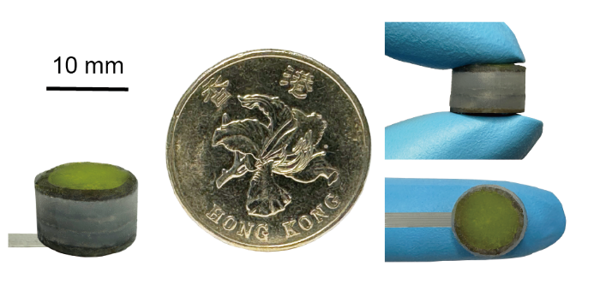
Figure S1. The physical appearance of F³T sensing unit. This unit is comparable in size to a human fingertip, making it easy to integrate into existing dexterous fingertips.

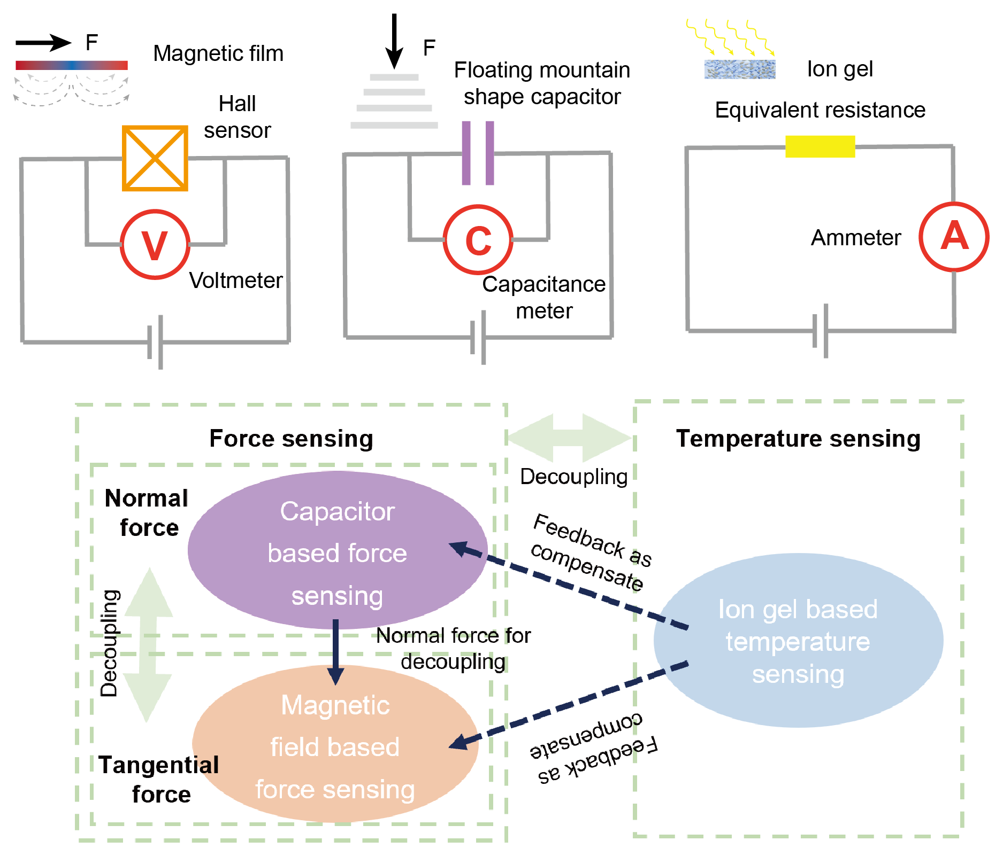
Figure S2. The principle of F³T multi-signal sensing and decoupling relationships. This mainly includes the normal force measurement unit, the omnidirectional shear force measurement unit, and the temperature sensing unit.

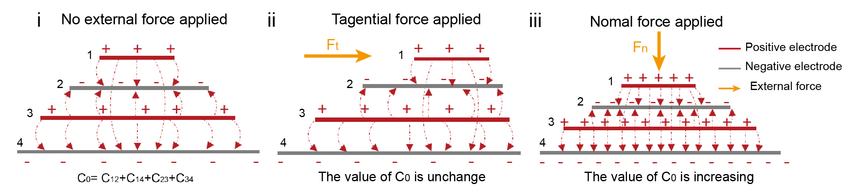
Figure S3. The floating mountain capacitor structure used for normal force measurement can eliminate interference from tangential forces.

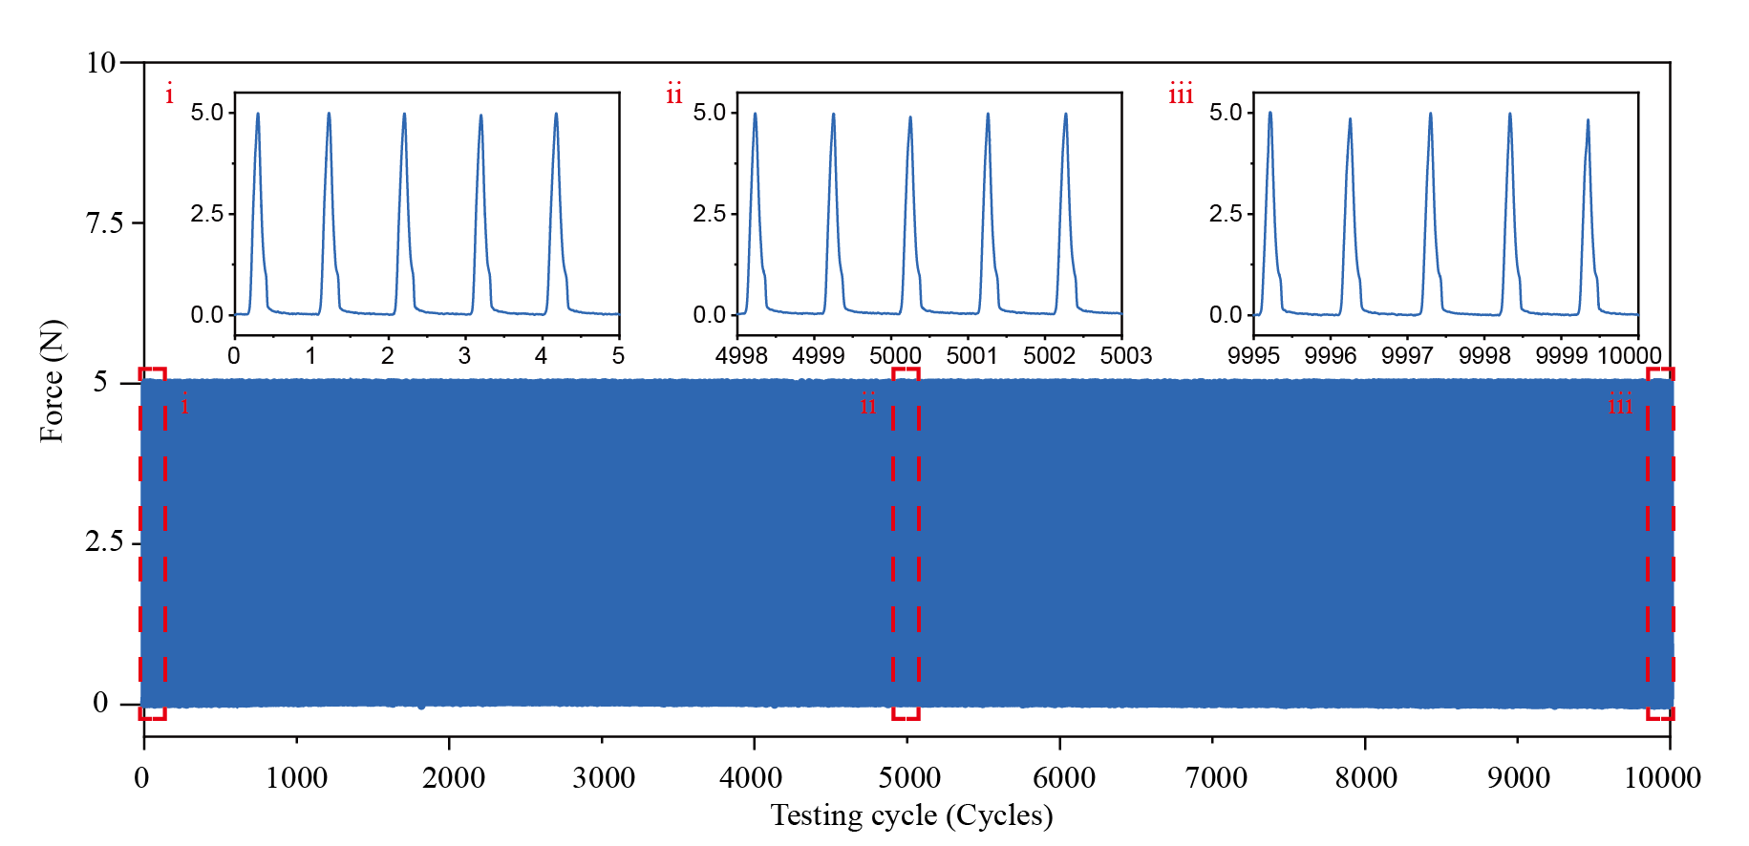
Figure S4. The cycling test of the sensor in force sensing mode.

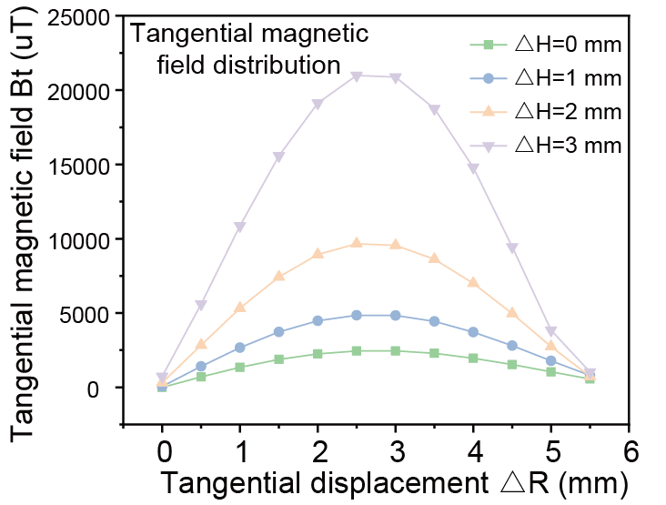
Figure S5. The magnetic field distribution along the radius of the coaxial Halbach magnetic film.

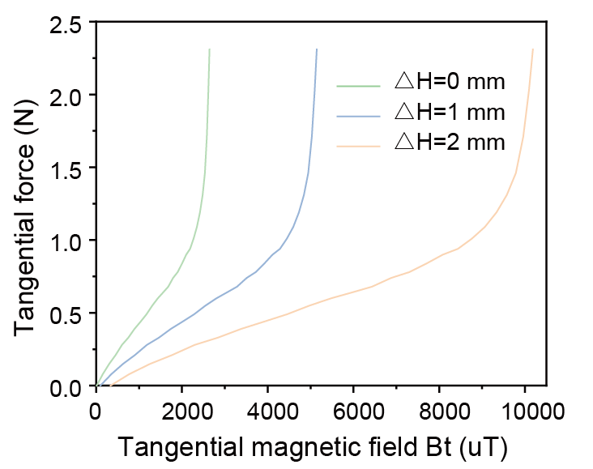
Figure S6. The relationship between tangential force and tangential magnetic field strength under different normal force conditions.
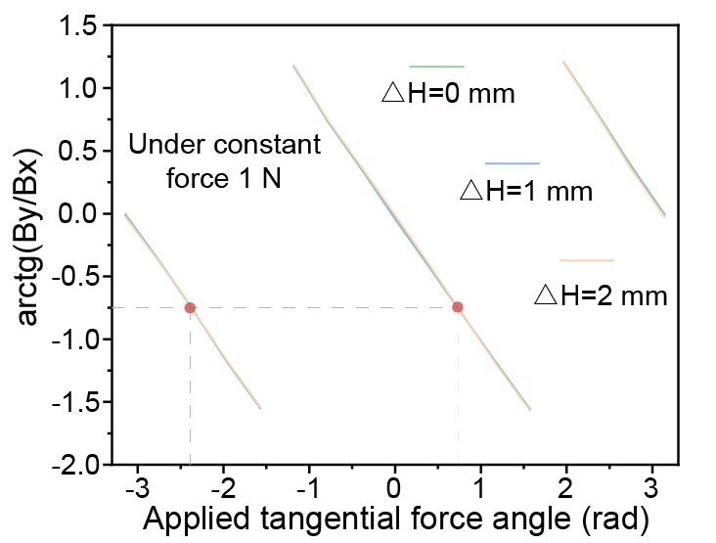
Figure S7. The relationship between the direction of the tangential force and the arctangent function of the tangential magnetic field before correction of the quadrant

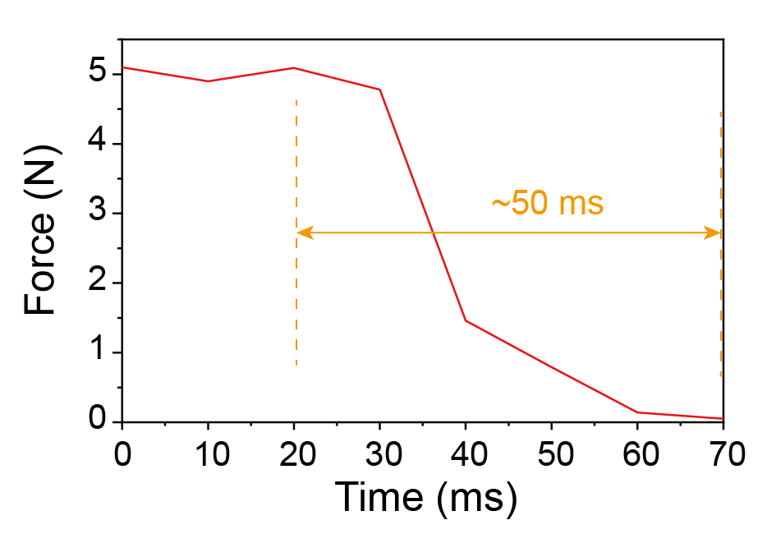
Figure S8. The dynamic recovery time of F³T sensing unit.

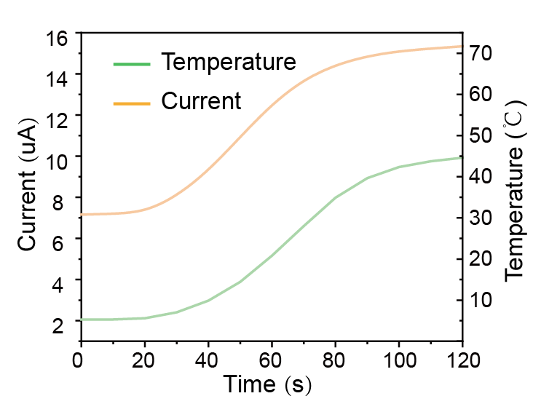
Figure S9. The ion gel temperature sensing layer monitors temperature change trends using a low-frequency acquisition mode.

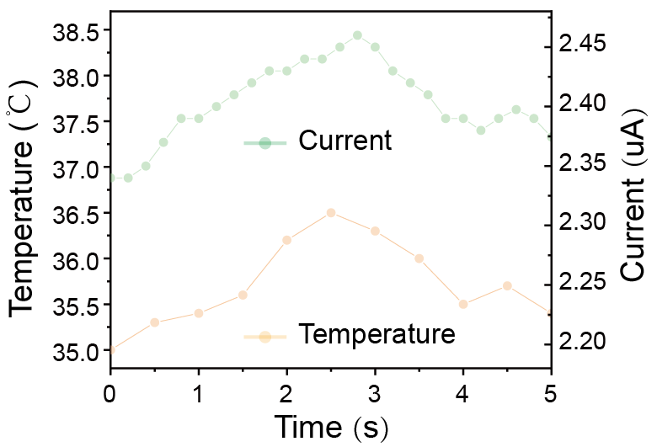
Figure S10. The ion gel temperature sensing layer before encapsuling responds rapidly to small temperature fluctuations under a high-frequency acquisition mode.

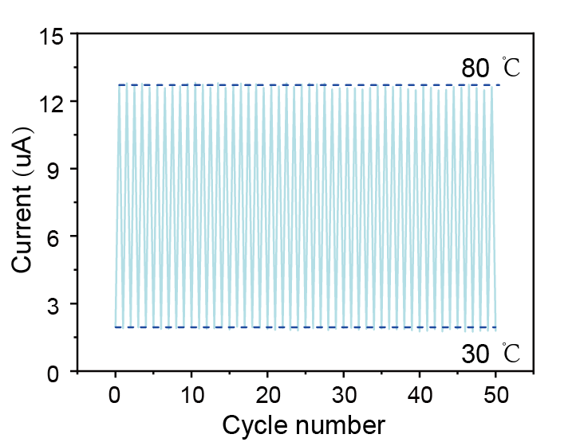
Figure S11. The performance of the ion gel temperature sensing layer over 50 cycles within the measurement range 30-80 ℃.

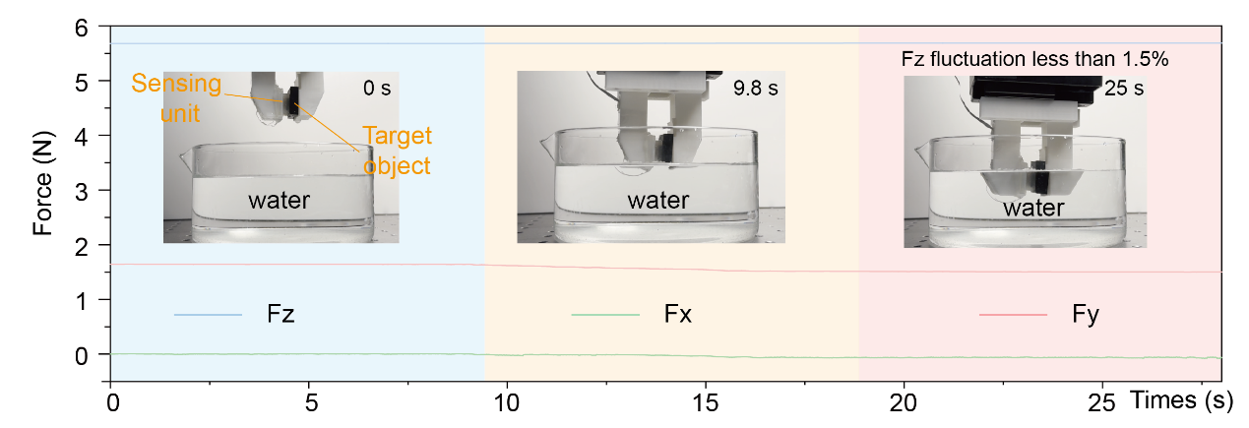
Figure S12. Stable force measurement in different humidity environments.

