Supplementary materials for
An Automatic Damage Detection Method Based on Adaptive Theory-Assisted Reinforcement Learning
Chengwen Zhang ^{a,b}, Qing Chun ^{a,b,}*, Yijie Lin ª
ª School of Architecture, Southeast University, Nanjing 210096, China
^{b} Key Lab of Urban & Architectural Heritage Conservation, Ministry of Education, Southeast University, Nanjing 210096, China

* Corresponding author.
E-mail address: cqnj1979@163.com (Q. Chun).

Section 1: Theory of sensitivity-based model updating
First, the damage reduction coefficients of the components at time T are denoted as $γ_{T}$. The dynamic equation considering the damage distribution can be expressed as Eq. (S1).
$$\begin{matrix}M_{d}\ddot{x}+C_{d}\dot{x}+K_{d}x=P_{f}, & C_{d}=β_{m}M_{d}+β_{k}K_{d}\end{matrix},M_{d}=\sum_{n_{e}=1}^{n_{E}}{\left(\left(1-γ_{T,n_{e}}\right)M_{n_{e},0}\right), }$$
$K_{d}=\sum_{n_{e}=1}^{n_{E}}{\left((1-γ_{T,n_{e}})K_{n_{e},0}\right)}$ (S1)
where $M_{d}$ and $K_{d}$ represent the matrix of mass and stiffness. $M_{n_{e},0}$ and $K_{n_{e},0}$ represent the matrix of mass and stiffness parameters for $n_{e}$th component without damage. $C_{d}$ is the damping matrix, and $β_{m}$, $β_{k}$ are the Rayleigh damping constants. $\ddot{x}$, $\dot{x}$, and $x$ are the acceleration, velocity, and displacement, respectively. $n_{E}$ is the total number of components to be detected. $P_{f}$ is the load vector. $n_{e}$ is the serial number of the parameters.
Decoupling Eq. (S1) to the modal space yields Eq. (S2):
$\ddot{q}+2ζ_{c}ω\dot{q}+ω^{2}q=Φ^{T}P_{f}$ (S2)
where $\ddot{q}$, $\dot{q}$ and $q$ are the modal acceleration, modal velocity, and modal displacement, respectively. $Φ$is the modal shape matrix, $ζ_{c}$ is a diagonal matrix of the damping ratio, and $ω$ is a natural frequency diagonal matrix. Therefore, the calculated modal parameters $Y_{T,cal}\left(γ_{T}\right)=\left[ω\left(γ_{T}\right),Φ\left(γ_{T}\right)\right]$ can be considered to be related to the damage vector $γ_{T}$. $ω\left(γ_{T}\right)$ or $Φ\left(γ_{T}\right)$ represent $ω$ or $Φ$ changing with $γ_{T}$.
At time T, based on the monitoring data from the onsite sensor, the test modal parameters $Y_{T,test}$ can be identified. Then, the error vectors of the calculation and test modal parameters at time T can be recorded as $W_{T}\left(γ_{T}\right)=Y_{T,test}-Y_{T,cal}\left(γ_{T}\right)$. Eq. (S3) can be obtained according to Newton’s method and Taylor’s theorem. The subscript p means the pth iteration step.
$\begin{matrix}Y_{T,test}=Y_{T,cal}\left(γ_{T,0}\right)+F_{T}\left(γ_{T,0}\right)Δγ_{T,1}+…+F_{T}\left(γ_{T,p-1}\right)Δγ_{T,p}+⋯ \\ γ_{T,p}=γ_{T,0}+\sum_{k=1}^{p-1}{Δγ_{T,k}}, { γ}_{T,0}=γ_{T-1}, Δγ_{T}=γ_{T}-γ_{T-1}\end{matrix}$ (S3)
where${ γ}_{T,0}$, $γ_{T,p-1}$ and $γ_{T,p}$ are the damage vector in initial, (p-1)th and pth iteration step at time T, respectively. $F_{T}$is the sensitivity matrix of $W_{T}$ with respect to $γ_{T}$ at time T. $Δγ_{T,1}$ and $Δγ_{T,p}$ are the damage increment vector in the first and pth iteration step at time T, respectively. $γ_{T-1}$ means the final damage vector at time T-1. The (p+1)th residual iteration formula $J\left(Δγ_{T,p+1}\right)$ can be written as Eq. (S4). The symbol ${\left\|·\right\|}_{2}$ represents the 2-norm.
$J\left(Δγ_{T,p+1}\right)={\left\|F_{T}(γ_{T,p})Δγ_{T,p+1}-W_{T}\left(γ_{T,p}\right)\right\|}_{2}$ (S4)
The stationary point of Eq. (S4) can be solved to determine the expression of the $Δγ_{T,p+1}$, as shown in Eq. (S5), which is also Eq. (1) in Section 2 of the main text.
$Δγ_{T,p+1}={\left(F_{T}^{H}\left(γ_{T,p}\right)F_{T}\left(γ_{T,p}\right)\right)}^{-1}F_{T}^{H}\left(γ_{T,p}\right)W_{T}\left(γ_{T,p}\right)$ (S5)
By iterating using Eq. (S5), $W_{T}\left(γ_{T}\right)$can decrease, which means that $Y_{T,cal}\left(γ_{T}\right)$ approaches $Y_{T,test}$. The final output at this time is $γ_{T}$, which is the damage array. More details about the algorithm and the related calculation process of the L-curve method are provided in the literature [12,13].

Section 2: Flow chart of the TA2-MATD3 algorithm
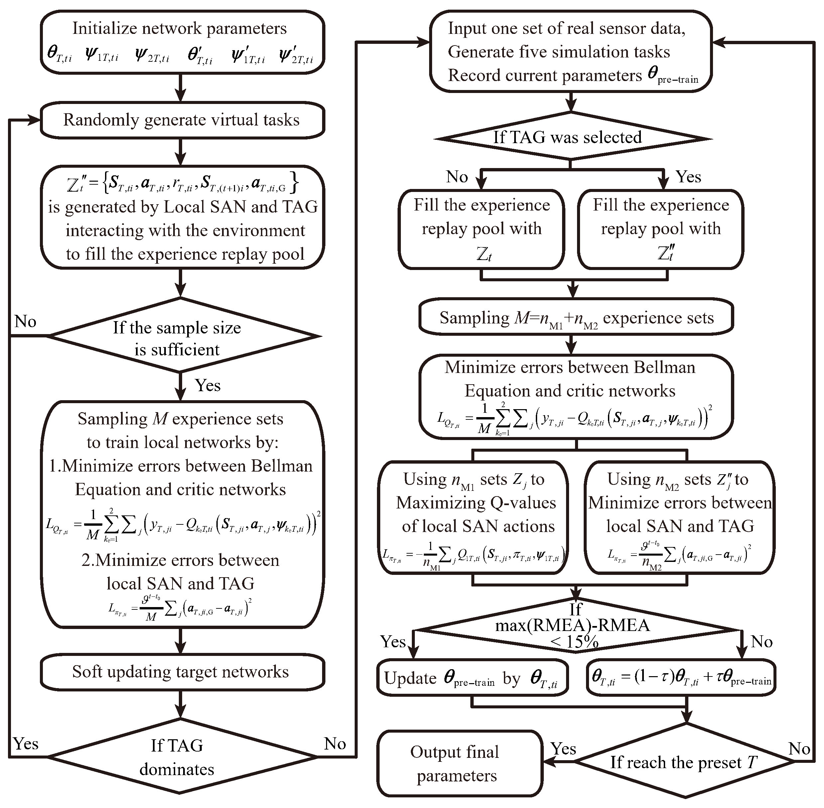
Fig. S1. Flow chart of the TA2-MATD3 algorithm.

Section 3: Analysis of hyperparameters in the model
The main hyperparameters of reinforcement learning can be divided into two categories. Hyperparameters of the first type determine the architecture of the network, and in this paper include Hyperparameters such as the structure of residual blocks, the number of residual block layers, activation functions, the number of hidden layer layers, and the number of neurons. An increasing number of studies have shown [55‒57] that ensuring sufficient fitting ability of network structures is always beneficial for the final results. Potential overfitting issues can be addressed through other hyperparameters or the introduction of corresponding mechanisms. Therefore, in this paper, the hyperparameters related to the network architecture were set as shown in Section 3.3 of the main text, taking into account the device’s memory and computing power.
Hyperparameters of the second type include the learning rate, soft update coefficient, etc., which are discussed below. First, the maximum number of explorations of each episode can be estimated using the theoretical model described in Section 1. For the same damage detection task, the maximum allowed number of actions by the final trained intelligent agent can be taken as 1–2 times the number of iterations required for the theoretical solution. Thus, when the agent is not trained sufficiently in the early stages, it will be forced to perform explorations for a specified number of times, and after being better trained in the later stages, it can often complete exploration ahead of schedule. Second, the hyperparameter batch size should be as large as possible to ensure optimization efficiency [58]. However, larger batch sizes require stronger equipment support. In Section 2.3 of the main text, an adaptive experience replay mechanism is introduced to help smaller batch sizes work. Furthermore, according to the Bellman equations (Eqs. (2) and (6)), the hyperparameter-discount rate reflects the potential impact of future actions. Therefore, this hyperparameter is related to the total exploration steps of the intelligent agent, which can be set to 0.95 in this paper.
Finally, parameter analysis is conducted on the remaining hyperparameters, such as the learning rate of the action network, the learning rate of the critic network, the soft update coefficient, and the maximum exploration noise, to verify the robustness and noise resistance of the proposed algorithm. In the calculations, to balance the calculation accuracy and calculation cost, the training is terminated if the network either converges or reaches the maximum number of iterations (set to 1 000 000). Dataset A is used to test network performance. Each time a hyperparameter is modified, the other hyperparameters remain unchanged, and 10 different seeds are used to repeat the training. After removing significant outliers, the box plot results are shown in Fig. S2.
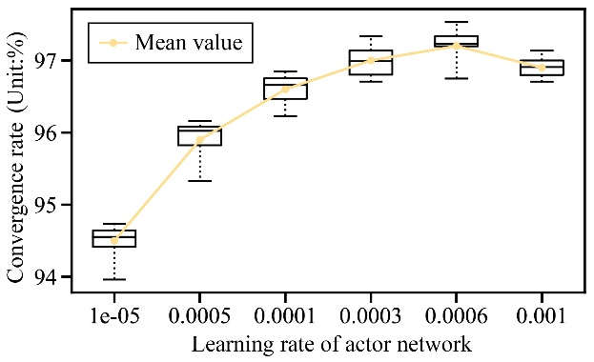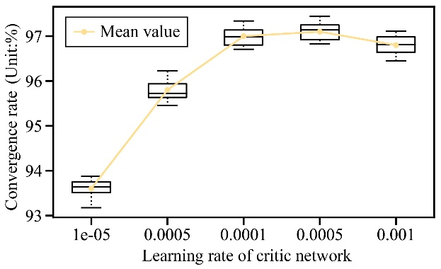
(a) (b)
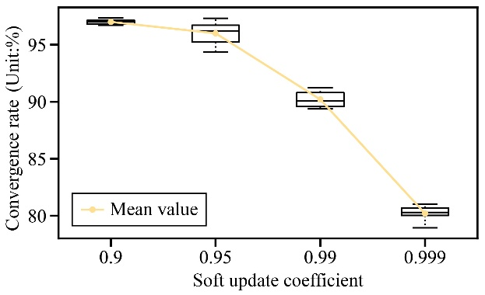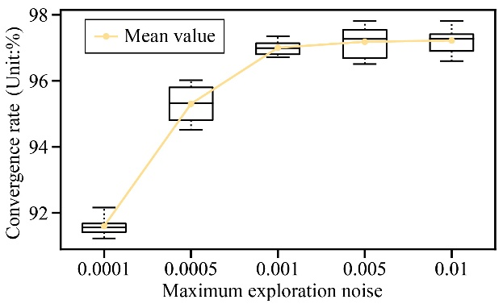
(c) (d)
Fig. S2. Parameter analysis of hyperparameters. (a) Learning rate of the action network; (b) learning rate of the critic network; (c) soft update coefficient; (d) maximum exploration noise
Figs. S2(a) and (b) indicate that due to the introduction of the warm-up mechanism and learning rate decay mechanism in this paper, the final network performance also has good accuracy near the high learning rate. When the learning rate is low, the accuracy decreases because of the network’s inability to fully converge within the specified maximum number of iterations. This phenomenon is also observed in Fig. S2(c) when the soft update coefficient approaches 1, which means that the update rate of the target network decreases. When computing power is limited and the task is relatively simple, it is not recommended to set this parameter to a too high value. Fig. S2(d) shows the impact of the maximum exploration noise on the results. This coefficient represents the exploration noise of the damage increment vector. Since this noise adopts an attenuation mechanism, it can take a slightly larger value. However, some damage increments are significantly sensitive, and excessive exploration noise is not conducive for the agents to learn stable environmental information. Therefore, the maximum exploration value can be taken as 0.1%–1%. In summary, the final hyperparameters were set as shown in Section 3.3 of the main text to ensure overall network performance.

References
[12] Li XY, Law SS. Adaptive Tikhonov regularization for damage detection based on nonlinear model updating. Mech Syst Signal Process 2010;24(6):1646–64.
[13] Zhang CW, Chun Q, Leng JW, Lin YJ, Qian YC, Cao G, et al. Optimal placement method of multi-objective and multi-type sensors for courtyard-style timber historical buildings based on meta-genetic algorithm. Struct Health Monit 2024;23(3):1468–97.
[55] Gotmare A, Shirish Keskar N, Xiong C, Socher R. A closer look at deep learning heuristics: learning rate restarts, warmup and distillation. 2018. arXiv:1810.13243.
[56] Co-Reyes JD, Miao Y, Peng D, Real E, Levine S, Le QV, et al. Evolving reinforcement learning algorithms. 2021. arXiv:2101.03958.
[57] Mnih V, Kavukcuoglu K, Silver D, Graves A, Antonoglou I, Wierstra D, et al. Playing atari with deep reinforcement learning. 2013. arXiv:1312.5602.
[58] Bhatt A, Palenicek D, Belousov B, Argus M, Amiranashvili A, Brox T, et al. CrossQ: batch normalization in deep reinforcement learning for greater sample efficiency and simplicity. 2019. arXiv:1902.05605.

