Supplementary data for
Tumor-Specific CircRNA-Derived Antigen Peptide Identification for Hepatobiliary Tumors
Wenwen Wang ^{a,#}, Lili Ma ^{b,c,#}, Zheng Xing ^{b,c,#}, Tinggan Yuan ^{b,c,d}, Jinxia Bao ^{e,f}, Yanjing Zhu ^{g,h}, Xiaofang Zhao ª, Yan Zhao ^{i}, Yali Zong ^{i}, Yani Zhang ^{i}, Siyun Shen ^{g,h}, Xinyao Qiu ª, Shuai Yang ª, Hongyang Wang ^{a,g,h,}*, Dong Gao ^{c,j,k,}*, Peng Wang ^{b,c,l,}*, Lei Chen ^{a,h,m,}*
ª Fudan University Shanghai Cancer Center, Shanghai 200032, China
^{b} Bio-Med Big Data Center, CAS Key Laboratory of Computational Biology, Shanghai Institute of Nutrition and Health, Chinese Academy of Sciences, Shanghai 200031, China
^{c} University of Chinese Academy of Sciences, Beijing 100049, China
^{d} School of Life Science and Technology, ShanghaiTech University, Shanghai 201210, China
^{e} State Key Laboratory of Pharmaceutical Biotechnology & Model Animal Research Center of Nanjing University and MOE Key Laboratory of Model Animal for Disease Study, Nanjing University, Nanjing 210061, China
^{f} School of Medicine, Nanjing University, Nanjing 210093, China
^{g} The International Cooperation Laboratory on Signal Transduction, Eastern Hepatobiliary Surgery Hospital, Second Military Medical University, Shanghai 200438, China
^{h} National Center for Liver Cancer, Shanghai 200441, China
^{i} Institute of Metabolism and Integrative Biology, Fudan University, Shanghai 200433, China
^{j} State Key Laboratory of Cell Biology & Shanghai Key Laboratory of Molecular Andrology, Center for Excellence in Molecular Cell Science, Chinese Academy of Sciences, Shanghai 200031, China
^{k} Institute for Stem Cell and Regeneration, Chinese Academy of Sciences, Beijing 100101, China
^{l} Faculty of Health Sciences, University of Macau, Macao 999078, China
^{m} Key Laboratory of Signaling Regulation and Targeting Therapy of Liver Cancer (SMMU), Ministry of Education & Shanghai Key Laboratory of Hepatobiliary Tumor Biology (EHBH), Eastern Hepatobiliary Surgery Hospital, Second Military Medical University, Shanghai 200438, China

Table S1
Clinical characteristics information of 27 patients.
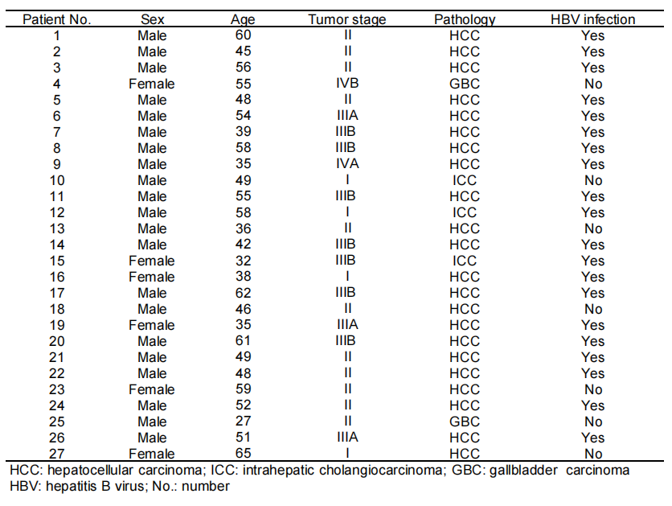
Table S2
HLA-A, -B, and -C information of peripheral blood mononuclear cells (PBMCs), tissues, organoids, and matched healthy PBMCs.
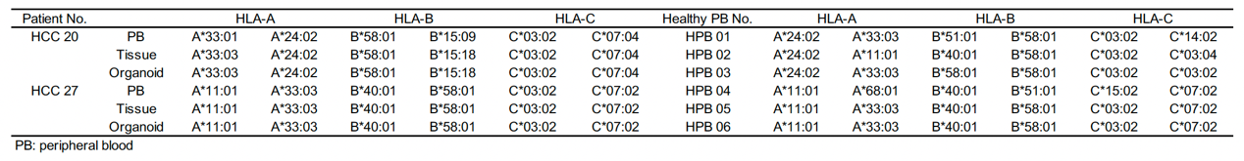

Fig. S1. Peptides detected with MS. HLA-ABC-presented peptides confirmed with mass spectrometry for validation experiments.

Table S3
Selected peptides for validation experiments.
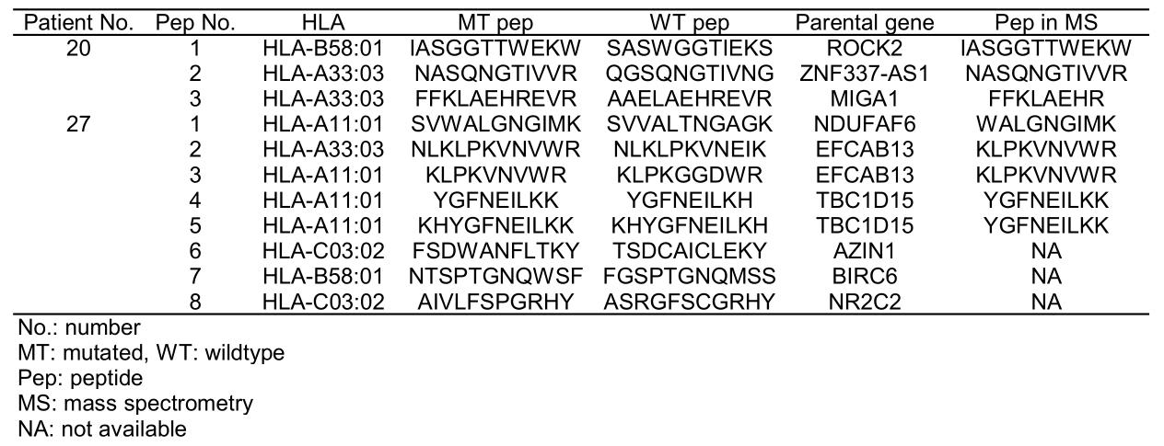

Table S4
Immunogenic potential-related scores of peptides selected for validation experiments.
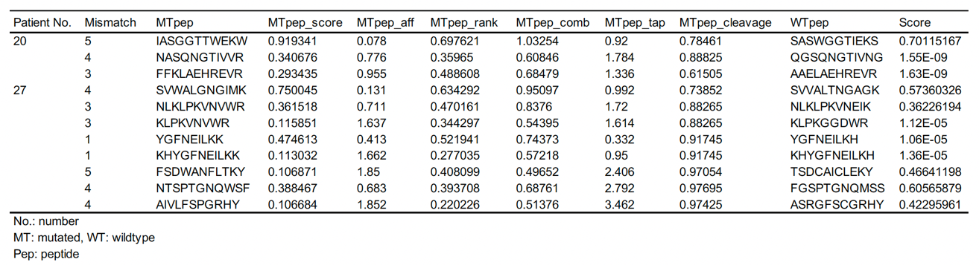

Fig. S2. Immunogenicity of peptides analyzed by CD107a⁺IFNγ⁺ expressions of peptide-reactive T cells. DMSO stimulation was used as control and the detailed fold changes of CD107a⁺IFNγ⁺ co-expressions of CD3⁺CD8⁺ T cells after three cycles of each peptide stimulation were shown.

Table S5
CD107a⁺IFNγ⁺ proportion of peptide-reactive CD8 T cells (%).
