Supplementary data for
Gut Microbiota Community Shift with Severity of Coronary Artery Disease
Jia-Lu Hu ^{a,#}, Zhi-Feng Yao ^{a,#}, Min-Na Tang ^{a,#}, Chun Tang ^{b,#}, Xiao-Fan Zhao ^{b}, Xi Su ^{c}, Dan-Bo Lu ª, Qiu-Rong Li ^{b}, Zhang-Sheng Wang ^{d}, Yan Yan ^{a,}*, Zeneng Wang ^{e,}*
ª Department of Cardiology, Zhongshan Hospital, Fudan University, Shanghai 200032, China
^{b} Research Institute of General Surgery, Jinling Hospital, Medical School of Nanjing University, Nanjing 210002, China
^{c} Department of Laboratory Medicine, Zhongshan Hospital, Fudan University, Shanghai 200032, China
^{d} Department of Cardiology, The Fifth People’s Hospital of Shanghai, Fudan University, Shanghai 200240, China
^{e} Department of Cardiovascular and Metabolic Sciences, Lerner Research Institute, Cleveland Clinic, Cleveland, OH 44195, USA

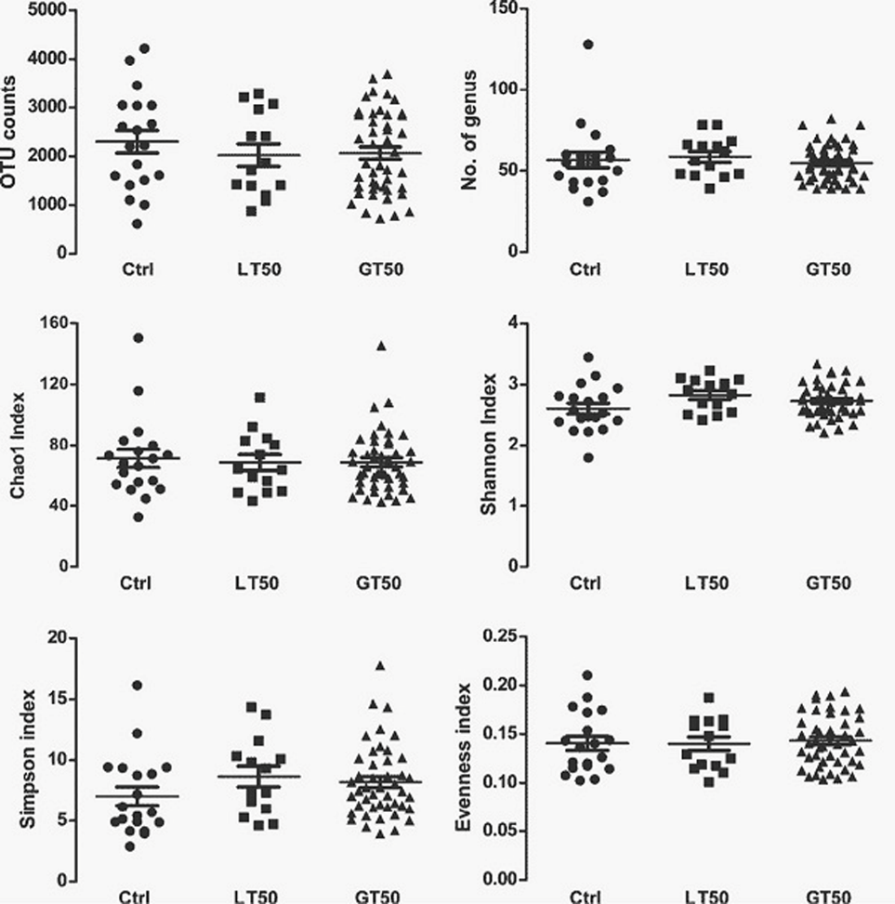
Fig. S1. Alpha diversity comparison using phylotype relative abundance measurements among humans with three different coronary atherosclerotic phenotypes (Kruskal–Wallis test, all p > 0.05).

